**LUKA: An Accident and Disaster Detection System using Convolutional Neural Network (CNN), CCTV, and IoT-Based Camera**

A Project Requirement in

Thesis Writing – CSM417N

Bachelor of Science in Computer Science

Submitted by:

**Maria Zorene J. Ramos**

**Mark Angelo P. Santonil**

**Brian O. Haw**

**Aldhen Keith M. Padilla**

Submitted to:

**Mrs. Analiza P. Berania, MIT**

Project Adviser

**May 2025**

**PRELIMINARY PAGES**

Title Page

Approval Sheet

Acknowledgement

Table of Contents

List of Figures

List of Tables

Abstract

**CHAPTER I**

**INTRODUCTION**

1.1 Background of the Study

1.2 Project Context

1.3 Statement of the Problem

1.4 Objectives of the Study

1.5 Purpose and Description

1.6 Significance of the Study

1.7 Scope and Limitations

1.8 Definition of Terms

**CHAPTER II**

**REVIEW OF RELATED LITERATURE AND STUDIES**

2.1 Technical Background

2.2 Related Literatures

2.3 Related Studies

2.4 Related Systems

2.5 Synthesis

2.6 Conceptual Framework

**CHAPTER III**

**METHODOLOGY**

3.1 Systems Methodology

3.2 Requirements Analysis

3.3 Requirements Documentation

3.4 Design of Systems

3.5 Feasibility Study

3.6 Development and Testing

3.7 Description of Prototype

3.8 Implementation Plan

3.9 Implementation Results

**CHAPTER IV**

**RESULTS AND DISCUSSIONS**

4.1 Results

4.2 Interpretation and Analysis of Data

**CHAPTER V**

**CONCLUSION AND RECOMMENDATIONS**

5.1 Summary of Findings

5.2 Future Works/Studies

**SUPPLEMENTARY PAGES:**

1. ~~References~~
2. ~~Appendices~~
3. ~~Relevant Source Code~~
4. Evaluation Tool or Test Documents
5. Sample Forms/Reports
6. Initial Screen Layouts
7. ~~Ethical Statements~~
8. ~~Routing Slip~~
9. ~~Mentoring Slip~~
10. Sample Generated Outputs
11. ~~Pictures showcasing the data gathering done~~
12. ~~Interview Letters~~
13. ~~End User System Evaluation~~
14. ~~User Acceptances~~
15. ~~One-page Curriculum Vitae per team member~~

**ABSTRACT**

Managing rescue operations within a small community poses issues such as limited coverage, insufficient patrollers, and delays in CCTV-based incident monitoring. In this research, we propose a surveillance system that uses Convolutional Neural Network (CNN) and IoT-based modules to identify natural disasters and daily incidents like vehicular crashes. To address these issues effectively, the system uses live CCTV feeds to process images, enabling automated detections. The study aimed to reduce live feed monitoring time by providing contextual environmental data and establishing an effective multi-level alert system. Prototyping was chosen as the methodology for the project as it aligns well with the system's iterative development, allowing for continuous refinement upon testing and evaluation. Multiple prototype development iterations were used to improve sensor accuracy, processing algorithms, and power efficiency. Various environmental and accident-related conditions were tested with validated sample test data and simulated testing to measure the detection performance. The experimental results show that there are significant improvements in monitoring time for surveilling live incidents, showing <1 second delay, compared to initial tests with an average of <4 second delay on an isolated feed. The performance of the integrated IoT modules resulted in 44mA power draw, reliability of 91%, and 90% accuracy. The proposed system showed promising potential in reducing monitoring time for live feed management, particularly through quick identification of several incidents and disasters. This system can contribute to managing rescue operations more efficiently by providing real-time notification of the accidents and/or disasters to the concerned departments.

*KEYWORDS: Convolutional Neural Networks (CNN), Internet of Things (IoT), Accident, Disaster, Prototyping, Philippines*

**CHAPTER I**

**INTRODUCTION**

**1.1 Background of the Study**

In recent years, artificial intelligence (AI) has grown significantly, transforming numerous fields using various algorithms and machine learning approaches. Among these, Convolutional Neural Network (CNN) has become a highly regarded tool for image analysis and recognition, enabling the creation of systems that can process visual data with remarkable precision.

Natural disasters and accidents have devastating effects on communities worldwide. Events such as earthquakes, floods, landslides, and fires often occur with little warning, leaving populations vulnerable and unprepared. The unpredictability of these disasters, coupled with the growing urbanization and population density, has underscored the need for more flexible disaster detection and response systems.

In terms of disaster risk, the Philippines has been ranked as the most at-risk country worldwide to effects of natural events for three consecutive years according to the 2024 World Risk Report (GMA Integrated News, 2024). The country was evaluated with a 46.91 world risk index value, 5.78 higher than the second ranking country, Indonesia. In 2022, the country's rating was 46.82, while in 2023 it rose slightly to 46.86. The report from the Institute for International Law of Peace and Armed Conflict evaluated 193 countries by considering natural hazards and their susceptibility to the harm from severe natural occurrences and adverse effects of climate change. This also included the occurrence and strength of earthquakes, tsunamis, floods, cyclones, droughts, and rising sea levels. They evaluated the exposure, vulnerability, susceptibility, lack of coping capacities, and lack of adaptive capacities of each country to various crises such as extreme natural disasters, conflicts, pandemics, and wars.

In 2022, the Philippines have experienced 18 tropical cyclone occurrences. The most devastating event in the past decade was Typhon Yolanda or Haiyan in 2013, resulting in more than 95 billion Philippine pesos in financial damages. Moreover, approximately 7,000 people were declared dead, while nearly 30,000 were reported as missing. In addition to typhoons, the nation is also vulnerable to earthquakes, with magnitudes ranging from two to seven. During 2021, more than 12,600 earthquakes were recorded in the Philippines, with the most powerful ones affecting the areas of Davao Oriental and Davao Occidental, each with a magnitude of 7.1. In 2019, Luzon was hit by a powerful earthquake measuring 6.1 on the Richter scale, resulting in multiple casualties (Balita, 2024).

According to Naderev Saño, the Executive Director at Greenpeace Southeast Asia, the Philippines faces annual cost of 2% of their GDP, and reconstruction costs additional 2%, losing 5% of their economy annually due to typhoons. This obstructs the overall economic development of the country (Vidal, 2021). At present, the industrial growth of the country is lacking compared to other countries residing in Southeast Asia, although it was predicted that the country would experience similar growth similar to top-performing neighbors like Thailand, Vietnam, and Indonesia (Tolo, 2011).

The current methods, which heavily relies on patrolling shifts and manual CCTV reviewing, are often incapable of providing timely interventions, exacerbating the damage caused by these events. Advancements in AI, particularly in image processing, offer promising solutions for early detection and timely response.

**1.2 Project Context**

Convolutional Neural Networks (CNN) is a type of feed-forward neural network that is regularized and learns features through filter optimization, making them highly effective in processing visual data, especially for tasks such as object detection and pattern recognition. In the context of disaster detection, CNNs analyze live video feeds from CCTV and IoT-based cameras to identify visual cues associated with natural disasters like rising floodwater, smoke from fires, or shifting ground indicative of landslides. The use of CNNs in the LUKA system allows for the automated detection of such events in real time, thereby minimizing potential delays caused by manual monitoring and helping with quicker response times.

One of the currently classified hazard-prone area in the Philippines is Olongapo City because of its vulnerability to earthquakes, tsunamis, landslides, volcanic eruptions, and floods. Due to the possibility of natural disasters, the city is consistently working to create a competent rescue team composed of trained personnel. The City Disaster Risk Reduction and Management Council, City Disaster Risk Reduction Management Office, frontline service providers, and rescuers are receiving training to improve their skills in disaster risk reduction and saving lives and properties. The City Government consistently updates and enhances its supplies and equipment as well.

Barangay Santa Rita, an area in Olongapo City, frequently faces natural disasters including floods and landslides. In recent years, the barangay has managed natural disasters more effectively compared to the past decade due to their response teams and Information, Education, and Communication (IEC) campaign, educating the local community on the importance of prevention and evacuation before disasters escalate. As a catch basin area, the focal training of the barangay’s response team is centered on calamity-based rescues such as swift water rescue, boat handling, and high-angled training.

Historically, the barangay has received a Gawad Kalansag Award by the DILG Region III - Central Luzon and was recognized as the nation's best at the barangay level. The Barangay Risk Reduction Management Committee of Sta. Rita was acknowledged as the best nationwide in disaster management, mitigation, preparedness, response, and rehabilitation.

In terms of disaster prevention, the barangay has several existing measures, including automated solutions. There are currently 36 CCTV cameras deployed throughout Santa Rita and its bridges for monitoring incidents, particularly disasters. With the cooperation of Department of Science and Technology (DOST), the Philippine Atmospheric, Geophysical and Astronomical Services Administration (PAGASA), and Korea International Cooperation Agency (KOICA), the barangay was provided with the Flood Forecasting and Early Warning System as part of reinforcing disaster resilience in the Philippines. Furthermore, there are annual programs aimed at enhancing disaster prevention, including river excavation and sewage draining. Although each bridge is equipped with a water level monitoring system, there have been instances where these readings were inaccurate. It might be based on preference, but when it comes to determining the water levels, analog measures are still reliable for the barangay’s response team because of its certain inadequacies for accurate measurement.

In terms of communication, the primary mode of communication of the barangay’s response team is through telecommunication. Radio communication is especially utilized during power outages in the area. However, if there is not enough electricity, radio communication becomes unviable and all remote communication methods are cut off.

During team operations, they prioritize assisting those closest to them in their designated area before considering other locations. As a result, the response team will disregard any additional requests for assistance not within their current vicinity, including pleas for help through radio communication.

One of the greater challenges that the disaster management operations face, particularly the local disaster response team, is handling forest fires in the barangay. Some of the mountains surrounding the barangay have ravines, which can escalate into greater fires, affecting nearby residential areas, if not immediately tended to.

Reported accidents within the area have been minimal in recent years, which are primarily characterized by minor vehicular accidents and self-inflicted injuries. The barangay's proactive approach to safety, including effective traffic management measures and IEC campaigns for various incidents, has significantly contributed to this positive outcome.

However, casualties have still been observed in recent months, particularly due to typhoon-related incidents. One of the recent major incidents that happened in the area is the 24-hour search for the missing 10-year-old boy who fell into the Mactan river during Tropical Storm “Kristine”. There have also been 2 reported incidents caused by ravine fires in the barangay during the month of April 2024 alone, where a fire razed a residential building, leaving 300,000 pesos worth of damage to the infrastructure (Aglibot, 2024), and a house fire that left the house owner and 2 dogs dead (Inquirer Central Luzon, April 2024).

Even with enhanced measures for natural and man-made disasters in recent years, Santa Rita’s current response team remains small, composing of only 25 members. With a total of 56,000 population in Santa Rita, managing disasters with a wide-scale impact has been extremely challenging. This locale serves as the target beneficiary of the LUKA system, which aims to enhance the capabilities of local government units and rescue teams.

The LUKA system proposes a comprehensive disaster and accident monitoring that integrates advanced technologies, including Convolutional Neural Networks (CNN), closed-circuit television (CCTV), and IoT-based cameras. LUKA aims to emphasize its real-time monitoring and automated alerts features which can contribute to enhancing decision-making and response times during emergencies. The design and development of this system software is significant to better manage disaster response efforts and improve overall public safety.

**1.3 Statement of the Problem**

**General Statement of the Problem**

The LUKA system aims to aid with challenges faced by Barangay Santa Rita, Olongapo City, in the context of local disaster response and management.

**Specific Statement of the Problem**

1. How can the monitoring process improve in terms of real-time disaster and accident response.
2. How can the system detect accidents and disasters using camera components.
3. How can the system help detect accidents and disasters in ways beyond just visual data.
4. What method and level of notification and alert will be appropriate for the use of the LUKA system.
5. How can the LUKA system's interface be designed to ensure an intuitive and efficient user experience for local staff.

**1.4 Objectives of the Study**

**General Objective of the Study**

To develop and evaluate LUKA as an integrated disaster response system aimed at enhancing the responsiveness of local governance and emergency operations in barangay Santa Rita, Olongapo City,

**Specific Objectives of the Study**

1. To reduce the time needed for monitoring live feeds by automating detection of disasters and accidents through CNN image analysis.
2. To enhance real-time response and reduce human intervention by automating the detection of accidents and disasters through CNN-based image analysis of live camera feeds.
3. To integrate IoT-based sensors with live video feed, providing contextual data such as temperature, humidity, or wind speed, which aids in visualizing environmental conditions.
4. To develop an automated alert system that notifies authorities of detected incidents.
5. To create an intuitive user interface that allows local staff to efficiently monitor and manage real-time alerts, historical data, and live streams of detected incidents.

**1.5 Purpose and Description**

The goal of the LUKA system is to provide support to barangay officials, the monitoring department, and disaster response teams in both emergency situations and day-to-day accidents, particularly vehicular crashes, the most common incident in several barangay in Olongapo City. LUKA aims to enhance the efficiency of delivering public services by incorporating real-time tracking, automated notifications, and playback management to the local monitoring department through CCTV cameras and IoT devices. The goal is to assist in notifying the authorities to decrease potential delays and aid in taking quick action in accidents and disasters that occur in the community.

Since the barangay has a control room in their Barangay Peacekeeping Action Team (BPAT) office, CCTVs deployed in the area can be monitored and surveilled using a centralized network and server. Currently, the barangay has plans to upgrade to CCTV infrared cameras.

Once LUKA is implemented in Barangay Santa Rita, Olongapo City, the local significance will include the following:

1. **Local Disaster Response.** LUKA aims to assist with quicker disaster response in coordination with the barangay monitoring personnel and rescue teams during emergencies. With automated notifications, the project will be able to assist in providing communication between the barangay officials and rescue units, thus further enhancing disaster management and preparedness of barangay Santa Rita.
2. **General Public.** The LUKA system aims to aid in faster response to emergencies due to natural disasters in Barangay Santa Rita. It enhances public through minimizing the time needed in dispatching rescue teams to urgent situations to address certain problems.
3. **Researchers.** LUKA gives information that other researchers engaging in disaster management, local governance and public safety can take into consideration. The researchers can analyze the data brought along by LUKA in its intensity as well as draw conclusions regarding local disaster response's effectiveness and evaluate factors that can optimize any resourcefulness, communications network and governance structures in other municipalities or barangays.

**1.6 Significance of the Study**

The LUKA system can potentially aid and improve local response to disaster management plans and encourage engagement and collaboration with local providers. Adding real-time monitoring and automated alerting to the current system and works in coordination with the CCTV monitoring personnel and the Barangay Santa Rita local response team. The goal of this project is to create assistive technology that can help in advancing disaster management in the region.

Its playback analysis feature allows monitoring and response teams to review past incidents together, fostering shared learning experiences that can be applied to future responses. This would at least help control the barangay’s response group and assist barangay officials to call for help from other barangays before a situation escalate.

This research has vast implications from both academic and professional perspectives. This gives realistic information on discussions containing technology in disaster response plans and serves as a valuable resource for further research and utilization. The results are not just to provide for local government units and disaster response agencies but promote comparable endeavors in other susceptible regions.

**1.7 Scope and Limitations**

This study involves the development and evaluation of the LUKA system's effectiveness in enhancing barangay operations and disaster response in Barangay Santa Rita, Olongapo City.

This study is based on the implementation and assessment of the LUKA system within Barangay Santa Rita during the year 2025. The focus is on improving local disaster response, public safety, and barangay operational efficiency. Key features such as real-time detection and automated notification for detected events are examined.

The data for this study is derived from system logs, additional but relevant resources outside barangay Santa Rita, and user feedback. Other factors such as socio-economic conditions, infrastructure limitations, and external communication channels are beyond the scope of this study. The personal profiles of officials and community members are not considered, except when relevant to their role in the disaster response process.

The system validates RTSP (Real-Time Streaming Protocol) and Hypertext Transfer Protocol/Secure (HTTP/HTTPS) for live monitoring. Therefore, the system can be used for IP cameras and online live streams.

Data transmission for the IoT-based components can be passed through Wi-Fi, with Bluetooth Low Energy (BLE) integration. Wireless signal interference may affect transmissions and ESP32-C3’s limited computational capacity restricts extensive real-time data processing.

In terms of detection, the system is bound to the identification of events in real-time and does not provide data indicating early signs of the specified incidents. Nevertheless, the system provides real-time environmental monitoring with motion, temperature, humidity, and rain, derived from its integrated IoT sensor module. However, its accuracy is influenced by environmental conditions, power fluctuations, and relies on stable power sources, although solar-powered alternatives are under research.

The system focuses on identifying five (5) specific events which are earthquakes, floods, landslides, fire incidents, and vehicular accidents. These restrictions on the system’s detection capability are intended to prevent strain in the system’s performance. Issues may involve high processing load due to detecting too many events, storage overload, and delayed event detection. Hence, we selected events that are frequently occurring in the area.

The landslide detection displayed an average of 47%, which could produce numerous false positive outputs. Model training proved difficult with minimal resources gathered for landslide detection. Hence, 47% accuracy is the best performance it can display currently.

Automated alerts are sent out through the system and mobile notifications, in which a third-party app must be downloaded for mobile alerts. We incorporated a third-party app instead of using Short Message Service (SMS) since SMS notification are only authorized for Philippine SMS providers. Notification alerts only produce details regarding the event type, location, and time of incident.

The system is also limited by the available technological infrastructure and equipment in the barangay, which may affect the system’s performance and user interaction. One of the setbacks in the system’s implementation is the RTSP streams’ susceptibility to latency issues, network congestion, and frame drops, especially in areas with unstable internet connections. These factors may influence the real-time effectiveness of the monitoring system and the accuracy of the detected incidents.

Another challenge faced in this study is the integration of multiple machine learning models for various types of accidents and disasters. The complexity of training and maintaining diverse models for different incidents, such as floods, fires, and structural collapses, presents significant computational and operational challenges. To address these constraints, this study focuses on a single but commonly occurring accident in the area, vehicular accidents, particularly collision between vehicles. However, this limits its ability to identify incidents involving other subjects like animals, infrastructure damage, and pedestrian-related incidents. This decision ensures that the model remains optimized for accuracy and efficiency, reducing the risk of false identification.

Furthermore, the monitoring system is highly dependent on network connectivity. Any disruptions in the local internet service or power supply can hinder the system’s ability to function effectively, delaying the detection and response process. This limitation must be considered when assessing the feasibility of real-time emergency response.

Due to privacy concerns of several barangays, we were prohibited from gathering video data and any form of private information from respective areas. This includes statistical data and past feeds from their CCTV cameras. This restriction prohibited this study from gathering local data and the proponents relied on online resources for model training instead.

The system operates solely when there is an available power supply; it cannot display any forms of data during power outages. In these cases, the responders must rely on their current methods such as radio communication and gathering in designated areas for updates on the current situation. Alternatively, they can ensure that backup power generators are operational, if there are any available.

**1.8 Definition of Terms**

**1. Convolutional Neural Network (CNN):** A type of deep learning algorithm particularly effective in processing and analyzing visual data, such as images or video feeds, and is used in the LUKA system for detecting natural disasters.

**2. IoT Devices:** Internet of Things (IoT) devices, such as cameras or sensors, that connect to the internet and transmit real-time data. In this study, they are integrated with the LUKA system for disaster detection.

**3. Kernel or filter:** A small matrix used to scan over an input image to detect specific features of certain disasters.

**4. LUKA System:** A proposed surveillance system designed to detect natural disasters (earthquakes, flooding, landslides, and fire incidents) in real-time using CCTV, IoT cameras, and a Convolutional Neural Network (CNN) model.

**5. Model:** A program that detects specific patterns in data to make predictions. In this study, the model is used for distinguishing disaster-related events from normal occurrences from real-time footage.

**6. Real-Time Monitoring:** The process of continuously observing and analyzing data as it is collected, enabling immediate detection of and response to natural disasters.

**7. Response Time:** The duration it takes for the LUKA system to detect a natural disaster and provide an alert after receiving data from the cameras and IoT devices.

**8. Simulated Environment:** A controlled testing setting that replicates real-world conditions to assess the LUKA system’s performance without deploying it in actual disaster scenarios.

**9. Surveillance System:** A setup that includes cameras and sensors for monitoring and collecting data, traditionally used for security but adapted here for detecting natural disasters.

**10. Accuracy:** Measures the correctness of the AI models when it comes to predicting certain events.

**11. Precision:** Measures how well the model matches positive predictions. This is important to measure when minimizing false positives.

**12. Recall:** Measures the ratio of true positives compared to actual positive instances of the model.

**13. F1-Score:** Merges precision and recall into a single metric, providing balance between the two. It provides a better oversight of the model’s overall performance.

**14. Type 1 Error or False Positive:** happens when the model wrongly identifies a positive instance, while the actual instance is negative.

**15. Type 2 Error or False Negative:** happens when the model wrongly identifies a negative instance, while the actual instance is positive.

**16. Confusion Matrix:** A table showcasing the AI model’s performance by comparing predictions with the actual results.

**17. Server:** This is where the proxy connection between the camera and end device, app launch, and back-end libraries are integrated.

**CHAPTER II**

**REVIEW OF RELATED LITERATURE**

**2.1 Technical Background**

The proponents examined technologies used for this study and had assessed corresponding research that could assist in evaluating suitable equipment and other resources required for the development of the LUKA system.

The LUKA system is a surveillance tool for detecting natural disasters and common accidents that happen in Santa Rita, enhancing the capabilities of the existing surveillance infrastructure. The system delves into Artificial Intelligence and Internet of Things. Thus, there are terms or terminologies that only students engaged in courses covering these subjects, along with those in the information technology field can comprehend. Some of the technical terms that are used by the proponents include Flask server, JSON, ESP32 microcontroller, YL-83, DFRobot, ADXL345, OpenCV, DS3231, ESP32-CAM, Ultralytics, Yolo, imgsz, batch size, epochs, workers, device, detection, and segmentation. Some of the terminologies mentioned also refer to the tools used by the proponents.

**IoT Module Integration**

The proponents designed and implemented an Internet of Things (IoT) device, which monitors environmental factors such as rainfall intensity, wind speed, earthquake detection, and weather predictions using a self-provided camera by the proponents. The device utilized an ESP32 microcontroller, which can handle Wi-Fi communication, sensor data collection, and image processing.

The IoT device was designed for monitoring weather and environmental conditions and can be applied in various fields, including disaster monitoring, weather prediction, and climate studies. The system used a combination of sensors such as rain sensors to measure rainfall intensity, anemometers for measuring wind speed, accelerometers for earthquake detection, Real-Time Clock (RTC) for Wi-Fi module for sending data over the internet for cloud-based analysis, along with a camera module for additional analysis of the sky for weather predictions.

The rain sensor scales the rain intensity through detecting the volume of water that falls onto a conductive surface. The sensor’s analog signal is read by the ESP32’s Analog to Digital Converter (ADC). In this sensor, higher reading indicates higher rainfall. The wind speed detection is done through the anemometer using a rotating mechanism that generates an analog signal proportional to the wind speed.

For earthquake detection, the accelerometer senses vibrations caused by earthquakes. The basis for measuring acceleration will be the X, Y, and Z axes, which are used for detecting abnormal changes in these values, indicative of seismic activity.

In sky analysis, the IoT-based camera captures images of the sky periodically. While this could be done with image processing and machine learning, for simplicity, this system assumed basic image capture. More advanced analysis could include sky classification (cloud cover, etc.) using machine learning models. The device also included data logging and transmission through sending sensor data to a server within intervals for lesser storage usage, create timestamps using RTC, and transmit data in JSON format.

The ESP32 Microcontroller was used for handling sensor data collection and Wi-Fi communications, connecting the cloud server to transmit data, controlling the camera module to capture periodic images, reads sensor data from the anemometer, accelerometer, rain sensor, and RTC.

To further specify the sensor models, the proponents used YL-83 rain sensor, connected with ESP32’s analog input pin and send analog signal to ESP32’s GPIO34. DFRobot Anemometer, which can be connected to an analog or digital pin, depends on the sensor’s output type and sends analog signal to ESP32’s GPIO35. ADXL345 Accelerometer and DS3231 RTC, which are connected to the ESP32 via the 12C interface. The OV2640 camera is connected to the ESP32 through the ESP32-CAM interface, which should capture Base64-encoded image data.

**Mathematical Computation for Sensor Data**

Mathematical computations are essential for accurately interpreting sensor data by minimizing errors and improving precision. For the MPU6050, acceleration along each axis (Ax, Ay, Az) is determined by dividing the raw sensor voltage output by the sensitivity scale factor:

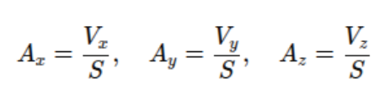

While angular velocity is obtained by subtracting the sensor’s bias offset from the raw output and dividing it by the gyroscope’s sensitivity factor:

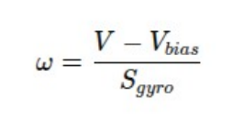

The DHT11 sensor calculates relative humidity (RH) by comparing the raw output to the maximum humidity reference:

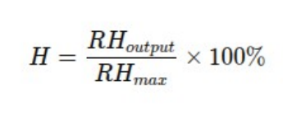

While temperature in Celsius is derived using the raw digital output and the temperature scale factor:

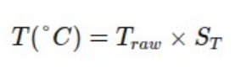

The rain module measures precipitation intensity by dividing the sensor’s output voltage by its maximum calibrated value:

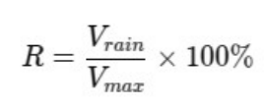

System efficiency is also evaluated using a power efficiency equation, where the ratio of power consumed by active components to the total power supplied:

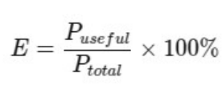

**Rain and Storm Detection using OpenCV**

In using OpenCV for rain and storm detection, it was employed for detecting motion and edge to identify raindrop streaks in frame, examine changes in contrast and brightness for fog or cloud cover detection, and detect lightning flashes by identifying sudden brightness change in consecutive frames. For real-time detection, OpenCV can process video frames in real-time, which can be suitable for dynamic environments.

**Computations used for Fire Detection Model**

In the fire detection model, there are several mathematical operations and computations used specifically for image conversion, color thresholding, contour detection, and bounding box.

1. Images are represented as 3D arrays, where the shape is calculated using the following formula:

*H x W x CH*

where:

* *H* is the height
* *W* is the width
* *C* is the number of channels (3 for RGB). Each pixel is defined as *(R, G, B)* values ranging from *000 to* *255.*

1. The conversion of image to HSV follows the following values:

* 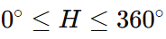H (Hue) represents the color (angle on the color wheel), where:
* 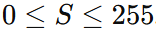S (Saturation) is the intensity of the color, where:

Higher values correspond to more vivid colors.

* 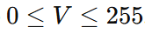V (Value) represents the brightness of the color, where:

Higher values correspond to brighter colors.

1. The following is the formula and values for a pixel in RGB space:

*H* (Hue) represents the RGB (red, green, blue components), which are the dominant colors.

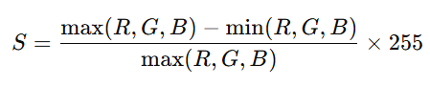,

where *S* (Saturation)measures the intensity or purity of the color.

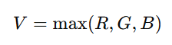

where *V* (Value) represents the color’s brightness.

1. The formula for thresholding each pixel uses the following computation for isolation of characteristics of fire in terms of its color:

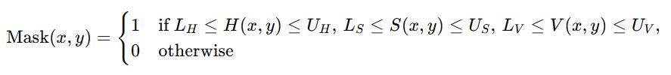

where 1 (white) pixel represents fire and 0 (black) represents pixels outside of the specified range.

1. The mathematical operation for dilation, which computes the maximum value of the defined neighborhood defined by the kernel applied to the binary mask:

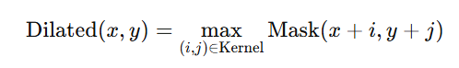

The mathematical operation for erosion, which computes the minimum value of the defined neighborhood defined by the kernel applied to the binary mask:

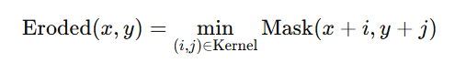

1. Contours are interconnected boundaries of regions in the binary mask. Contours are computed using:

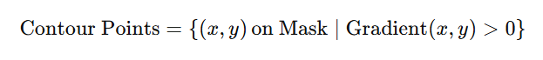

This formula provides the magnitude of the gradient vector, highlighting regions in the image where intensity changes rapidly, which are typically associated with edges or boundaries:

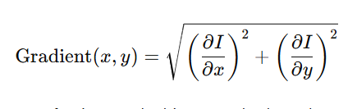

1. The area (*A*) is calculated as the number of pixels enclosed by the contour.

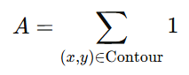

If the computed area exceeds a predefined threshold area, the region is considered an explosion:

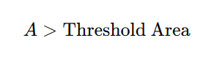

For each valid contour, the model computes the bounding rectangle to:

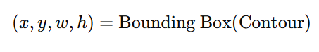

where:

* (x,y): Coordinates of the top-left corner of the bounding rectangle.
* w,h: Width and height of the bounding rectangle, respectively.

**MPU6050 Computations**

For the MPU6050, acceleration along each axis (Ax, Ay, Az) is determined by dividing the raw sensor voltage output by the sensitivity scale factor:



While angular velocity is obtained by subtracting the sensor’s bias offset from the raw output and dividing it by the gyroscope’s sensitivity factor:



The DHT11 sensor calculates relative humidity (RH) by comparing the raw output to the maximum humidity reference:



While temperature in Celsius is derived using the raw digital output and the temperature scale factor:



The rain module measures precipitation intensity by dividing the sensor’s output voltage by its maximum calibrated value:



System efficiency is also evaluated using a power efficiency equation, where the ratio of power consumed by active components to the total power supplied:



**Integrating YOLOv11 for Accident and Natural Disasters Detection**

In machine learning models for detecting car accidents and other natural disasters, the proponents used Yolo or You Only Look Once, a model created by Ultralytics for real-time object detection algorithms used in computer vision. Computer vision allows for data extraction, analysis, and interpretation of data from images. The proponents used Yolov11 for detecting multiple objects in an image or video frame in a single pass, making it fast and efficient for object detection. The image below shows the difference between Yolov11 compared to other yolo models.

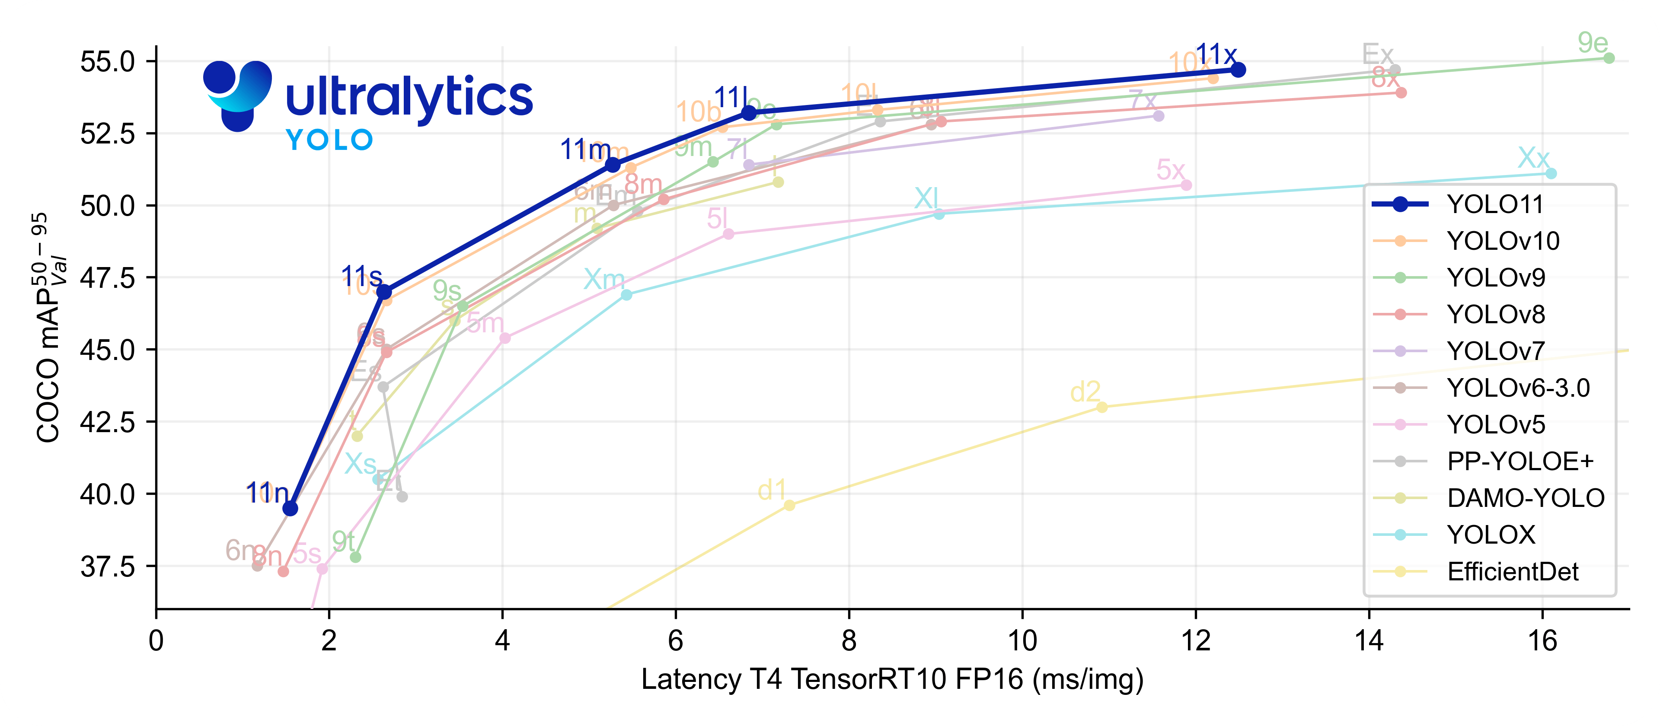**Figure 1. Ultralytics Yolo Model Performance Chart**

**Machine Learning Model Processes and Training**

Object detection identifies and locates objects within an image using bounding boxes, while instance segmentation outlines the exact shape of each object with pixel-level precision. Detection is faster and sufficient for car and fire accidents, whereas segmentation is more detailed and useful for landslides and floods.

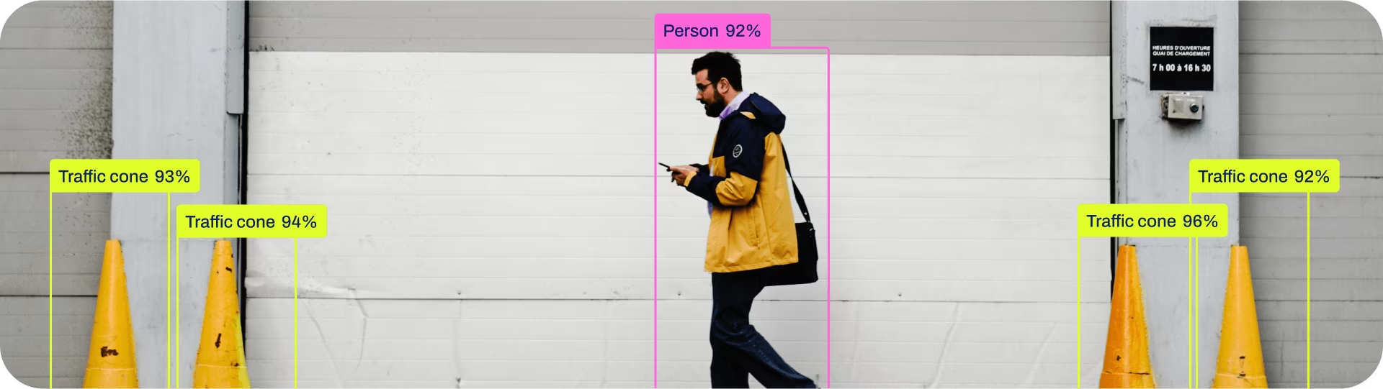**Figure 2. Object Detection**

Object detection is ideal for fire and car accident detection as it quickly identifies flames, smoke, and vehicle deformations in real-time video feeds. Models like YOLO and Faster R-CNN process frame efficiently, enabling automated alerts in smart surveillance and intelligent transportation systems (ITS). Fire detection leverages thermal and RGB data to distinguish flames, while accident detection tracks vehicle trajectories and impact patterns. These systems integrate with edge devices and cloud networks, ensuring fast emergency response.

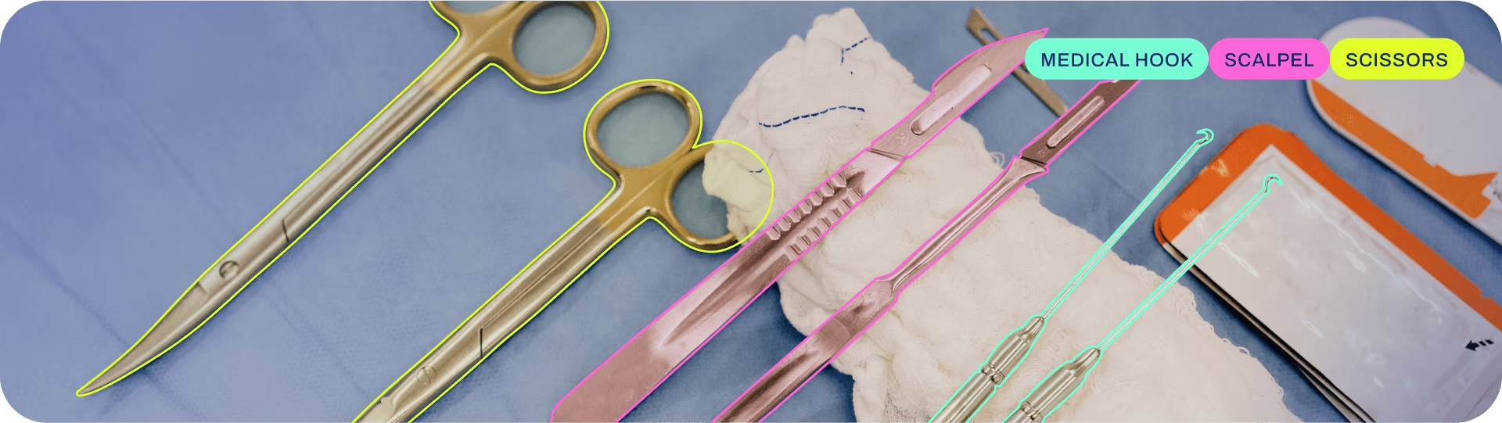**Figure 3. Instance Segmentation**

Instance segmentation excels in landslide and flood analysis by providing pixel-level mapping of affected areas. Models like Mask R-CNN and DeepLabV3+ analyze satellite and drone imagery, distinguishing terrain shifts, and water spread. Landslide detection incorporates digital elevation models (DEMs) and soil data, while flood segmentation uses synthetic aperture radar (SAR) to assess water levels. This precision supports disaster response, hydrological modeling, and GIS-based risk management.

In model training, aspects such as imgsz, batch size, epochs, workers, and device configuration provide better results when training a model. imgsz (image size) defines the input resolution, where values like 640 or 1280 balance detection accuracy and computational efficiency. batch size controls how many images are processed simultaneously, with 16–64 recommended for GPUs to optimize memory usage and speed. epochs determine the number of complete datasets passes, typically set between 50–100 with early stopping to prevent overfitting. workers handle parallel data loading, with 4–8 ideal for large datasets on multi-core CPUs. Device selection impacts training speed, with Cuda for GPUs, CPU for general use, and TPU for large-scale distributed training. Proper tuning of these parameters ensures efficient and accurate model performance.

**Metrics used for Evaluating the Models**

In determining the performance of each machine learning models, we performed evaluation metrics to measure how reliable the models are in detecting events. The following are the metrics we used in determining its performance:

1. **Accuracy**

* 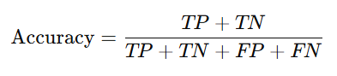measures the occurrences of correct predictions in the model:

where:

* *TP* stands for True Positives
* *TN* stands for True Negatives
* *FP* stands for False Positives
* *FN* stands for False Negatives

1. **Precision (or Positive Predicted Value)**

* 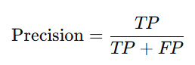measures how many of the predicted positive instances are actually correct:

1. **Recall**

* 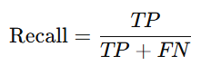measures correctly identified positive instances:

1. **mAP50**

* metric used in object detection that computes the mean of Average Precision scores at IoU threshold of 0.50. The formula is as follows:

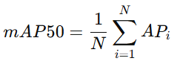

where we compute the Precision-Recall curve and Average Precision for each class. *N* stands for the number of classes.

1. **Fitness**

* 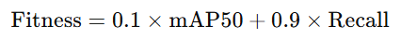metric used to evaluate model’s overall performance. In YOLO-based models, the following formula is used:

**Web Interface and Server**

In designing the web interface, we used Hypertext Markup Language (HTML), Cascading Style Sheets (CSS), and JavaScript (JS) to create a functional website. We created a system similar to a CCTV live feed monitoring system for familiarity. We used Flask, a micro web framework in Python, to create a server that will interconnect the system with the CCTV and IoT-based camera live feeds with the use of Internet Protocol (IP) address and Real-time Streaming Protocol (RTSP).

**Relevant Libraries**

The Flask server also uses different Python libraries including `time` for time-related operations like sleeping and calculating elapsed time, `webbrowser` to automatically open the website interface automatically upon execution, and threading to run the Flask server in a separate thread for concurrent execution, `sqlite3` to manage an SQLite database for storing system-related information, and `psutil` to monitor system resources such as memory usage. For video processing, cv2 (OpenCV) handles frame capturing and overlays text on video, while `ultralytics.YOLO` enables real-time object detection, and `watchdog` detects file changes in the project directory for reloading or debugging. While `flask_cors` enables Cross-Origin Resource Sharing (CORS) to allow frontend requests.

**Mobile Notifications**

The Pushover application is used for receiving push notifications in mobile devices. The user will automatically receive messages in the application when an incident is detected by the LUKA system. This application is available in Android and Apple (iPhone, iPad, Apple Watch) devices and Desktop.

**2.2 Related Literature**

In recent years, the integration of artificial intelligence with CCTV surveillance has been a notable area of research. Relatively, there has been a growing demand in this area of research. Recent advancements in employing machine learning algorithms, driven by hardware and software improvements, resulted in widespread implementation of Smart Video Surveillance (SVS) system across different industries (Yao, 2024).

AI-based systems serve as a key element in protecting communities through continuous monitoring and quick response to detected anomalies. Moreover, artificial intelligence can be used for implementing intelligent CCTV systems, which can maximize detection of abnormal events, patterns, or behavior (Ryu, 2023), providing aid on certain communal areas with low security and safety measures.

There are various machine learning algorithms that can be used in object detection, one of which is the Support Vector Machine (SVM), one of the leading classification algorithms employed in object detection, producing high accuracy levels. Nevertheless, current hardware implementations of SVM aimed at enhancing the speed of SVM classification have focused solely on basic applications or on SVM training. However, there are few suggested hardware architectures that are versatile enough for use across different object detection applications (Kyrkou & Theocharides, 2012).

Machine learning algorithms such as Artificial Neural Network (ANN) and CNN has been discussed in the research conducted by Moorthy, R., et al., (2020) ANN exhibits a high accuracy rate. For face recognition during nighttime, Eigenface is an effective algorithm to use, with an average of over 50%. This can also be correlated, not only with facial recognition, but also with general object detection. However, CNN is determined best in identifying several faces simultaneously with both images and video frames and detecting faces with significant pose variations. Therefore, the proponents were certain in using the CNN machine learning algorithm for their accident and natural disasters detection system.

There are numerous risks linked to the implementation of CCTV cameras as the main surveillance system. A potential risk is the lack of awareness of the human operator monitoring the connected CCTV display, which includes the danger of disseminating sensitive and unauthorized footage. In addition, CCTV cameras can capture information about vehicles, especially in public areas like schools, streets, and hospitals (Alblooshi, 2021).

There are also concerns surrounding AI surveillance technologies. As AI continues to progress, its integration with surveillance systems poses significant concerns regarding personal rights, social standards, and the possibility of misuse (Ergashev, 2023).

There is a focal concern regarding misuse of personal information, interrelated with AI-based system’s vulnerability with various security threats. These threats span from data gathering and preparation, training process, inference, to deployment stages. In an AI-driven system, the data gathering and pre-processing stages are susceptible to sensor spoofing and scaling attacks, whereas the model's training and inference phases face poisoning and adversarial attacks (Hu et.al., 2021).

**2.3 Related Studies**

Salb et al. (2023) explored a hybrid Convolutional Neural Network (CNN) model combined with XGBoost to enhance IoT network security. By tuning parameters using a modified reptile search algorithm, the model achieved efficient network intrusion detection and real-time data management. The findings demonstrated the potential of AI-based methods for improving IoT security, with implications for real-time disaster and accident detection systems.

Barathwaj et al. (2024) proposed a real-time accident detection and reporting system that utilizes a CNN algorithm to process video data. This system identifies potential accidents, sends alerts to relevant authorities, and improves emergency response times. CNN’s capabilities in image recognition enable accurate detection and analysis of accident events, making it suitable for use in smart surveillance systems.

In the research study conducted by Mullan, et al. (2024), they integrated an image segmentation based on deep learning to address problems such as time and location, hydrological applications, where water bodies can be affected by light reflections, surface waves, and complex shapes (Lin et al., 2018, Bai et al., 2021). In recent years, image segmentation has been used effectively for computer vision.

Hyperparameter tuning is a fundamental process for optimizing machine learning models, balancing overfitting and underfitting. Techniques like grid search, randomized search, and genetic algorithms are commonly used to find the best configurations. Rimal, et al. (2024) showed that genetic algorithm tuning provided the highest accuracy and AUC-ROC score in student grade classification. However, accuracy can be misleading, especially in imbalanced datasets. As Bobbitt (2022) noted, metrics like the F1 score, which accounts for both precision and recall, offer a more accurate assessment of model performance in such cases.

According to Hendricks (2022), industry benchmarks for the accuracy of machine models range from 70% to 90%. Any value exceeding 70% is deemed acceptable as a practical and useful model data result. It is important for a model's data output to be realistic since this data can subsequently be integrated into models that serve different businesses and sector needs.

Based on the sensor specifications from Aosong Electronics (2021), DHT11 operates within a voltage range of 3V to 5.5V DC. After powering on, it requires a one-second stabilization period before receiving commands. To improve power stability, a 100nF capacitor can be placed between VDD and GND. The DHT11 sensor communicates with the MCU using a single-bus data format, which are also used for proper synchronization. Each data transmission lasts approximately 4 milliseconds and consists of 40 bits, with higher-order bits sent first. The data structure includes an 8-bit integer and 8-bit decimal value for both relative humidity and temperature, followed by an 8-bit checksum. The checksum is derived from the sum of the first four data segments, if the data transmission is right.

**2.4 Related Systems**

Convolutional Neural Networks (CNNs) are particularly effective in image recognition tasks due to their layered architecture, which progressively identifies complex patterns and features in visual data. Each layer enhances detection accuracy, mimicking the way the human visual cortex processes images. The efficiency of CNNs is further augmented when embedded in specialized processors like the Cadence Tensilica Vision P5 DSP, which provides high performance with low power consumption—critical for AI-driven applications (Edge AI Vision Alliance, 2015).

A low-cost intelligent surveillance system utilizes CNNs on compact platforms such as the Raspberry Pi to bolster security measures. This system integrates ultrasonic sensors and cameras to detect motion and track suspicious activities in real-time. By employing saliency algorithms, it improves pattern recognition and object isolation, effectively identifying potential threats with high accuracy. This solution is adaptable for both open and closed environments, making it a cost-effective option for remote monitoring and automated threat detection (Hussain et al., 2021).

In the realm of emergency response, an IoT-based accident detection and alert system leverages AI to enhance response times in smart cities. Utilizing various sensors to gather data related to accidents—including speed, impact force, and location—this system employs deep learning techniques for validation and promptly alerts emergency services upon detecting incidents. The use of ensemble transfer learning techniques significantly reduces false positives, showcasing the potential of combining IoT with AI for effective real-time emergency responses (Khan et al., 2022).

Another innovative approach is the IoT-Based Automatic Vehicle Accident Detection and Visual Situation Reporting System, which utilizes on-vehicle sensors along with the ESP32 microcontroller to autonomously detect accidents. The system transmits critical information such as vehicle location, accident severity, and visual data to emergency responders and family members. Additionally, a mobile application assists bystanders in reporting accidents when sensor systems fail. This design aims to enhance the accuracy of emergency responses while minimizing false reporting, thereby improving safety and situational awareness during road incidents (Zhang et al., 2023).

**2.5 Synthesis**

Studies regarding surveillance systems with integrated deep learning techniques concluded several factors regarding their performance.

The research study by Wei Yang and Yen Su (2018) emphasized the use of hardware accelerators, such as the Neural Compute Stick (NCS), to significantly reduce execution times on devices like Raspberry Pi 3 and Rock64, resulting up to 6x speedup and enabling frame rates, which is suitable for tracking fast-moving subjects. However, the research study conducted by Sabri and Li (2021) uses a faster RCNN model optimized with a saliency algorithm to reduce computational demands while maintaining high accuracy in human and threat recognition, even in complex scenarios. While Wei Yang and Yen Su’s research emphasizes hardware architecture optimization for speed, Sabri and Li’s study focuses on algorithmic efficiency and feature isolation to achieve fast and accurate recognition on low-computation systems, showcasing complementary approaches to advancing surveillance technologies.

Selvi et al. (2022) proposed an Enhanced CNN (ECNN), with a 98.38% accuracy, displaying superior performance across metrics compared to CNN, DNN, and 2D CNN models. This study focuses on enhancing the model’s accuracy, providing an effective CNN model for real-time surveillance. In the research study by Vosta and Yow (2022), they used ResNet50-ConvLSTM architecture which showed promising results at anomaly detection with higher accuracy and AUC scores than prior methods like C3D, displaying good performance in detecting in a live environment.

In relation to the challenges in video processing with IoT integration, in the research study of Muhammad, et al. (2019), they proposed a deep CNN framework which primarily focuses in shot segmentation, intelligent feature extraction, and hierarchical fusion for keyframe selection. In another research study by Baccour et al. (2024), they have developed CNN systems that have privacy awareness using multi-agent reinforcement learning (MARL). This study addresses problems in resource allocation and privacy concerns in large-scale smart city environments, which can contribute to slow detection, memory allocation, and potential infringement risks.

**2.6 Conceptual Framework**

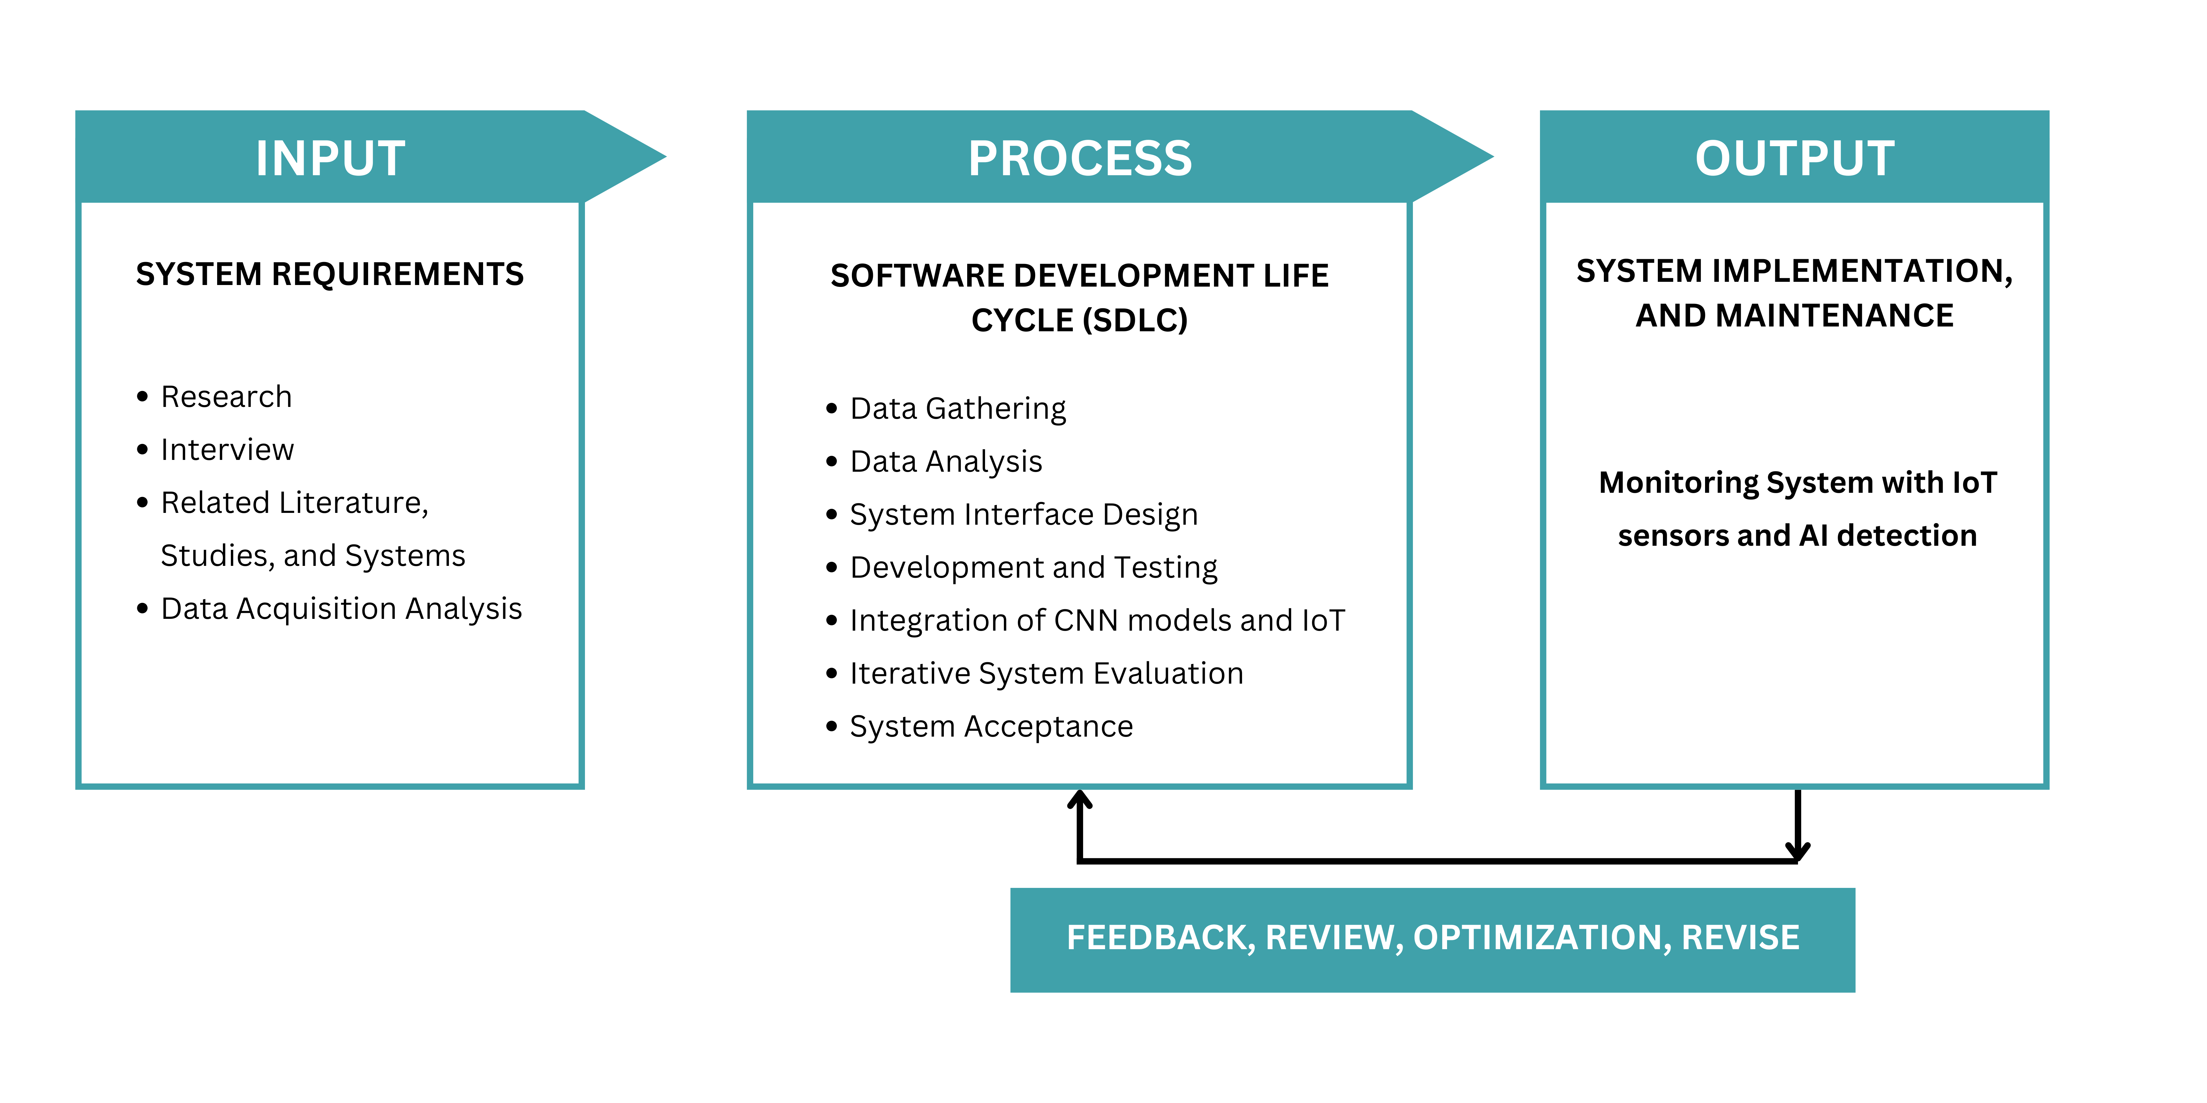

**Figure 4: Input Process Output (IPO) Diagram**

The conceptual framework of the LUKA system establishes a structured approach towards disaster monitoring and response, which has three major layers: Data Acquisition, Data Processing, and Response Mechanism. These layers conform to the Input, Process, and Output structure as presented by the Software Development Life Cycle (SDLC), thus ensuring systematized implementation and continuous improvement.

The Data Acquisition layer corresponds to the Inputs stage, in which system-specific requirements are defined through research, interviews, literature review, and data acquisition. Integration of camera modules, environmental sensors, and an ESP32 microcontroller were used for collecting and managing real-time environmental and visual data. Sensors will detect temperature, humidity, motion, and other environmental factors, while cameras will capture images and videos for anomaly detection. The ESP32 microcontroller will function as the central hub for data collection and for communication between the above components.

The Data Processing layer aligns with the Process stage in the SDLC. This stage involves data gathering, analysis, system interface design, development, testing, and integration of machine learning models with IoT components. OpenCV is used for image processing tasks, such as weather patterns and anomaly detections, while object detection and classification are performed by CNN-based machine learning models, with iterative system evaluation ensuring that the model becomes better over time and optimizes the accuracy for disaster detection. This stage also includes system acceptance, ensuring that the LUKA system meets functional and reliability standards before deployment.

The Response Mechanism layer is reflected in the Output stage, within where the system is implemented and maintained. Hence, with detected anomalies, the system further sends out alerts to concerned authorities. Moreover, a data visualization analytics dashboard involves list of detected events and statistics of weekly and monthly occurrence of specified events, enabling users to perceive the system’s status and informed decision-making. Feedback, review, optimization, and revision ensure consistent improvements through enhancing the system’s efficiency in disaster response and public security.

**CHAPTER III**

**METHODOLOGY**

**3.1 Systems Methodology**

**Methodology Overview**

The LUKA system will adopt the prototyping methodology for designing and developing the Accident and Disaster Detection System using Convolutional Neural Networks (CNN), CCTV, and IoT-based cameras through unit testing, component interface testing, end-to-end testing, and user feedback. Continuous evaluation from mentors and end users guides iterative improvements, contributing to significant milestones, such as functional prototypes and system deployments, possible to achieve on time. The prototyping model facilitates incremental refinements that align with evolving project requirements and stakeholder expectations. Alongside software development, the LUKA IoT device follows a prototype-based approach, including iterative testing, component refinement, and systematic validation. The ESP32-C3 microcontroller was selected for its low-power consumption, built-in Wi-Fi/Bluetooth capabilities, and sufficient processing power to handle sensor data. Multiple prototype iterations focus on improving sensor accuracy, optimizing data processing algorithms, and power efficiency.

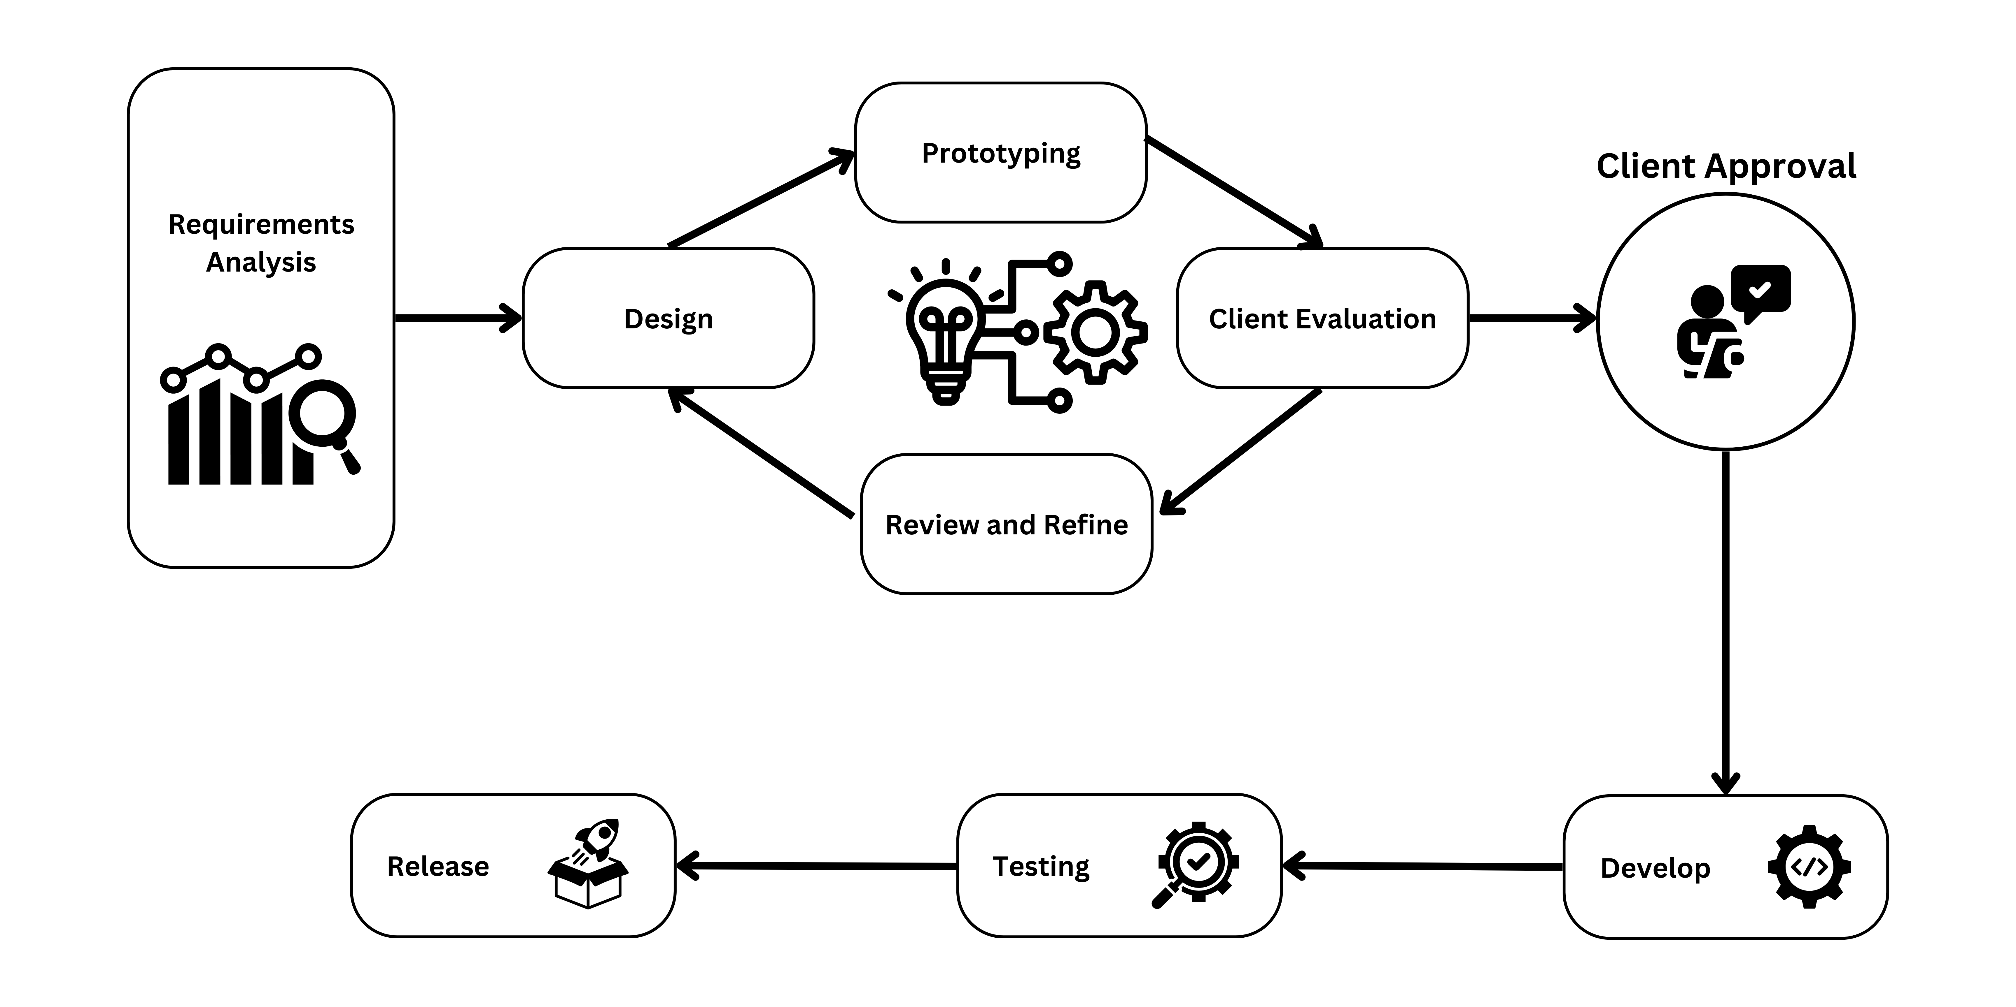

**Figure 5. Prototyping Model Diagram**

**Data Gathering and Preprocessing for Detection Model Training**

To build the AI model, diverse datasets were gathered from sources such as YouTube videos, public repositories (e.g., Rotoflow), and custom web scraping algorithms. These datasets covered various scenarios including car crashes, fires, floods, and landslides, incorporating both normal and incident events across different lighting, weather, and environmental conditions.

1. The collected data underwent comprehensive preprocessing to ensure quality and consistency. This included:
2. Data Cleaning: Removal of corrupted or mislabeled data.
3. Frame Extraction: Extraction and resizing of video frames for model input compatibility.
4. Data Augmentation: Techniques like rotation, flipping, zooming, and brightness adjustments to increase variability and prevent overfitting.
5. Filter Optimization: Enhancing CNN performance by fine-tuning convolutional filters for improved feature extraction.

**Iterative CNN Model Implementation for Accident and Disaster Detection**:

A preliminary Convolutional Neural Network (CNN) implementation is developed for accident and disaster detection, using multiple convolutional and pooling layers to extract distinguishing features from images. Early iterations will prioritize basic feature extraction before refining model accuracy.

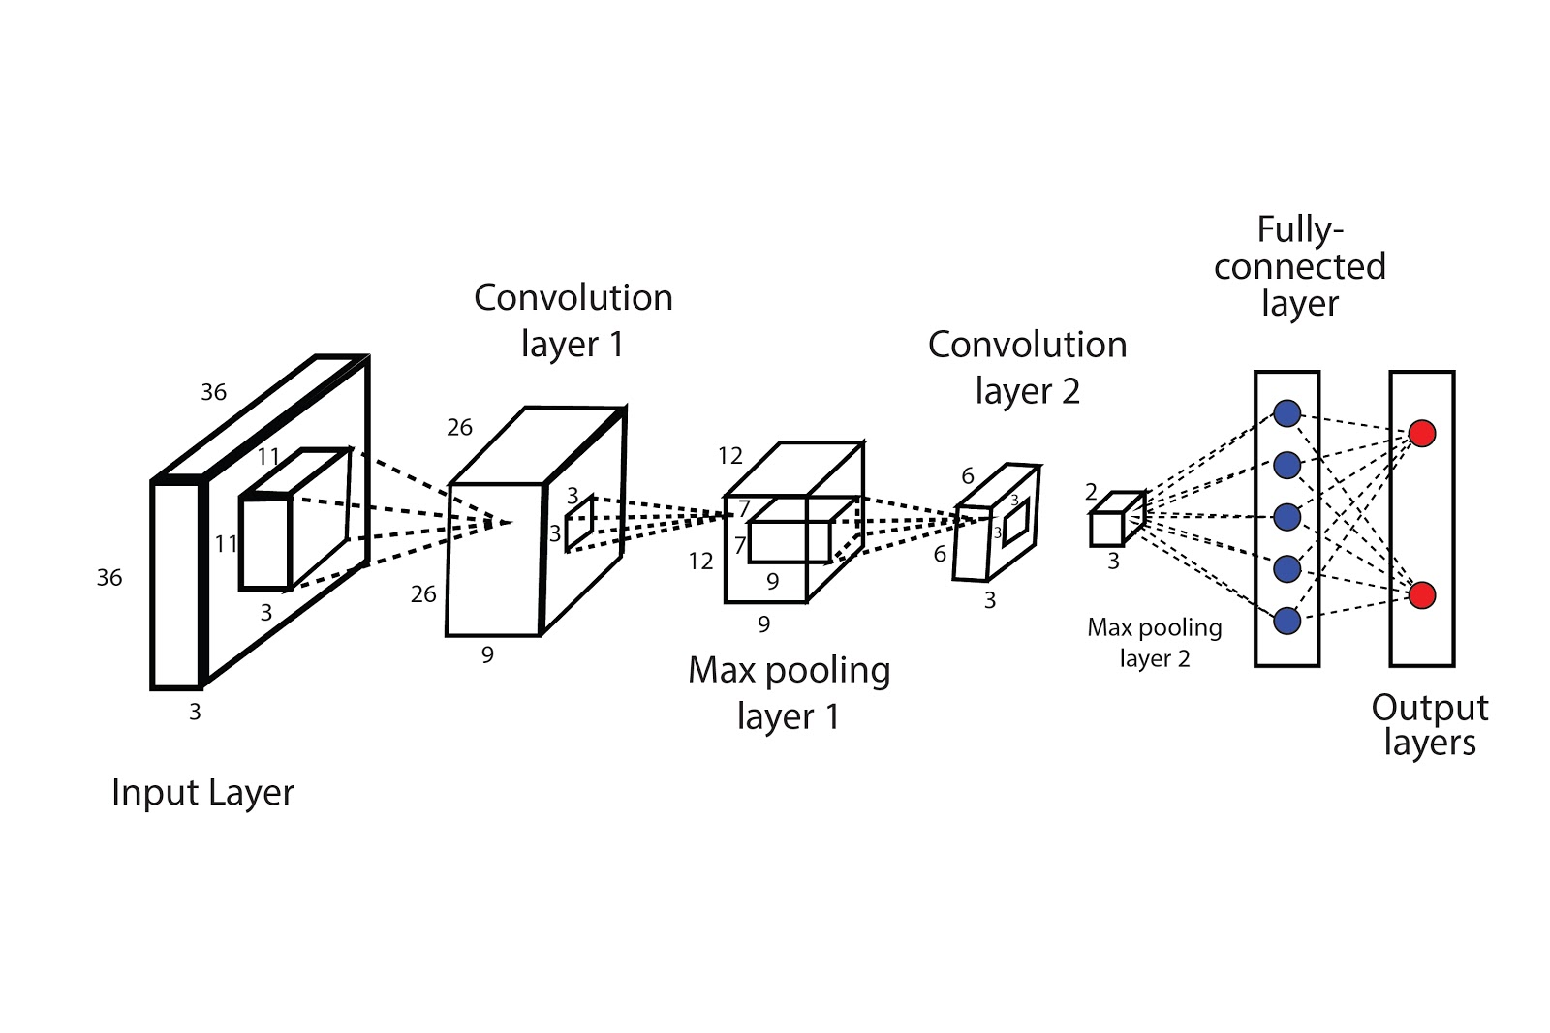**Figure 6. CNN Architecture (Dwivedi, 2020)**

The CNN model architecture for detecting accidents and disasters can be outlined as follows:

1. Input Layer: Accepts resized images as inputs.
2. Convolutional Layers: Comprise several convolutional layers with activation functions (e.g., ReLU) to extract complex features from images.
3. Pooling Layers: Reduce the spatial dimensions of features and mitigate overfitting by selecting key features.
4. Flatten Layer: Flattens the output from the final convolutional layer, preparing it for the fully connected layers.
5. Fully Connected Layers: Process the extracted features to learn relevant patterns for prediction.
6. Output Layer: Generates the final output, indicating the presence or absence of an accident or disaster.

Each iteration of the prototype will incorporate feedback from testing and performance evaluation, ensuring continuous improvement in the model’s efficiency.

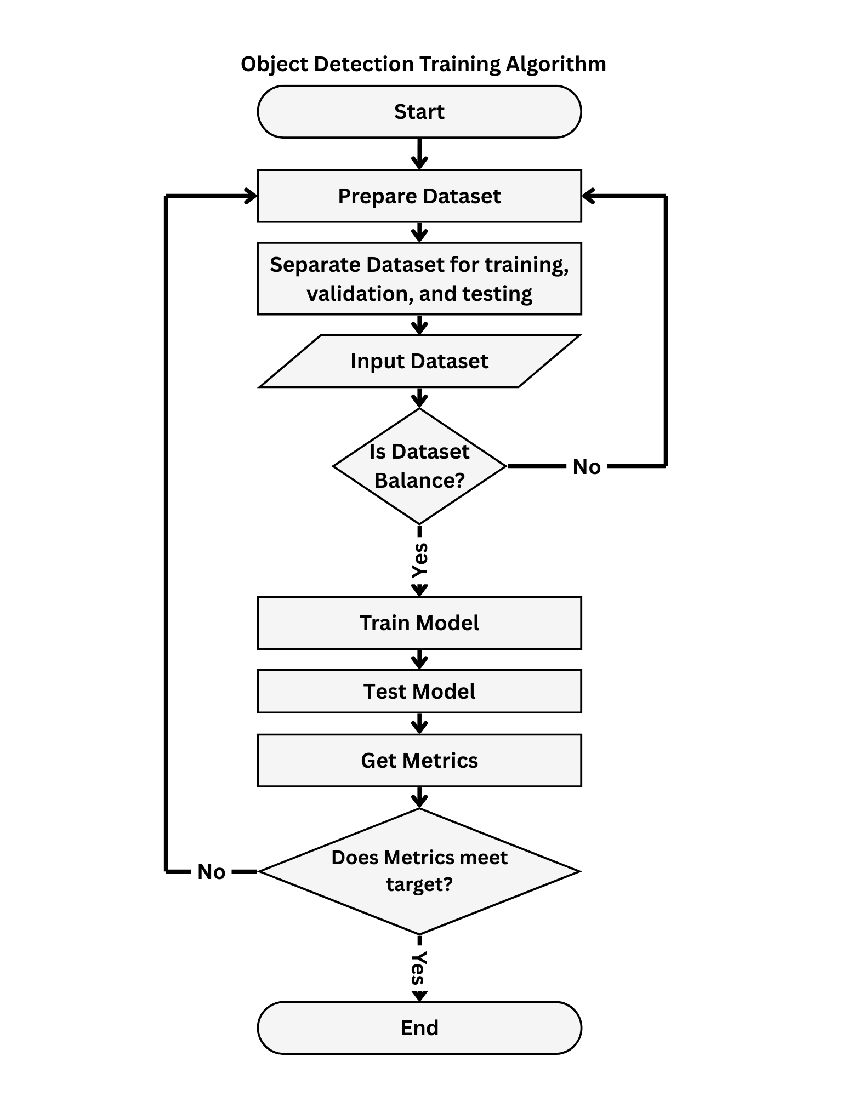  
**Figure 7. Object Detection Training Algorithm**

**Model Training, Evaluation, and Refinement**

The CNN model is trained with the use of preprocessed dataset, optimizing it through backpropagation to minimize a loss function. The training process adjusts model weights using optimizers such as Adam or SGD to enhance performance gradually (Kingma & Ba, 2015). Post-training, the model will be evaluated on a test dataset using metrics such as accuracy, precision, recall, and F1-score to assess its reliability (Sokolova & Lapalme, 2009). Errors and misclassifications will be analyzed to iteratively adjust parameters and improve the model’s effectiveness.

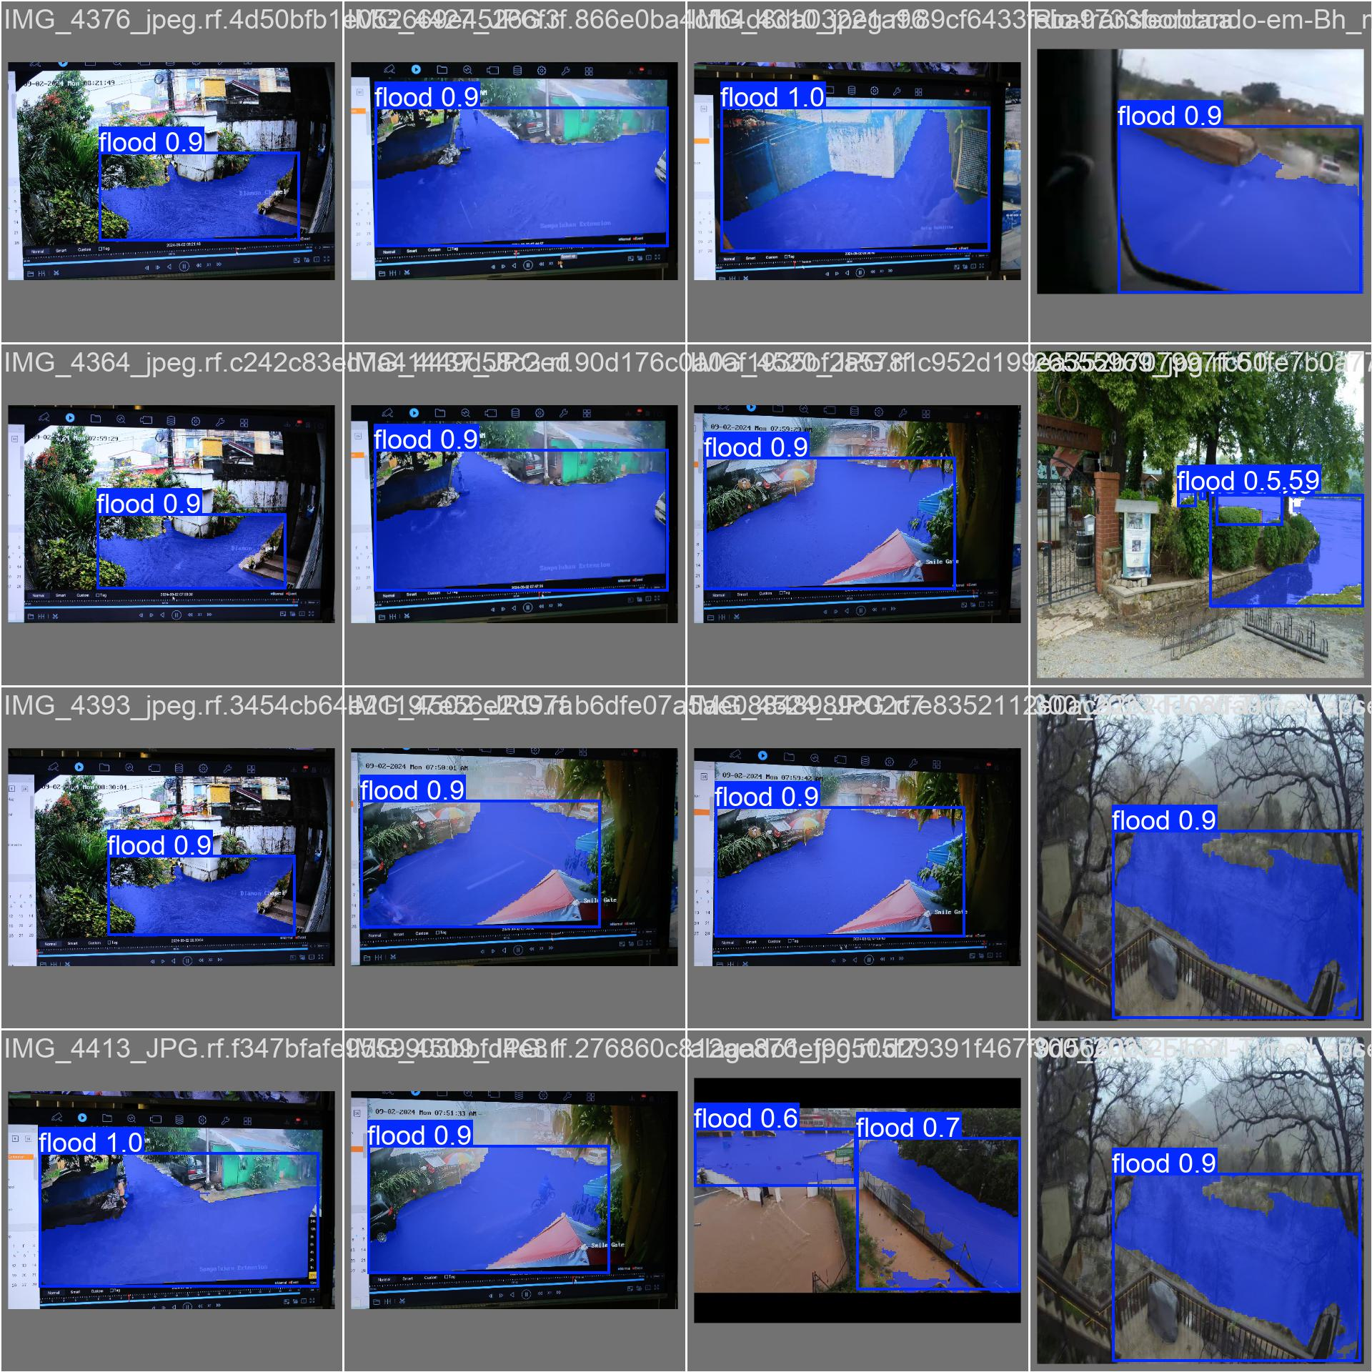**Figure 8. Sample Model Training for Flood Detection**

Once trained, the model can be integrated into the system capable of processing live video feeds continuously. It will promptly alert the monitoring department upon detecting accidents or disasters, thereby improving response times in critical situations.

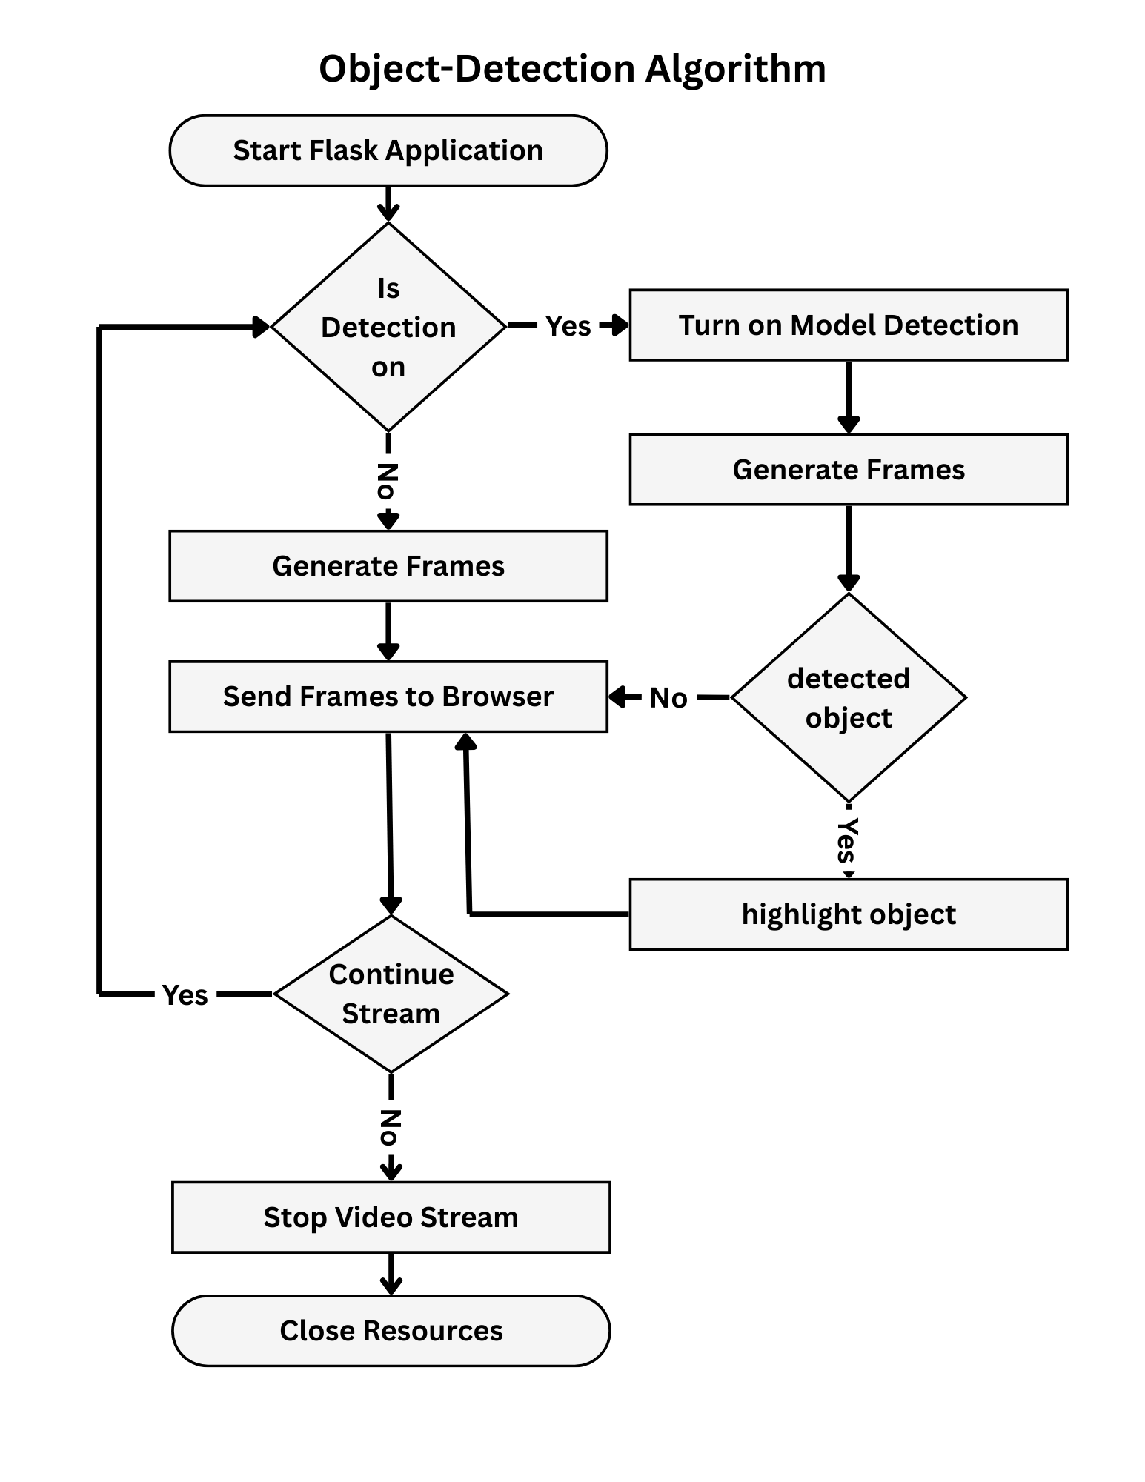  
**Figure 9:**

**Hardware and Software Prototyping and Iterative Development of the IoT device**

The ESP32-C3 microcontroller was integrated into the LUKA system to facilitate real-time environmental monitoring. The primary goal was to assess its ability to handle multiple sensors added with extra features such as data acquisition, processing, and transmission. To achieve this, the microcontroller was configured to interface with the MPU6050 accelerometer and gyroscope, DHT11 temperature and humidity sensor, and a rain module using I2C and SPI communication protocols. Power management was highly considered, leading to the implementation of a 5V power module with capacitor filtering and voltage regulators to maintain stability, along with pulse width modulation (PWM) and deep sleep mode to optimize power consumption. One way to improve the optimization of the system was to employ edge computing techniques, which allowed the ESP32-C3 to process the data from sensors locally before transmission, reducing the computation load on the Raspberry Pi. This involved Kalman filtering for accelerometer noise reduction and threshold-based event triggers to only transmit relevant data.

**IoT Failure Analysis**

Errors in hardware selection or embedded design can result in significant failures affecting system reliability and performance. Using an incompatible power module, such as a 3.3V supply instead of 5V, can lead to instability, while excessive voltage (e.g., 12V) may permanently damage circuit components. Faulty circuit wiring, particularly misconfigured I2C/SPI connections, can cause corrupted sensor readings, leading to inaccurate environmental data. Software-related issues, such as inefficient deep sleep management, increase power consumption and shorten device lifespan. Moreover, poorly structured communication protocols may cause data loss, compromising system reliability and making it unsuitable for real-time monitoring applications.

**Integration of Machine Learning Model with the LUKA Web System**

The CNN model prototype was integrated into the LUKA web system to enable its core functionality of detecting accidents and natural disasters in real time. The primary goal was to assess how well the model could be incorporated into the system while maintaining optimal performance in terms of response time and accuracy. In this phase, it was determined how many simultaneous video streams the system could handle without compromising its monitoring capabilities. To establish a baseline comparison, the proponents analyzed the difference in performance between standard video streaming and streaming with the model actively processing the feed for detections. However, due to the lack of available real-time incident-related video streams from currently available IP devices for testing, an alternative approach was taken. Instead of immediately using the CNN-based accident and disaster detection model, the proponents decided to first integrate a pre-trained YOLO object detection model. This initial CNN integration testing measured the system's capacity for real-time video monitoring while considering the web application’s capability to handle computational load efficiently. Initially, the system could display only a single stream at a time while maintaining real-time monitoring performance. Running multiple streams at once led to noticeable stream latency and processing slowdowns. The proponents incorporated several optimizations to handle this problem, such as improving model efficiency, hardware acceleration use (e.g., GPU processing), and refining streaming techniques using OpenCV and Flask. This phase helped the proponents gain valuable insights into the technical limitations of the LUKA system’s event detection functionality.

**3.2 Requirements Analysis**

**Class Diagram**

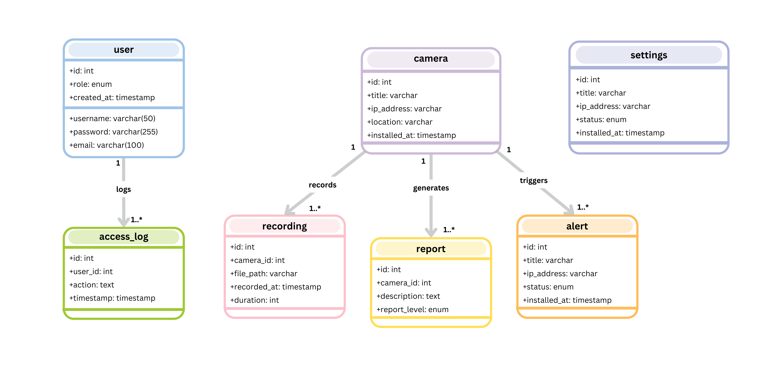

**Figure 12. Class Diagram of LUKA’s Database Schema**

Class Diagram Relationships

* User logs activities in Access Log (1:M relationship).
* Camera records videos stored in Recording (1:M relationship).
* Camera generates Reports (1:M relationship).
* Camera triggers Alerts (1:M relationship).
* Settings manage system configurations.

**Sequence Diagram**

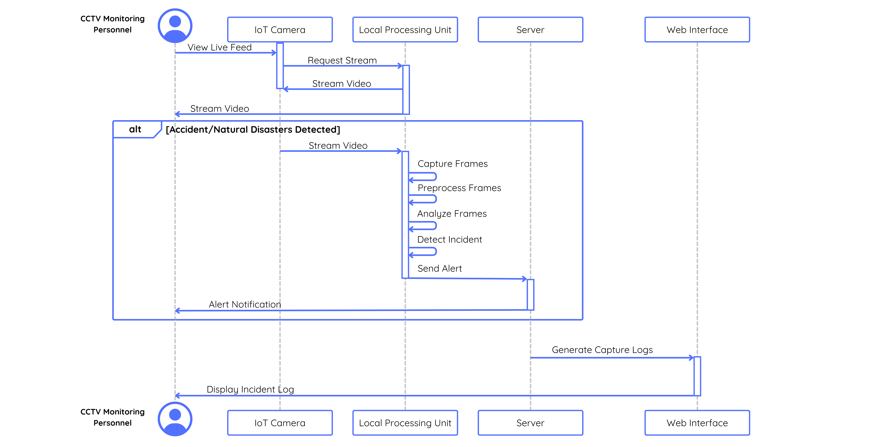

**Figure 13. LUKA Sequence Diagram**

Overview:

1. Live Video Streaming – CCTV monitoring personnel request and monitor live video streams from IoT cameras through a local processing unit.

2. Incident Detection Process – In the event of an accident or natural disaster, the system captures, preprocesses, and analyzes frames before triggering an alert notification.

3. Alert Notification & Logging – When an incident is verified, the system alerts monitoring staff and produces capture logs in the web interface for documentation and audit.

**State Machine Diagram**

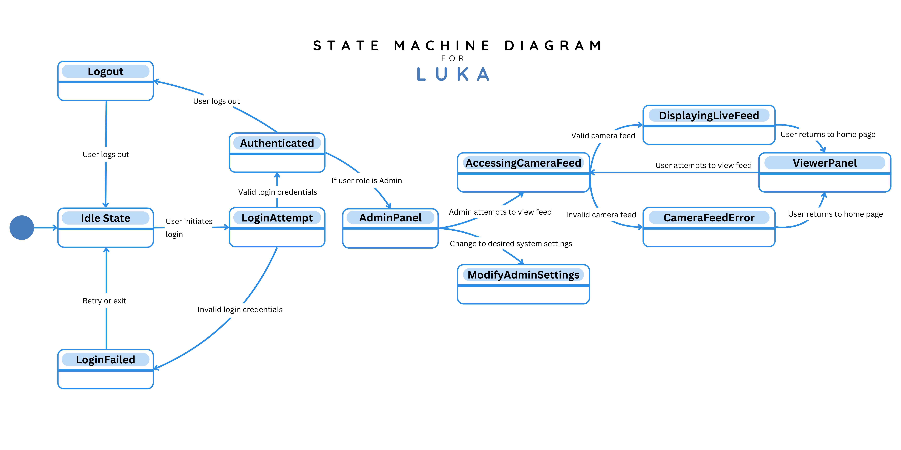

**Figure 14. State Machine Diagram for the LUKA System**

Overview:

1. User Login Process

* The system starts in the Idle State. In this state, a user can attempt to log in.
* If login credentials are invalid, the system moves to LoginFailed, allowing the user to retry their input or exit the system.
* With successful authentication, the user transitions into an Authenticated state.

2. Admin Panel and System Settings

* If the user is an Admin, they can access the AdminPanel and update system settings based on desired preference/necessity.

3. Camera Feed Access and Monitoring

* Users can access the AccessingCameraFeed state to spectate live footage.
* If the feed is valid, the system transitions to DisplayingLiveFeed; otherwise, it moves to CameraFeedError.
* Users can go back to the ViewerPanel or home page when finished.

4. User Logout

* Users may log out at any state, returning to the Idle State.

**Use Case Diagram**

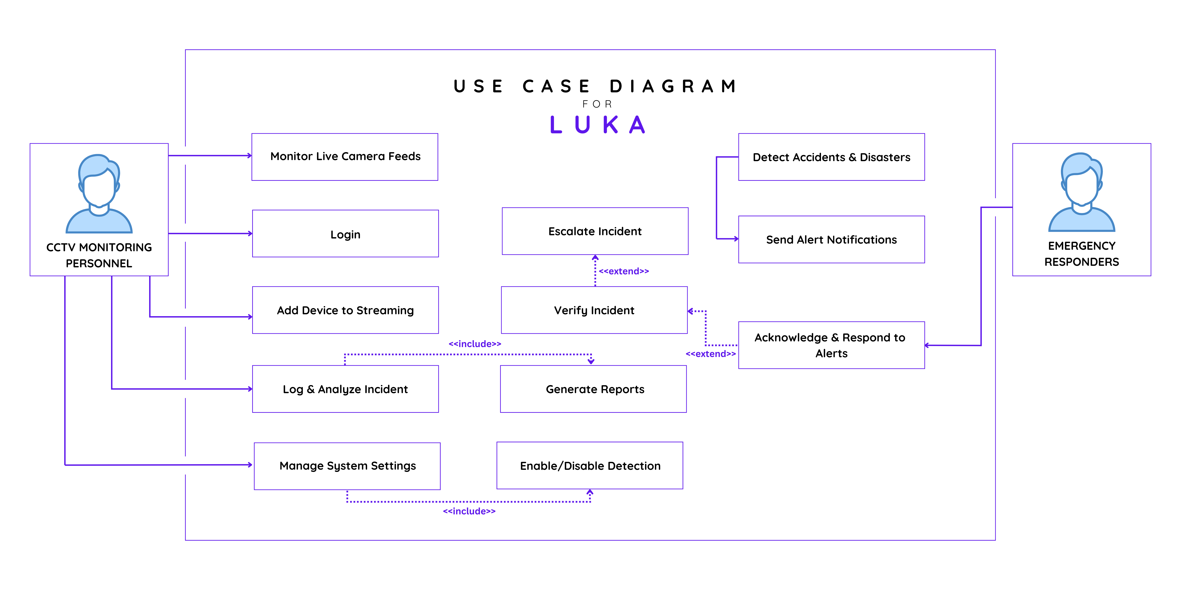

**Figure 15. Use Case Diagram for the LUKA System**

**Use Case Diagram Descriptions**

|  |  |
| --- | --- |
| Use Case ID | 001 |
| Use Case Name | Login |
| Actors | CCTV Monitoring Personnel |
| Description | Allows users to log in to the system to access monitoring and management functionalities. |
| Pre-Conditions | The user has existing account. |
| Post-Conditions | The user gains access to system functionalities. |
| Normal Flow | 1. User enters login credentials. 2. System verifies the credentials. 3. If valid, user is granted access. 4. If invalid, system displays an error message. |

**Table 1. Login**

|  |  |
| --- | --- |
| Use Case ID | 002 |
| Use Case Name | Monitor Live Camera Feeds |
| Actors | CCTV Monitoring Personnel |
| Description | Personnel can view real-time footage from multiple cameras to observe ongoing activities and detect possible incidents. |
| Pre-Conditions | Cameras must be properly connected to the system. |
| Post-Conditions | Personnel can observe live feeds for monitoring purposes. |
| Normal Flow | 1. Personnel select live feed input option (e.g., RTSP, HTTP link). 2. The system retrieves and displays real-time camera feeds. 3. The user monitors the feed. |

**Table 2. Monitor Live Camera Feeds**

|  |  |
| --- | --- |
| Use Case ID | 003 |
| Use Case Name | Add Device to Streaming |
| Actors | CCTV Monitoring Personnel |
| Description | Allows personnel to add new CCTV or IoT-based cameras for real-time monitoring. |
| Pre-Conditions | System must support device integration. |
| Post-Conditions | New devices are successfully added and can transmit live feeds. |
| Normal Flow | 1. Personnel selects "Add Device" option. 2. System prompts the user to enter device details. 3. System connects the device. 4. Device is added to the monitoring system. |

**Table 3. Add Device to Streaming**

|  |  |
| --- | --- |
| Use Case ID | 004 |
| Use Case Name | Log & Analyze Incident |
| Actors | CCTV Monitoring Personnel |
| Description | Detected incidents are logged for analysis and future decision-making. |
| Pre-Conditions | An incident has been detected. |
| Post-Conditions | Incident details are stored for reference. |
| Normal Flow | 1. System detects an incident. 2. Personnel logs the details. 3. System analyzes incident data. 4. Incident is stored for reporting. |

**Table 4. Log & Analyze Incident**

|  |  |
| --- | --- |
| Use Case ID | 005 |
| Use Case Name | Detect Accidents & Disasters |
| Actors | System (Automated) |
| Description | System uses CNN and IoT sensors to detect accidents and disasters from live feeds. |
| Pre-Conditions | Live camera feeds must be operational. |
| Post-Conditions | System detects and flags incidents. |
| Normal Flow | 1. System analyzes live feeds. 2. Incident is detected. 3. System flags the event as an alert. |

**Table 5. Detect Accidents & Disasters**

|  |  |
| --- | --- |
| Use Case ID | 006 |
| Use Case Name | Send Alert Notifications |
| Actors | System sends notifications to emergency responders and monitoring personnel when an incident is detected. |
| Description | Detected incidents are logged for analysis and future decision-making. |
| Pre-Conditions | An accident or disaster is detected. |
| Post-Conditions | Alerts are sent to the appropriate user. |
| Normal Flow | 1. System generates an alert. 2. Notifications are sent to the monitoring personnel. |

**Table 6. Send Alert Notifications**

|  |  |
| --- | --- |
| Use Case ID | 007 |
| Use Case Name | Escalate Incident |
| Actors | CCTV Monitoring Personnel |
| Description | Personnel can escalate incidents to emergency responders for immediate action. |
| Pre-Conditions | An incident has been verified. |
| Post-Conditions | Emergency responders are notified. |
| Normal Flow | 1. Personnel reviews the incident. 2. Personnel selects "Escalate Incident". 3. System sends urgent alert to responders. |

**Table 7. Escalate Incident**

|  |  |
| --- | --- |
| Use Case ID | 008 |
| Use Case Name | Verify Incident |
| Actors | CCTV Monitoring Personnel |
| Description | Personnel verify detected incidents before alerting responders. |
| Pre-Conditions | An incident has been flagged. |
| Post-Conditions | Incident is either confirmed or dismissed. |
| Normal Flow | 1. Personnel reviews incident details. 2. If valid, incident is confirmed. 3. If invalid, incident is dismissed. |

**Table 8. Verify Incident**

|  |  |
| --- | --- |
| Use Case ID | 009 |
| Use Case Name | Acknowledge & Respond to Alerts |
| Actors | Emergency Responders |
| Description | Responders receive alerts and take necessary actions. |
| Pre-Conditions | System has sent an alert notification. |
| Post-Conditions | Emergency response actions are initiated. |
| Normal Flow | 1. Responders receive an alert. 2. Responders acknowledge alert. 3. Appropriate response actions are taken. |

**Table 9. Acknowledge & Respond to Alerts**

|  |  |
| --- | --- |
| Use Case ID | 010 |
| Use Case Name | Generate Reports |
| Actors | CCTV Monitoring Personnel |
| Description | The system compiles incident data into structured reports (statistics and list). |
| Pre-Conditions | Incident logs exist in the system. |
| Post-Conditions | Reports are generated and stored. |
| Normal Flow | 1. Personnel access "Analytics" nav section in web. 2. System compiles incident data. 3. Report is generated and stored. |

**Table 10. Generate Reports**

|  |  |
| --- | --- |
| Use Case ID | 011 |
| Use Case Name | Manage System Settings |
| Actors | CCTV Monitoring Personnel |
| Description | Allows personnel to configure system settings, including FPS, video quality, confidence level, and toggle visibility of boundary boxes. |
| Pre-Conditions | The user is logged into the system. |
| Post-Conditions | System settings are updated and saved. |
| Normal Flow | 1. The personnel goes to the settings page. 2. The system displays available configurations. 3. The user modifies the settings. 4. The system saves the updates. |

**Table 11. Manage System Settings**

|  |  |
| --- | --- |
| Use Case ID | 012 |
| Use Case Name | Enable/Disable Detection |
| Actors | CCTV Monitoring Personnel |
| Description | Allows users to enable or disable the system’s accident and disaster detection feature. |
| Pre-Conditions | The system must be running. |
| Post-Conditions | The detection system is either activated or deactivated. |
| Normal Flow | 1. Personnel access the detection settings. 2. User tick/untick detection mode. 3. System updates detection status. |

**Table 12. Enable/Disable Detection**

**3.3 Requirements Documentation**

Functional Requirements

1. The system must detect disasters like floods, landslides, and fires through real-time image processing.
2. Provide immediate alerts to the relevant authorities when a disaster is detected.
3. Store data on detected disasters for later analysis and playback.

Non-Functional Requirements

1. The system must operate with 80% accuracy in disaster detection.
2. The detection and alert time must be within 5 seconds.
3. The interface should be user-friendly and accessible for the monitoring department.

User Requirements

1. Authorized users should be able to view live monitoring footage.
2. Authorized users must receive immediate notifications of detected disasters.
3. Users should have access to playback features for past disaster events.

Hardware and Software Requirements

1. Hardware: CCTV IP cameras, IoT-enabled devices, server infrastructure. 8gb ram, dual-core CPU.

2. Software: Convolutional Neural Network (CNN) frameworks, OpenCV for image processing, cloud-based storage solutions.

3. Libraries: Ultralytics YOLO, Flask, OpenCV, NumPy.

4. Programming Languages: HTML, CSS, JavaScript, SQL, PHP, Python.

**3.4 Design of Systems**

**System Architecture**

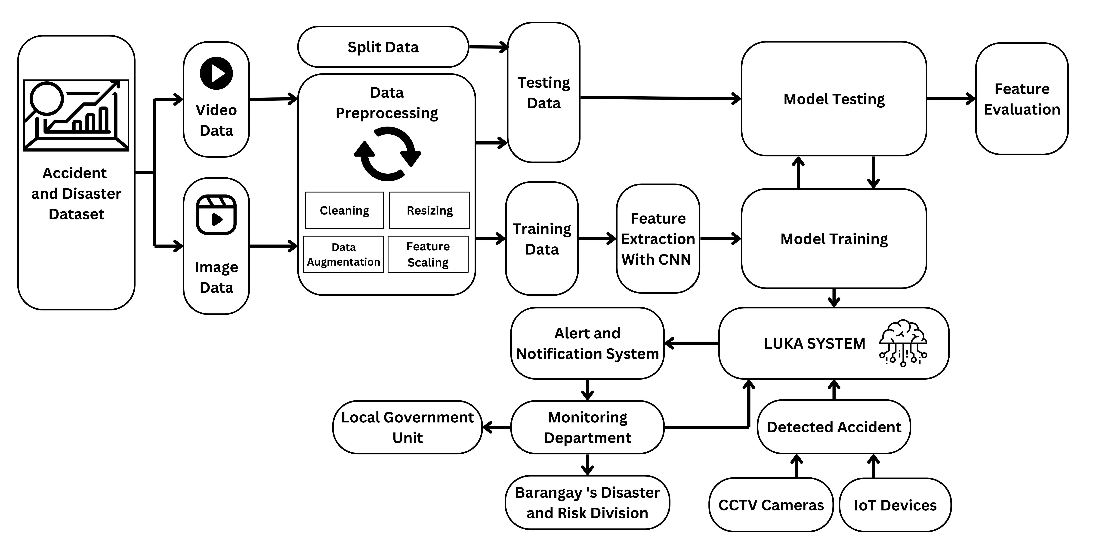**Figure 16. Machine Learning Model System Design**

The machine learning model for LUKA system focuses on real-time data gathering, CNN processing for disaster detection, and the system for monitoring and alerts.

1. Data Collection: Video and image data from the accident and disaster dataset serve as the primary input.
2. Data Preprocessing: The data is preprocessed through several steps, including cleaning, resizing, data augmentation, and feature scaling, to prepare it for analysis.
3. Data Splitting: The data is split into training and testing sets to allow for model evaluation and improvement.
4. Feature Extraction with CNN (Convolutional Neural Network): This process involves extracting features from the training data using CNNs, which are effective for image and video data analysis.
5. Model Training and Testing: The extracted features are used to train a machine learning model, which is then tested with the testing data for validation. This model will be capable of identifying accidents or disasters in new data.
6. LUKA System: The trained model forms the core of the LUKA System, capable of detecting incidents in real-time by processing incoming data.
7. Alert and Notification System: When an accident is detected, the system sends alerts to the monitoring department, which oversees incident management.
8. Monitoring Department and Local Government Communication: The monitoring department notifies the local government and the barangay’s disaster and risk division to facilitate a swift response.
9. Integration with IoT Devices and CCTV Cameras: The LUKA System also integrates with IoT devices and CCTV cameras to enhance the real-time detection capabilities and feed live data into the model.
10. Feature Evaluation: Periodic feature evaluation is conducted to improve model accuracy and adapt the system to changing conditions or new types of incidents.

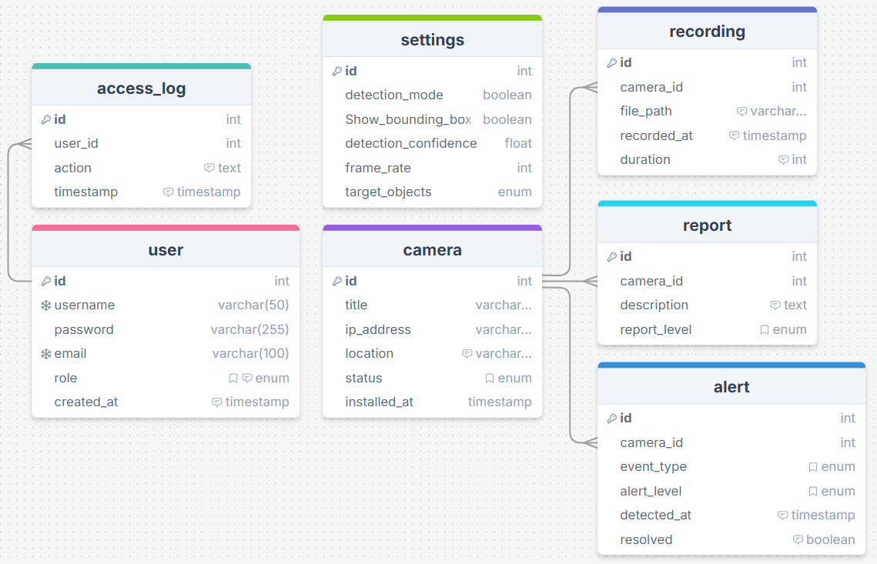**Figure 17. LUKA System Database**

Below is a description of the system’s database.

1. User

* Stores user information, including login credentials and role-based access.

Attributes:

* + id: Unique identifier for the user.
  + role: Defines the user's role.
  + created_at: Timestamp of user registration.
  + username: Unique username for login.
  + password: Hashed password for authentication.
  + email: User's email address.

1. Access Log

* Logs user activities related to the system.

Attributes:

* + id: Unique identifier for the log entry.
  + user_id: Foreign key referencing the user table.
  + action: Describes the action performed.
  + timestamp: Time when the action was performed.

1. Camera

* Represents a surveillance camera monitoring an area.

Attributes:

* + id: Unique identifier for the camera.
  + title: Name or identifier of the camera.
  + ip_address: IP address for network access.
  + location: Physical location of the camera.
  + installed_at: Timestamp when the camera was set up.

1. Recording

* Stores video recordings captured by cameras.

Attributes:

* + id: Unique identifier for the recording.
  + camera_id: Foreign key linking to the camera table.
  + file_path: Location of the stored recording file.
  + recorded_at: Timestamp when the recording was captured.
  + duration: Length of the recorded video in seconds.

1. Report

* Generated reports based on recorded incidents.

Attributes:

* + id: Unique identifier for the report.
  + camera_id: Foreign key linking to the camera table.
  + description: Details about the incident recorded.
  + report_level: Categorization of the report (e.g., low, medium, high severity).

1. Alert

* System-generated automated alerts triggered by detected incidents.

Attributes:

* + id: Unique identifier for the alert.
  + title: Name or description of the alert.
  + ip_address: IP of the triggering device.
  + status: Current status of the alert (e.g., active, resolved).
  + installed_at: Timestamp when the alert was generated.

1. Settings

* Stores system-wide configuration settings.

Attributes:

* + id: Unique identifier for the settings entry.
  + title: Name of the setting.
  + ip_address: IP address related to the setting.
  + status: Current status (e.g., enabled, disabled).
  + installed_at: Timestamp when the setting was applied.

**3.5 Feasibility Study**

**Schedule Feasibility**

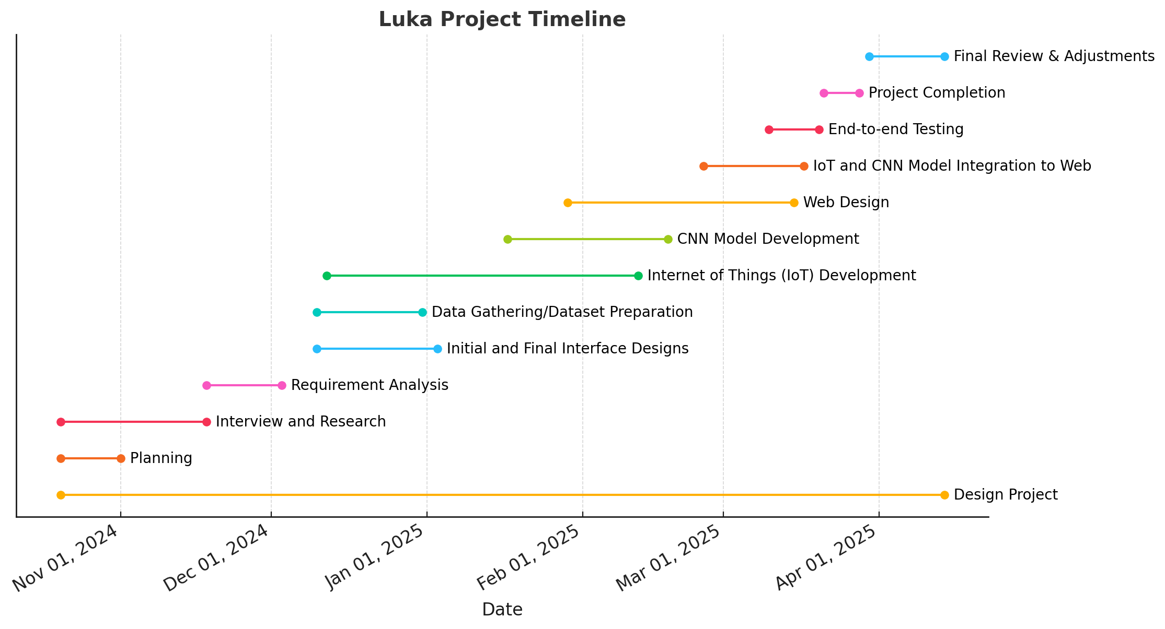The schedule feasibility of this project is determined using a Gantt Chart, allocating tasks to each proponent and assigning designated deadlines for the deliverables. The development of the LUKA system is estimated to be within a 6-month timeframe. The following shows the development process of this project:

**Figure 18. Gantt Chart**

**Economic Feasibility**

In this section, factors such as already existing hardware, which helps against incurring additional costs, and the potential need for backup components are taken into consideration. The estimated cost may vary, either lower or higher, depending on whether substitutions or additional components are required. This breakdown is entirely focused on maximizing the system’s capabilities.

|  |  |  |  |
| --- | --- | --- | --- |
| **Object Detection's Model Training** | | | |
| **Description** | **Quantity** | **Unit Cost (PHP)** | **Total Cost (PHP)** |
| PC/Laptop with Ryzen7, 32gb ram, Nvidia 4060, or higher | 1 | 150,000 | 150,000 |
| Data Acquisition/Scraping Labor or dataset | 1 | 30,000 | 30,000 |
| Data Annotation Labor or tool | 1 | 30,000 | 30,000 |
| **Total** |  | **210,000** | **210,000** |
|  |  |  |  |
| **CCTV Monitoring Room** | | | |
| **Description** | **Quantity** | **Unit Cost (PHP)** | **Total Cost (PHP)** |
| CCTV Cameras | 10-50 |  |  |
| Monitors (24–27") | 2-4 | 8,000 | 32,000 |
| Desktop PCs (for video decoding) | 1-2 | 35,000 | 70,000 |
| Network Video Recorder (NVR) | 1-2 | 20,000 | 40,000 |
| Hard Drives (8TB Surveillance) | 2-4 | 10,000 | 40,000 |
| Network Switch (Gigabit, PoE) | 1-2 | 10,000 | 20,000 |
| UPS (Uninterruptible Power Supply) | 2 | 6,000 | 12,000 |
| Air Conditioner (1.5 HP) | 1 | 25,000 | 25,000 |
| Cabling & Network Setup | Lump Sum | 30,000 | 30,000 |
| Installation & Labor | Lump Sum | 20,000 | 20,000 |
| **Total** |  | **164,000** | **289,000** |
|  |  |  |  |
| **IoT Camera and Sensors** | | | |
| **Description** | **Quantity** | **Unit Cost (PHP)** | **Total Cost (PHP)** |
| ESP32 Wi-Fi-Bluetooth Camera Module Development Board | 5 | 500 | 2,500 |
| Custom 2-layer PCB Design for ESP32-S3 | 2 | 1,275 | 2,550 |
| Raspberry Pi 4 Model B | 1 | 5,990 | 5,990 |
| PROLiNK-PRO2000SFCU Power Backup (UPS) | 2 | 8,098 | 16,106 |
| 4G LTE Router with SIM Support | 1 | 4,500 | 4,500 |
| MicroSD Card (128GB) | 2 | 800 | 1,600 |
| IoT Sensors (e.g., Humidity, Temperature, Smoke) | 4 | 950 | 3,800 |
| Enclosure and Weatherproof Casing | 3 | 1,200 | 3,600 |
| Miscellaneous (Cables, Connectors, Mounting Materials) | - | 2,500 | 2,500 |
| **Total Cost** |  | **23313** | **43,146** |
|  |  |  |  |
| **Overall Cost** |  | **Unit Cost (PHP)** | **Total Cost (PHP)** |
| Object Detection's Model Training |  | 210,000 | 210,000 |
| CCTV Monitoring Room |  | 164,000 | 289,000 |
| IoT Camera and Sensors |  | 23313 | 43,146 |
| **Total Cost** |  | **397,313** | **542,146** |

**Table 13. Economic Feasibility**

**Intangible Benefits**

The intangible benefits for Barangay Santa Rita upon developing the LUKA system are the following:

**1. Faster Emergency Response**

* The LUKA system offers real-time monitoring with an automated setup that identifies disasters and accidents, potentially reducing response times.

**2. Analyze Past Data**

* The system collects and analyzes data on accidents, fire outbreaks, and natural disasters.
* Historical data can be used for predictive analytics, helping authorities implement preventive measures.

**3. Scalability and Future Expansion**

* The modular design allows integration with more IoT devices, additional cameras, and AI models in the future.
* It can be expanded to cover other barangays, making it a city-wide disaster monitoring system.

**4. Support for Government and LGUs**

* Possibly help LGUs comply with national disaster preparedness policies and secure funding for safety initiatives.

**Operational Feasibility**

**Usability**

The LUKA System introduces real-time monitoring and emergency response designed to automate the detection of accidents and natural disasters, thereby minimizing the need for continuous human supervision with the advantage that critical incidents are quickly flagged.

**User Adoption and Training**

LUKA features a user interface similar to existing barangay monitoring systems, making it easier for users to navigate. Monitoring staff only need basic training to handle alerts and verify incidents as the system automatically analyzes video footage.

**Logging and Reporting Incidents**

CCTV monitoring personnel can view live feeds with automated alert notification, aiding the personnel to focus on responding to emergencies. This reduces the time and effort exerted in monitoring feeds. The system's web interface provides record logs that show screen captured events upon detection, which helps with incident review management.

**Infrastructure Requirement**

The infrastructure requirement of the LUKA System comprises IoT components integrated with existing CCTV infrastructure to allow real-time monitoring and automate incident detection. IoT cameras capture real-time feed and IoT sensors are used to check environmental factors. The system also requires a reliable network connection to facilitate easy transmission of data to the LUKA web interface system.

**Deployment**

The system will be implemented in the Control Room of the Barangay Peacekeeping Action Team (BPAT), where they oversee and manage the area’s CCTV monitoring operations.

**Potential Challenges**

The system does have some challenges, especially with the possibility of producing false alarms and detection performance relative to the specifications of the existing CCTV infrastructure. Periodical adjustments of the detection setting may be needed for good accuracy. If set up well and improved, it could greatly augment the real-time monitoring and disaster response.

**Technical Feasibility**

**Technical Feasibility – Hardware**

The hardware requirements for the proposed project, LUKA: An Accident and Disaster Detection using CNN, CCTV, and IoT camera, are as follows:

|  |  |  |
| --- | --- | --- |
| **Hardware** | **Minimum Requirements** | **Recommended** |
| GPU | NVIDIA GTX 1660 (6GB VRAM) or equivalent | NVIDIA RTX 3060 (12GB VRAM) or better |
|  | AMD RX 580 (8GB VRAM) or equivalent | NVIDIA RTX 3080 (10GB VRAM) or better |
| CPU | Intel i5-10400 (6 cores, 2.9 GHz) or equivalent | Intel i7-12700K (12 cores, 3.6 GHz) or better |
|  | AMD Ryzen 5 5600X (6 cores, 3.7 GHz) or equivalent | AMD Ryzen 9 5900X (12 cores, 3.7 GHz) or better |
| Cores | At least 6 cores | 12 or more cores (for parallel processing) |
| RAM | 16 GB DDR4 | 32 GB DDR4 or more (for large batch processing) |
| Storage | SSD with at least 200 GB free | NVMe SSD with 1 TB+ (for fast read/write) |
| Network | 150 Mbps+ for streaming & model inference | 1 Gbps+ with low latency |
| Additional Notes | Can run YOLOv5/v8 at 10-15 FPS streams | Optimized for 20+ FPS streams with YOLO |

**Table 14: Hardware Specification**

The specified hardware requirements for the proposed system are determined by considering the user's minimum requirements and the availability of the resources on the market. These requirements are readily obtainable and do not necessitate higher specification, but it is encouraged. Nonetheless, the user may choose to operate the system using higher specifications or similar capacity.

**Technical Feasibility – Software**

The software requirements for the proposed project, LUKA: An Accident and Disaster Detection using CNN, CCTV, and IoT camera, are as follows:

|  |  |  |  |
| --- | --- | --- | --- |
| **Software** | **Minimum Requirements** | | **Recommended** |
| Operating System | Windows 10 or Linux (Ubuntu 20.04) | | Windows 10/11 or Linux (Ubuntu 22.04+) |
| Website Interface | Frontend | HTML, CSS, JavaScript |  |
| Database | SQLite |  |
| Server | Flask |  |
| Website Browser | Google Chrome | Ver. 85 | Latest stable versions |
| Microsoft Edge | Ver. 85 |
| Programming Language | Python 3.8 | | Python 3.10+ |
| Library (ML) | YOLO, OpenCV | |  |
| YOLO Object Detection Framework | YOLOv5 (or compatible version) with Python 3.7, PyTorch, OpenCV, NumPy, Flask, SQLite | | YOLOv8/YOLOv11 with Python 3.8+, PyTorch with CUDA, OpenCV, NumPy, Flask/Django, PostgreSQL/MySQL, Redis |
| Video Streaming Software | OpenCV (for RTSP/YouTube/Local stream input), FFmpeg, Flask (for web UI) | | OpenCV with GPU support, FFmpeg for stream optimization, GStreamer for advanced features |
| Model Training/Inference | PyTorch with CUDA support, Pre-trained YOLOv8 model | | PyTorch with CUDA, YOLOv8/YOLOv11, TensorRT or ONNX for optimized inference |
| Database System | SQLite | | PostgreSQL/MySQL (for scalable data storage), Redis (for caching alerts/detections) |
| Web Interface | HTML/CSS/JS, Flask for backend API (streaming, alerts, inference) | | React.js/Vue.js for frontend, WebSocket or Server-Sent Events for real-time updates, Docker for containerization |
| Monitoring & Performance | Prometheus/Grafana for basic system monitoring (CPU, GPU, RAM, FPS), Flask-Logging for events/logging | | Prometheus/Grafana with real-time dashboards, OpenTelemetry for observability, GPU monitoring tools (e.g., nvidia-smi) |
| Security | HTTPS for secure streaming and web interface, Basic authentication (JWT) | | Secure WebSocket (WSS), Advanced authentication with multi-factor authentication (MFA), Role-based access control (RBAC) |

**Table 15: Software Specification**

The software requirements consider both the user’s and the system's development requirements. The listed requirements are intended as a starting point, users and developers may choose to use more advanced software or applications to enhance the capabilities of the monitoring system.

**3.6 Development and Testing**

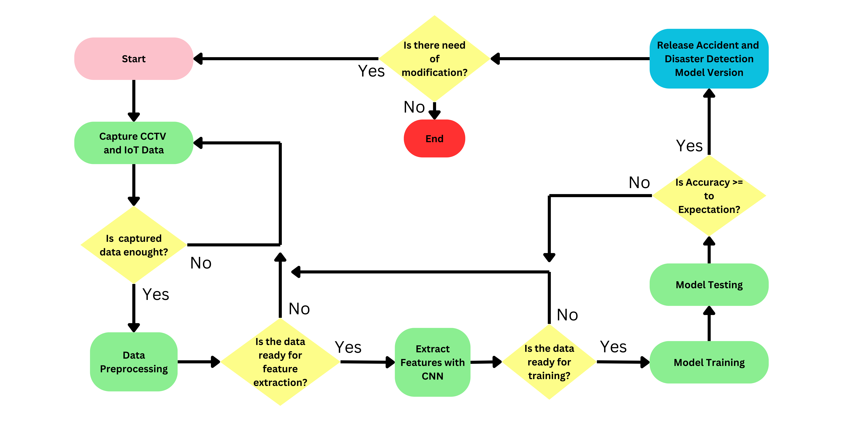**Figure 19. LUKA Development and Testing Flowchart**

This flowchart outlines the development and testing process for the Accident and Disaster Detection Model in the LUKA System.

1. Start: The process begins with initiating the system.
2. Capture CCTV and IoT Data: Data is captured from CCTV and IoT devices to gather information needed for accident or disaster detection.
3. Is Captured Data Enough: This decision point checks if the captured data is sufficient. If not, the process returns to capture more data. If yes, it moves forward.
4. Data Preprocessing: Once sufficient data is available, it undergoes preprocessing, including cleaning, resizing, and feature scaling, to prepare it for model training.
5. Is the Data Ready for Feature Extraction: This decision point evaluates whether the data is in a suitable state for feature extraction. If not, it loops back for further preprocessing. If ready, it continues.
6. Extract Features with CNN: Features are extracted from the data using a Convolutional Neural Network (CNN) to identify critical patterns and characteristics in the data.
7. Is the Data Ready for Training: After feature extraction, a check is made to ensure the data is ready for model training. If not, it goes back for adjustments.
8. Model Training: The processed and feature-extracted data is used to train the detection model, allowing it to learn how to identify accidents and disasters.
9. Model Testing: The trained model is tested on a separate dataset to evaluate its performance.
10. Is Accuracy Greater Than or Equal to Expectation: This decision point checks if the model's accuracy meets the required expectations. If it does, the model is prepared for release. If not, it returns to earlier stages for retraining or data adjustments.
11. Release Accident and Disaster Detection Model Version: If accuracy requirements are met, the current model version is released for deployment in the LUKA System.
12. Is There Need for Modification: After release, the model may be periodically reviewed to determine if modifications are needed based on new data or performance metrics. If modifications are needed, the process restarts. Otherwise, the process ends.

**Testing**

This research conducted unit testing, component interface testing, database testing, security testing, and end-to-end testing, with the goal of refining system functionalities through intensive testing aside from user feedback. In this section, we had additional help from one of our mentors, a Quality Assurance Engineer L2, to guide us with our development iterations.

**3.5a Unit Testing**

The flask server is tested through the `unittest` library. The methods in the python file are verified individually to check for any errors or unexpected outputs. This ensures that the server's core functionalities perform as intended and helps catch potential bugs early in the development process. Unit testing also promotes code reliability and maintainability by allowing developers to isolate and evaluate specific components of the application, ensuring that any changes or updates do not introduce new issues.

**3.5b Component Interface Testing**

The individual component of the system are tested before integration through component interface testing. This is to verify that individual components function properly and minimize possible problems upon integration.

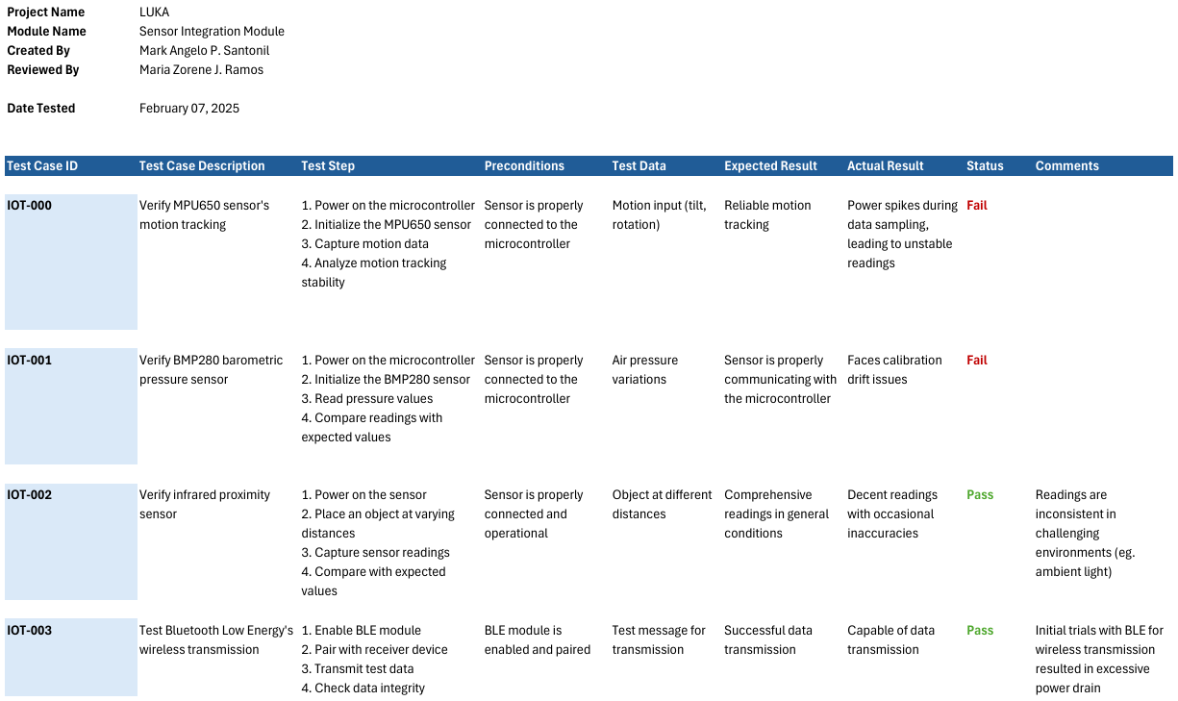**Table 15. Motion tracking, barometric pressure, and infrared sensors test module**

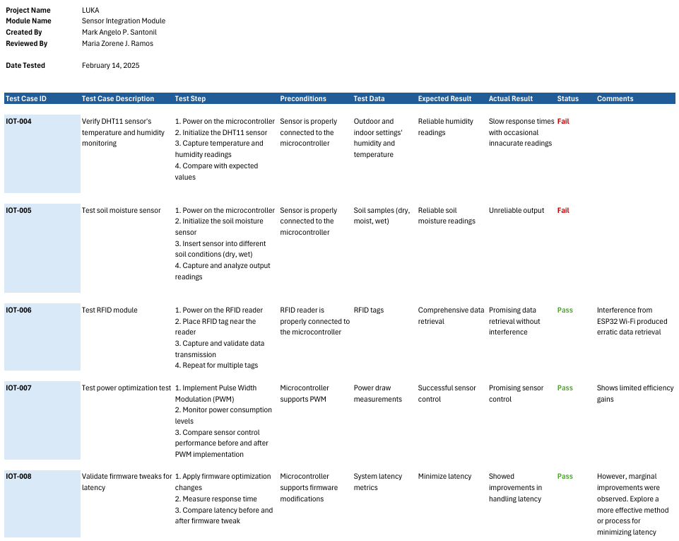**Table 16. Humidity, temperature, and soil sensors, and optimizations test module**

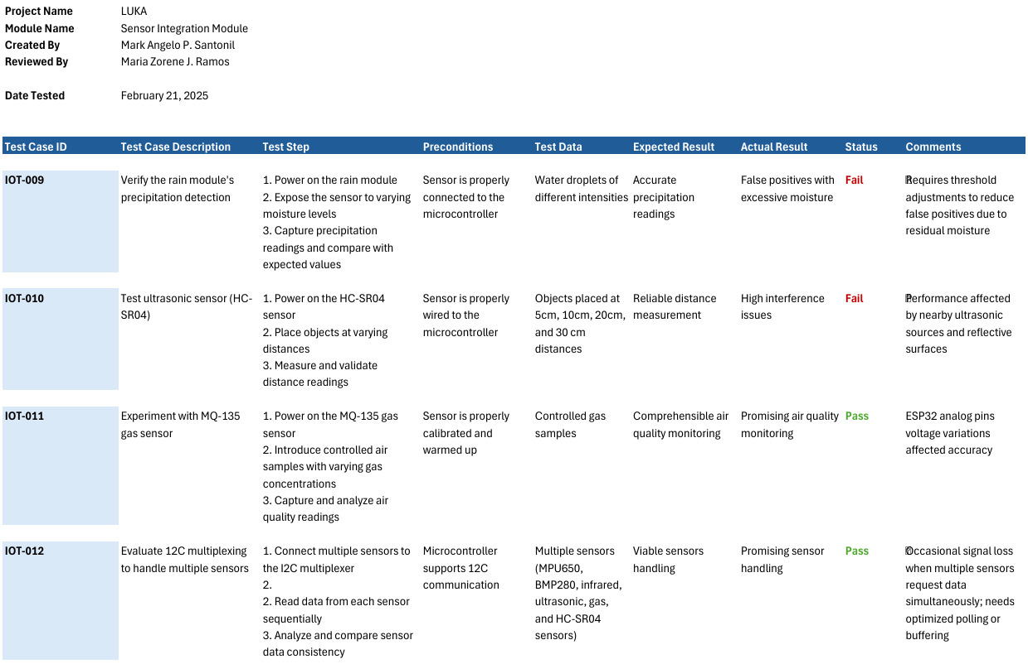

**Table 17. Rain module, ultrasonic and gas sensors test module**

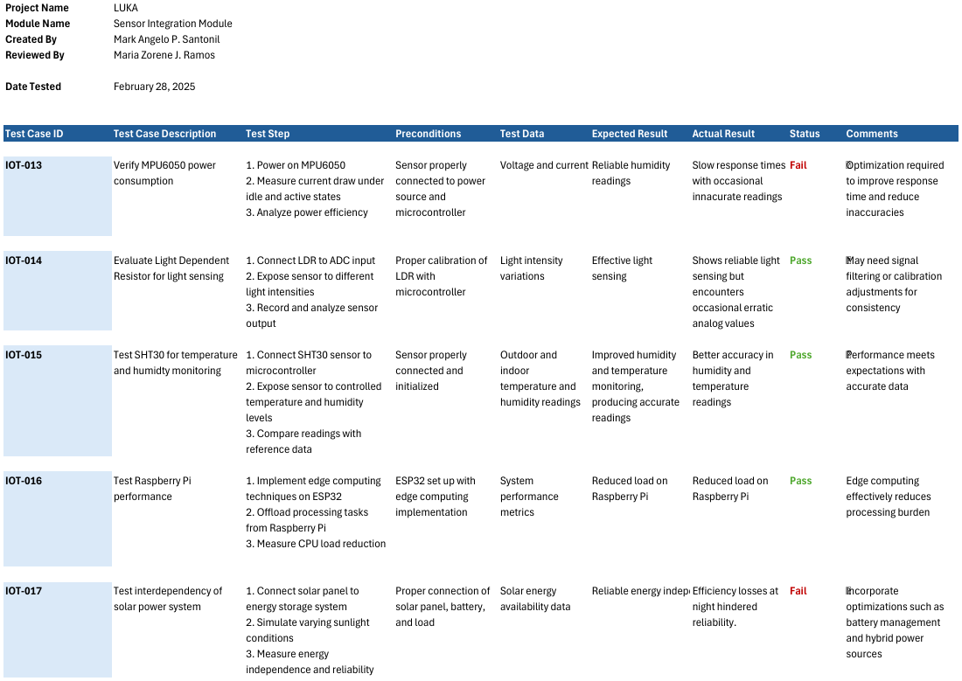

**Table 18. Sensor performance test module**

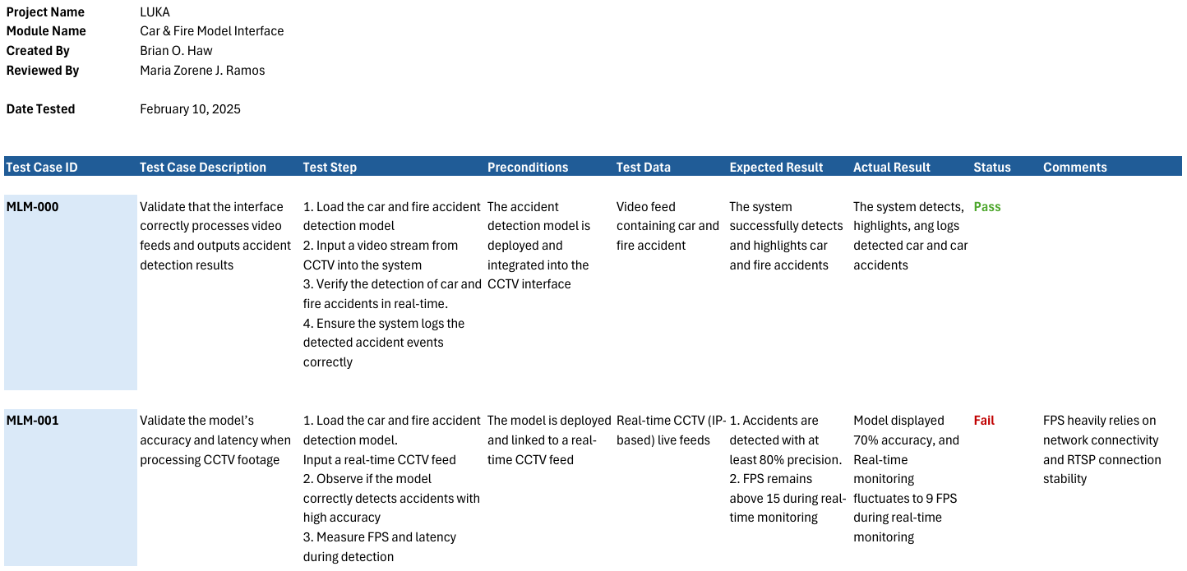

**Table 19. Car and fire model test module**

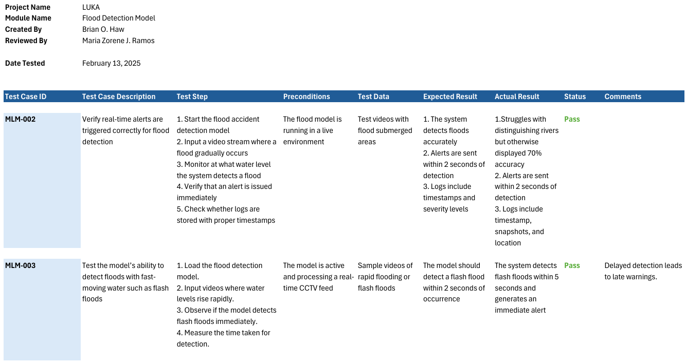

**Table 20. Flood detection test module**

**3.5c Integration Testing**

Integration testing is performed to ensure that different components or modules of the system work together as expected when combined. This phase focuses on verifying the interactions between integrated components, checking for data flow consistency, and ensuring that interfaces between modules function correctly. The goal is to identify and resolve issues related to communication between components that may not have been apparent during individual component testing.

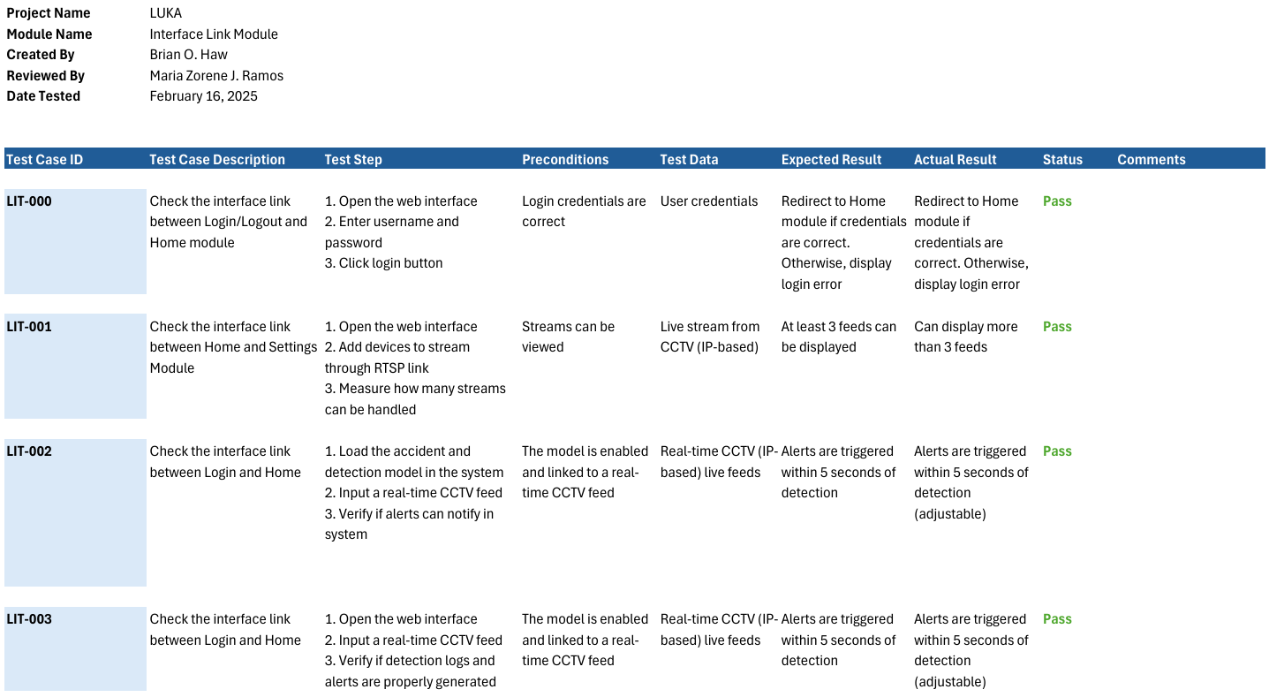

**Table 21. Interface link test module**

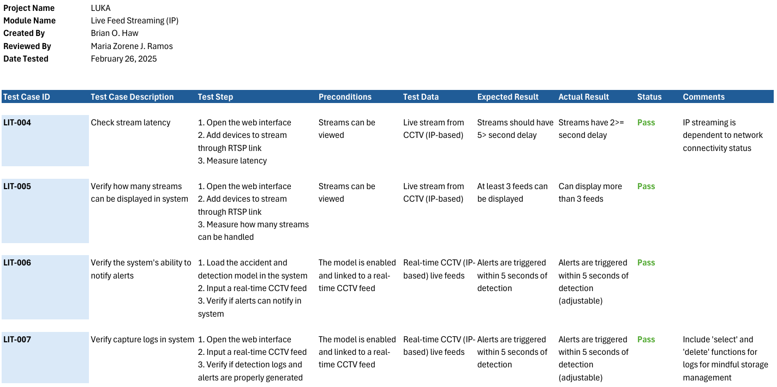

**Table 22. Live feed stream test module**

**3.5d Database Testing**

Database testing is conducted to verify the integrity, reliability, and performance of the database system. This includes verifying that the database functions as expected, with accurate data retrieval, updates, and deletions.

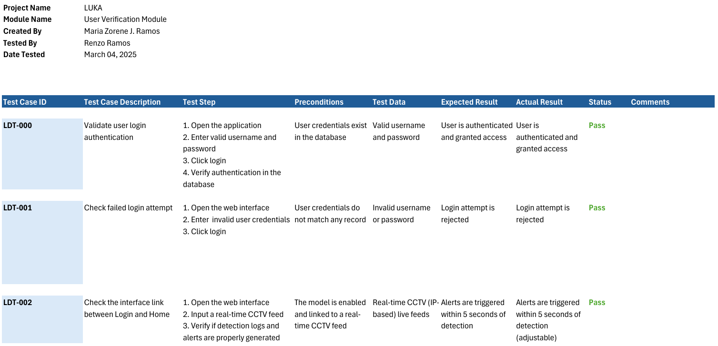

**Table 23. User verification test module**

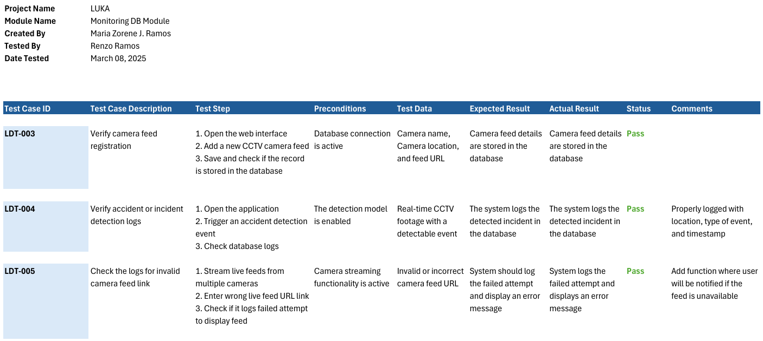

**Table 24. Camera Feed and Log Verification test module**

**3.5e Security Testing**

Security testing is conducted to identify vulnerabilities, weaknesses, and potential threats in the system that could be exploited by malicious users. This type of testing focuses on ensuring the system’s data, resources, and processes are protected against unauthorized access, data breaches, and other security risks. It includes testing for common security issues such as data encryption problems, and injection attacks.

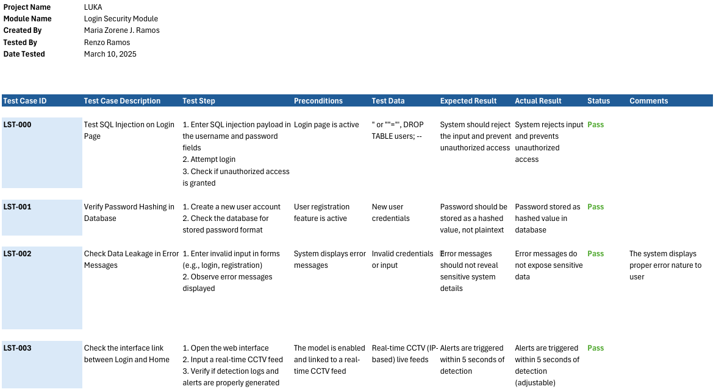

**Table 25. Login security test module**

**3.5d End-to-end Testing**

End-to-end testing was conducted to evaluate the system workflow, from start to finish. This is to verify that all components interact as expected. This simulates user operations and experience, verifying that the system functions correctly across all integrated components, including databases, user interfaces, APIs, and external services.

**3.7 Description of Prototype**

The proposed Real-Time Accident and Disaster Detection System integrates IoT-enabled or CCTV cameras with a Convolutional Neural Network (CNN) to detect disasters such as fires and explosions in real time. This system integrates a trained CNN model to analyze video frames, identify disaster patterns, and provide immediate alerts through a user-friendly web-based dashboard. Using OpenCV, live video feeds are captured from IoT cameras or CCTV systems, processed in real time, and fed into the CNN model, which determines the likelihood of a disaster. Alerts are triggered when the model’s confidence exceeds a customizable threshold, and these alerts are visually overlaid on the live video feed for instant recognition.

The system features a Flask-based backend for efficient handling of video streams and user interactions, while a simple HTML/CSS frontend delivers a live monitoring dashboard. The detection framework is highly adaptable, with options to integrate RTSP-enabled cameras or deploy on local hardware or cloud platforms like AWS or Google Cloud. Moreover, the system’s performance can be enhanced by using GPUs for faster inference or through edge devices like Raspberry Pi for remote applications.

To ensure scalability and practicality, the system supports disaster snapshot storage with timestamps, and the potential for multiclass detection to identify various types of disasters, including floods or earthquakes. Future improvements include integrating environmental sensors, refining the CNN model with broader datasets, and developing a companion mobile app for remote monitoring and notifications.

**3.8 Implementation Plan**

Deployment Preparation:

1. Finalize the developed system's architecture and functionalities based on feedback during testing.
2. Procure and test the required hardware, including CCTV cameras, IoT devices, and server infrastructure.

Installation and Configuration:

1. Install and configure the system to the monitoring department as well as the IoT to the CCTV cameras at Barangay Santa Rita.

Training and Knowledge Transfer

1. Provide instructions to the monitoring personnel and local disaster response teams on system usage and troubleshooting.
2. Provide comprehensive documentation, including a user manual and maintenance guidelines.

System Handbook:

1. Present the system to local officials and stakeholders for review.
2. Transfer ownership of the system, along with documentation and access rights, to the local government or assigned administrators.

Post-Implementation Support:

1. Offer limited-time technical support to address initial issues.
2. Monitor system performance and make adjustments as necessary.

**CHAPTER IV**

**RESULTS AND DISCUSSION**

**4.1 Results**

**Simulated Testing**

The proponents gathered experimental results through simulated testing, due to the constraints of testing in live environment. Testing the system with actual events and user operations allowed the proponents to gather necessary information on the system’s capability, functionality, and reliability.

**Stream Capacity**

The proponents tested the system’s capabilities through its stream handling. Certain metrics were used to measure the system’s performance, comparing stream capacity with the detection model enabled and disabled. The following shows the result with different numbers of streams:

***Device Used for Testing***

|  |  |
| --- | --- |
| *Component* | *Specification* |
| *Model* | ASUS ROG Strix G15 G513 |
| *CPU* | AMD Ryzen 7 (8-Core/16-thread) |
| *Graphics Card* | NVIDIA GTX 1650 |
| *RAM* | 24GB DDR4-3200 SO-DIMM |
| *Primary Storage* | 512GB Internal |
| *Secondary Storage* | 1TB |

**Table_. ROG Strix Specifications**

* Test Case 1: One Active Stream – max framerate of 30

|  |  |  |  |  |  |
| --- | --- | --- | --- | --- | --- |
| **FPS** | **Processing Time** | **Streaming Delay** | **CPU Usage** | **Description** | **Model Status** |
| 29 - 26 | 0.000s | 0.010s - 0.07s | 20% | minimal to no lag | Off |
| 24 - 19 | 0.020s - 0.014s | 0.024s - 0.017s | 30% - 10% | minimal to no lag, with a bit of glitching from time to time | On |

**Table _. Comparison with 1 Active Stream**

* Test Case 2: Three Active Stream – max framerate of 30

|  |  |  |  |  |  |
| --- | --- | --- | --- | --- | --- |
| **FPS** | **Processing Time** | **Streaming Delay** | **CPU Usage** | **Description** | **Model Status** |
| 28 - 22 | 0.000s | 0.010s - 0.07s | 40% | minimal to no lag, with glitching from time to time. | Off |
| 16 - 14 | 0.050s - 0.030s | 0.070s - 0.040s | 40% - 25% | minimal lag with noticeable delay, as well as glitching from time to time. | On |

**Table _. Comparison with 3 Active Streams**

* Test Case 3: Six Active Stream – max framerate of 30

|  |  |  |  |  |  |
| --- | --- | --- | --- | --- | --- |
| **FPS** | **Processing Time** | **Streaming Delay** | **CPU Usage** | **Description** | **Model Status** |
| 25 - 13 | 0.000s | 0.010s - 0.07s | 100% - 50% | Noticeable lag and glitching | Off |
| 15 - 8 | 0.130s - 0.110s | 0.140s - 0.080s | 100% - 30% | Heavy lag and glitching. | On |

**Table _. Comparison with 6 Active Streams**

**Monitoring Time**

The time needed for live monitoring was tested by measuring how the model detection can aid with the monitoring process in viewing live feeds, this majorly includes how efficient and fast the system can assist the user when it comes to determining incidents. The system displayed three simultaneous video streams for monitoring with model enabled and disabled to assess if the system displays noticeable assistance to user.

|  |  |  |  |  |  |
| --- | --- | --- | --- | --- | --- |
| **Test Case** | **Model Status** | **Incident Detected** | **Detection Time (seconds)** | **User Response Time (seconds)** |  |
| 1 | Enabled | Fire | 0.8 | 1.5 |  |
| 2 | Disabled | Fire | N/A | 2.2 |  |
| 3 | Enabled | Car Crash | 0.9 | 1.0 |  |
| 4 | Disabled | Car Crash | N/A | 8.1 |  |
| 5 | Enabled | Car Crash | 0.5 | 2.0 |  |
| 6 | Disabled | Car Crash | N/A | 5.0 |  |
| 7 | Enabled | Smoke | 0.5 | 1.2 |
| 8 | Disabled | Smoke | N/A | 4.3 |
| 9 | Enabled | Car Crash | 0.5 | 1.2 |
| 10 | Disabled | Car Crash | N/A | 3.4 |

**Table _. User Response Test**

**Alert Speed**

The proponents conducted test runs to measure how well the alert notifications can provide real-time information from detected events. This assessment includes system and mobile notifications for evaluation.

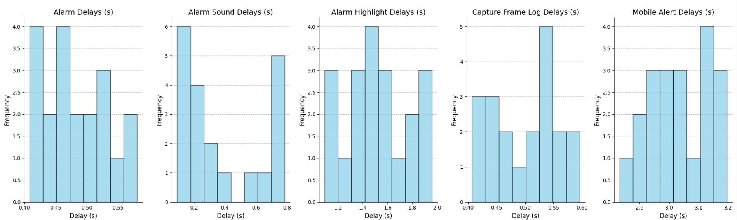

**Figure 20. Bar Chart of Different Notification Delays**

**Environmental Data using IoT Sensors**

asd

**Sensor Module Performance Data**

The proponents conducted weekly tests for the MPU6050, DHT11, and Rain sensor modules’ performance based on their power draw, usage, performance, reliability, and accuracy.

|  |  |  |  |  |  |
| --- | --- | --- | --- | --- | --- |
|  | **Power (mA)** | **Usage (%)** | **Performance** | **Reliability (%)** | **Accuracy (%)** |
| Week 1 | 50 | 75 | 65 | 85 | 88 |
| Week 2 | 45 | 78 | 70 | 87 | 86 |
| Week 3 | 48 | 80 | 72 | 89 | 89 |
| Week 4 | 44 | 82 | 74 | 91 | 90 |

**Table…**

**Camera Module Comparison**

The proponents conducted comparison between various camera devices, this includes Raspberry Pi Camera Module 3, Raspberry Pi High Quality Camera, and a custom CCTV camera. The following tables showcases the performance of each device on certain factors:

* Image Quality and Sensor Performance

|  |  |  |  |
| --- | --- | --- | --- |
| **Feature** | **Raspberry Pi Camera Module 3** | **Raspberry Pi High Quality Camera** | **Custom CCTV Camera** |
| **Sensor** | Sony IMX708 | Sony IMX477 | Varies by manufacturer |
| **Resolution** | 11.9 MP | 12.3 MP | Typically ranges from 2 MP to 8 MP |
| **Pixel Size** | 1.4 µm x 1.4 µm | 1.55 µm x 1.55 µm | Varies; larger pixels often in low-light models |
| **Dynamic Range** | High Dynamic Range (HDR) support | Standard dynamic range | Varies; some models offer HDR capabilities |

**Table…**

* Lens Flexibility and Field of View

|  |  |  |  |
| --- | --- | --- | --- |
| **Feature** | **Raspberry Pi Camera Module 3** | **Raspberry Pi High Quality Camera** | **Custom CCTV Camera** |
| **Lens Type** | Fixed autofocus lens | Interchangeable C/CS mount lenses | Typically fixed; some models offer varifocal lenses |
| **Field of View (FoV)** | Standard: 75° diagonal; Wide: 120° diagonal | Depends on attached lens; e.g., 6mm lens offers ~63° diagonal FoV | Varies; wide-angle lenses available for broader coverage |

**Table…**

* Low-Light Performance

|  |  |  |  |
| --- | --- | --- | --- |
| **Feature** | **Raspberry Pi Camera Module 3** | **Raspberry Pi High Quality Camera** | **Custom CCTV Camera** |
| **NoIR (No Infrared Filter) Version** | Available | Available | Many models available with IR sensitivity |
| **Low-Light Sensitivity** | Improved over previous models; benefits from HDR | Enhanced with appropriate lens selection | Varies; models with larger sensors and IR capabilities perform better |

**Table…**

* Integration and Customization

|  |  |  |  |
| --- | --- | --- | --- |
| **Feature** | **Raspberry Pi Camera Module 3** | **Raspberry Pi High Quality Camera** | **Custom CCTV Camera** |
| **Integration with Systems** | Seamless with Raspberry Pi boards; extensive community support | Often requires proprietary systems; integration varies by manufacturer | Can be integrated in different projects via analog |
| **Customization** | High; programmable features, adaptable for various projects | Limited; primarily designed for standard surveillance tasks | N/A |

**Table…**

**4.2 Interpretation and Analysis of Data**

**User Response Time with Live Feed Monitoring**

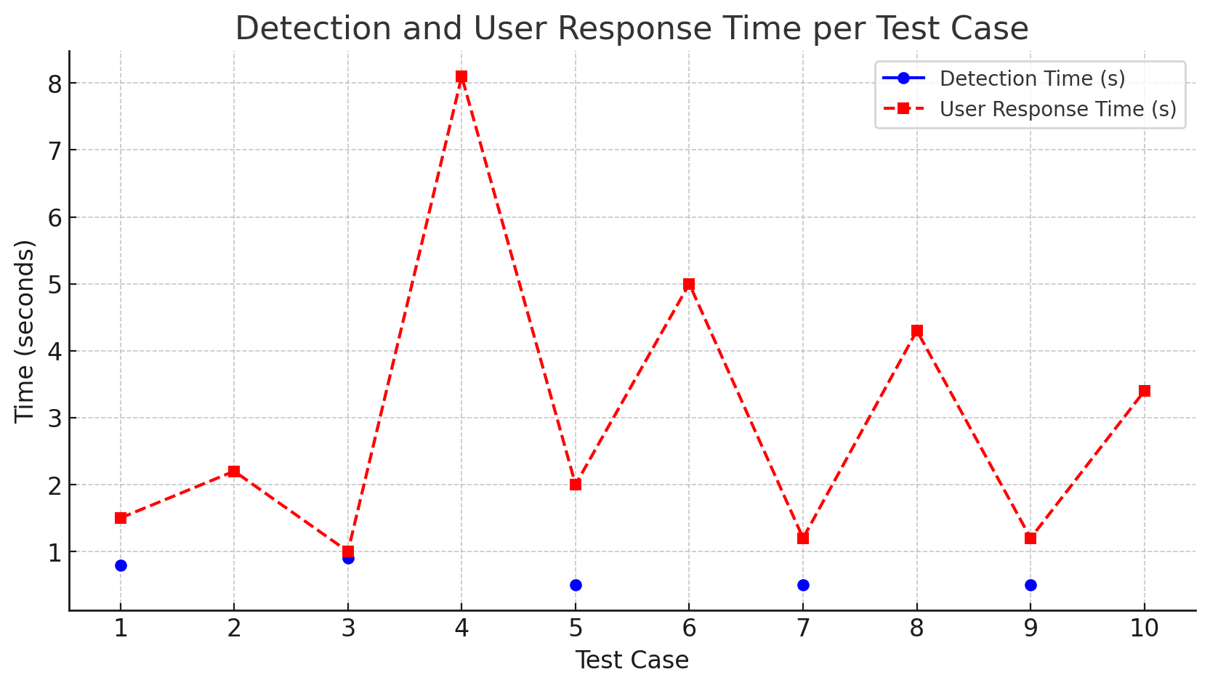

**Figure 21. Test Cases for Monitoring Time**

Test cases 1, 3, 5, 7, and 9 were conducted with incident detection enabled and test cases 2, 4, 6, 8, and 10 were conducted with incident detection disabled. This shows the relative speed in monitoring with the detection model. With the help of LUKA’s AI detection, the monitoring speed is relatively faster than relying on manual monitoring alone. The standalone detection system has a mean average of 0.80 seconds in an isolated feed, which shows potential for dispatching immediate disaster response before incidents escalate further. The mean average for user response time is 1.7 seconds with automated detection, which concludes that personnel are more likely to respond to incidents faster after an event is notified, unlike with AI detection disabled which produced 6.6 seconds in user response time and several missed incidents.

**Alarm and Notification Delays**

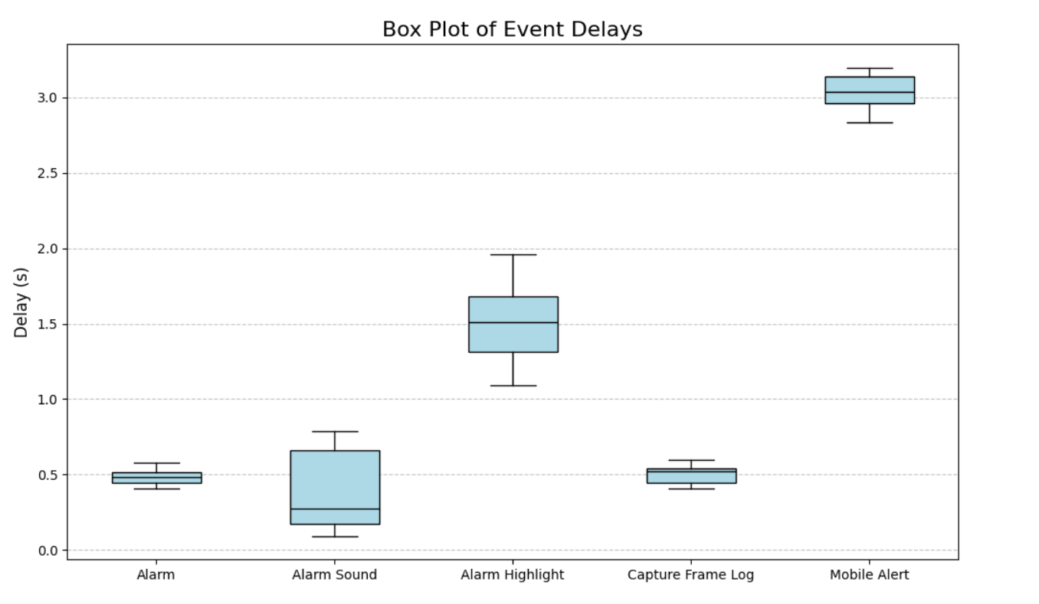

**Figure 22. Box Plot of Different Notifications Delay**

The notification delays range significantly between events, with Alarm and Capture Frame Log providing the shortest, consistent delay times to the user (~0.4–0.5s). This indicates a relatively quick timeframe for responding to the alerts. Alarm Sound has slightly more variability, with delay times between 0.1 and 0.8s. The Alarm Highlight has a longer delay (~1.0–2.0s) indicating that the visual alert takes more time to identify and process. The Mobile Alert has the longest, but most consistent delay (~2.8-3.2s) the general consensus is that the local system alerts are the most efficient, while mobile notifications delay the response significantly. This is an area of opportunity for optimization in real time alerts within the systems.

**Weekly Performance Metrics of Different Camera Devices**

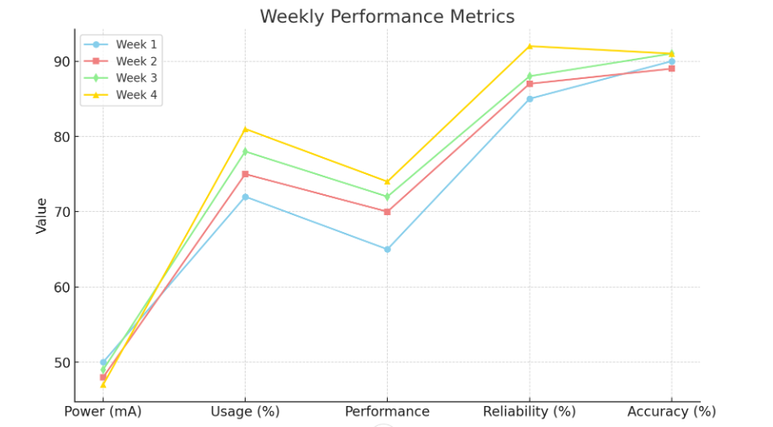

**Figure 23. Overall Performance Metrics of Sensor Integration**

The IoT sensors showed consistent improvement for major performance measures. Each week provided small modifications. These improvements progressed from the implementation of the MPU6050 which had initial stability and power concerns, to Week 4 where new firmware was installed, data acquisition was refined, and edge computing was explored. Power draw decreased from consistent 50mA to 44mA, while performance, reliability, and accuracy improved to 74%, 91%, and 90% from 65%, 85%, and 88%, respectively. The weekly metrics exhibited the value of focused improvements such as power management techniques, sensor thresholds, and improved resource allocation on the ESP32.

**Camera Module Multi-feature Comparison**

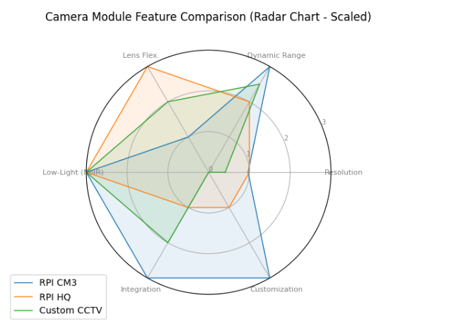

**Figure 24. Radar Chart Showcasing Multi-Feature Comparisons**

Raspberry Pi Camera Modules, especially the Camera Module 3 and High-Quality Camera, offer high resolution imaging, flexible lens options, and ease of integration, making them potentially effective for custom surveillance solutions. However, custom CCTV cameras are specifically designed for surveillance and often incorporate optimized low-light performance and sturdy construction. The final decision between these two options should be determined by the surveillance requirements, environment, and customization of the system.

**CHAPTER V**

**CONCLUSION AND RECOMMENDATIONS**

**5.1 Summary of Findings**

The reliability of the LUKA system is influenced by the quality of hardware components. Artificial intelligence technology performs well with higher hardware specifications, making system performance optimal through faster processors, larger memory capacity, and dedicated GPUs. With high-end devices, it should allow the system to provide smoother real-time processing, quicker response times, and improved accuracy for accident and disaster detection, contributing to the technological improvement of peace and order operations. In contrast, low-end devices result in streaming delays, frame drops, intermittent monitoring, and reduced precision.

In terms of system alert, automated detection reduced incident identification time to 0.80 seconds compared to 6.6 seconds with manual monitoring. Live feed monitoring with the system’s AI detection drastically improved user response speed.

Environmental factors including moisture, temperature, variations, and electromagnetic interference significantly influenced sensor performance.

Upon software evaluation, the client stated that the system would be extremely helpful once implemented in barangay Santa Rita. Reducing the time needed for CCTV monitoring-related tasks through automated detection would help improve response time, reduce manpower, promote reasonable working hours, and drastically decrease workload, especially since the area is accident and disaster prone.

**5.2 Future Works/Studies**

This section lists future enhancements to be implemented in the study or future versions of the system.

1. Researchers may include a functionality that allows additional options to detect incidents through uploaded video recordings for incident analyzation.
2. Researchers may include more variations of accidents/natural disasters for widened scope of incidents.
3. Researchers may establish an automated multi-level alert system to improve prioritization of events.
4. Researchers may establish an early warning detection feature and predictive analysis for different incidents.
5. Researchers may implement geospatial mapping and risk assessment to visualize disaster-prone areas and improve strategic response planning.
6. Researchers may enhance the system that can handle operations in the entirety of Olongapo City.
7. Researchers may optimize the system's code to improve performance and efficiency.
8. Researchers may implement further usage and optimization of GPU/CUDA for faster processing.
9. Researchers may enhance the accuracy and other metrics of the YOLO detection model.
10. Researchers may further train the YOLO detection models to improve detection reliability.
11. Researchers may integrate the YOLO model directly into IoT cameras instead of relying on the central system for processing.
12. Researchers may enhance the system's compatibility with other operating systems to broaden its deployment potential.

**List of References**

Abualigah, L. (2023) Enhancing Internet of Things Network Security Using Hybrid CNN and XGBoost Model Tuned via Modified Reptile Search Algorithm. Retrieved from <https://doi.org/10.3390/app132312687>

Aglibot, J. R. (2024, April 15). *Fire hits residential building in Olongapo City*. INQUIRER.net. <https://newsinfo.inquirer.net/1929977/fire-hits-residential-building-in-olongapo-city>

Alblooshi, F. S. (2021, May). *Artificial Intelligence for smarter surveillance using CCTV cameras in the UAE*. RIT Digital Institutional Repository. <https://repository.rit.edu/theses/11091/>

Balita, C. (2024, March 26). *Natural disasters in the Philippines - statistics & facts*. Statista. <https://www.statista.com/topics/5845/natural-disasters-in-the-philippines-at-a-glance/#topicOverview>

Baccour, E., Erbad, A., Mohamed, A., Hamdi, M., & Guizani, M. (2024). Multi-agent reinforcement learning for privacy-aware distributed CNN in heterogeneous IoT surveillance systems. *Journal of Network and Computer Applications*, 103933. <https://doi.org/10.1016/j.jnca.2024.103933>

Barathwaj, K., GaneshKumar, H., Charan, M. J., Dineshkumar, P., & Kirubadevi, T. (2024). Real-time accident detection and reporting system using CNN algorithm. Retrieved frmo <https://www.ijerst.drmgrjournals.org/index.php/ijerst/article/view/82/48>

Bosano, R. (2024, September 12). *Philippines is “world’s riskiest country” for 3rd straight year.* ABS-CBN News. <https://news.abs-cbn.com/news/2024/9/12/philippines-is-world-s-riskiest-country-for-3rd-straight-year-1758>

DILG Region III – Central Luzon (n.d.). *Olongapo City & Barangay Sta. Rita. . . nation’s best local Disaster Risk Reduction Councils.* <https://region3.dilg.gov.ph/index.php/73-provincial-and-city-pages/olongapo-city/424-olongapo-city-barangay-sta-rita-nation-s-best-local-disaster-risk-reduction-councils>

Dwivedi, R. (2020, June). *5 Common Architectures in Convolution Neural Networks (CNN)*. Analytic Steps. Retrieved from <https://www.analyticssteps.com/blogs/common-architectures-convolution-neural-networks>

Edge AI Vision Alliance. (2015). Using Convolutional Neural Networks for Image Recognition. Retrieved from <https://www.edge-ai-vision.com/2015/11/using-convolutional-neural-networks-for-image-recognition/>

Ergashev, A. (2023). PRIVACY CONCERNS AND DATA PROTECTION IN AN ERA OF AI SURVEILLANCE TECHNOLOGIES. *International Journal Of Law And Criminology*, *3*(08), 71–76. <https://doi.org/10.37547/ijlc/Volume03Issue08-14>

GMA Integrated News. (2024, September 10). Philippines has highest world risk index anew in 2024 report. *GMA News Online*. <https://www.gmanetwork.com/news/topstories/nation/920021/philippines-highest-world-risk-index-2024/story/>

Hu, Y., Kuang, W., Qin, Z., Li, K., Zhang, J., Gao, Y., Li, W., & Li, K. (2021). Artificial intelligence Security: Threats and countermeasures. *ACM Computing Surveys*, *55*(1), 1–36. <https://doi.org/10.1145/3487890>

Hussain, S., Ali, A., & Khan, F. (2021). A Low-Cost Intelligent Surveillance System Using CNNs on Raspberry Pi. *PMC*. Retrieved from <https://pmc.ncbi.nlm.nih.gov/articles/PMC7959643/>

Inquirer Central Luzon (2024, April 27). *Fire hits house in Olongapo City*. INQUIRER.net. <https://newsinfo.inquirer.net/1934269/fire-hits-house-in-olongapo-city>

Jung, D., Son, J.-W., & Kim, S.-J. (2018). Shot category detection based on object detection using convolutional neural networks. *Proceedings of the 2018 20th International Conference on Advanced Communication Technology (ICACT)*, 8323638. <https://doi.org/10.23919/ICACT.2018.8323638>

Kingma, D. P., & Ba, J. (2015). Adam: A method for stochastic optimization. *Proceedings of the 3rd International Conference on Learning*

*Representations (ICLR)*. <https://arxiv.org/abs/1412.6980>

Koo, J. H., Cho, S. W., Baek, N. R., Kim, M. C., & Park, K. R. (2018). CNN-Based multimodal human recognition in surveillance environments. *Sensors*, *18*(9), 3040. <https://doi.org/10.3390/s18093040>

Kyrkou, C., & Theocharides, T. (2012, June). *A Parallel Hardware Architecture for Real-Time Object Detection with Support Vector Machines*. IEEE Journals & Magazine | IEEE Xplore. <https://ieeexplore.ieee.org/abstract/document/5928327>

Lin, Y., Lin, Y., & Han, J. (2018). Automatic water-level detection using single-camera images with varied poses. *Measurement*, *127*, 167–174. <https://doi.org/10.1016/j.measurement.2018.05.100>

Rimal, Y., Sharma, N., & Alsadoon, A. (2024). The accuracy of machine learning models relies on hyperparameter tuning: student result classification using random forest, randomized search, grid search, bayesian, genetic, and optuna algorithms. *Multimedia Tools and Applications*, *83*(30), 74349–74364. <https://doi.org/10.1007/s11042-024-18426-2>

Bobbitt, Z. (2022). *What is a “Good” Accuracy for Machine Learning Models?* Statology. <https://www.statology.org/good-accuracy-machine-learning/>

Hendricks, R. (2022). *What is a good accuracy score in Machine Learning?* Deepchecks. <https://www.deepchecks.com/question/what-is-a-good-accuracy-score-in-machine-learning/>

Aosong Electronics. (2021). DHT11 temperature & humidity sensor datasheet. Retrieved from <https://www.sparkfun.com/datasheets/Sensors/Temperature/DHT11.pdf>

Moorthy, R., Upadhya, V., Holla, V., Sunil S., & Tantry, V., (2020). *Challenges Encountered In Building a Fast and Efficient Surveillance System: An Overview*. IEEE Conference Publication | IEEE Xplore. <https://ieeexplore.ieee.org/document/9243563>

Muhammad, K., Hussain, T., Tanveer, M., Sannino, G., & de Albuquerque, V. H. C. (2019). Cost-Effective Video Summarization using Deep CNN with Hierarchical Weighted Fusion for IoT Surveillance Networks. IEEE Internet of Things Journal, 1–1. doi:10.1109/jiot.2019.2950469

Ryu, D., & Kim, S. H. (2023). AI-Based Intelligent CCTV Detection Performance Improvement. *Journal of Information and Security*, *23*(5), 117–123. <https://doi.org/10.33778/kcsa.2023.23.5.117>

Sabri, Z. S., & Li, Z. (2021). Low-cost intelligent surveillance system based on fast CNN. *PeerJ Computer Science*, *7*, e402. <https://doi.org/10.7717/peerj-cs.402>

Salb, M., Jovanovic, L., Bacanin, N., Antonijevic, M., Zivkovic, M., Budimirovic, N., & Abualigah, L. (2023). Enhancing internet of things network security using hybrid CNN and XGBOOST model tuned via modified reptile search algorithm. *Applied Sciences*, *13*(23), 12687. <https://doi.org/10.3390/app132312687>

Selvi, E., Adimoolam, M., Karthi, G., Thinakaran, K., Balamurugan, N. M., Kannadasan, R., Wechtaisong, C., & Khan, A. A. (2022). Suspicious Actions Detection system using enhanced CNN and surveillance video. *Electronics*, *11*(24), 4210. <https://doi.org/10.3390/electronics11244210>

Sokolova, M., & Lapalme, G. (2009). A systematic analysis of performance measures for classification tasks. Information Processing & Management, 45(4), 427–437. <https://doi.org/10.1016/j.ipm.2009.03.002>

Subba Raju, P., Jabir, M., Pavan, K. N., & Chaitanya, K. S. S. K. S. V. (2024). Accident detection system on roads using convolutional neural network. International Journal of Advanced Research in Science, Communication and Technology, 4(4), 415-420. <https://doi.org/10.48175/IJARSCT-17471>

Tolo, W. B. J. (2011). The Determinants of Economic Growth in the Philippines, Manila: International Monetary Fund. IMF Working Paper. <https://www.imf.org/external/pubs/ft/wp/2011/wp11288.pdf>

Vidal, J. (2021, August 25). Typhoon Haiyan: what really alarms Filipinos is the rich world ignoring climate change. *The Guardian*. <https://www.theguardian.com/commentisfree/2013/nov/08/typhoon-haiyan-rich-ignore-climate-change>

Vosta, S., & Yow, K. (2022). A CNN-RNN combined structure for Real-World violence detection in surveillance cameras. *Applied Sciences*, *12*(3), 1021. <https://doi.org/10.3390/app12031021>

Wei Yang, L. & Yen Su, C. (2018). *Low-Cost CNN Design for Intelligent Surveillance System.* 2018 International Conference on System Science and Engineering (ICSSE), New Taipei, Taiwan, pp. 1-4. <https://doi.org/10.1109/ICSSE.2018.8520133>

Yao, S. (2024). *Integrating AI into CCTV Systems: A comprehensive evaluation of smart video surveillance in community space with online anomaly training - ProQuest*. <https://www.proquest.com/openview/c2739d2200df7359ea1f70cd2edc89b7/1?pq-origsite=gscholar&cbl=18750&diss=y>

Zhang, Y., Li, J., & Wang, H. (2023). An IoT-Based Automatic Vehicle Accident Detection and Visual Situation Reporting System. *ResearchGate*. Retrieved from <https://www.researchgate.net/publication/380846454_An_IoT-Based_Automatic_Vehicle_Accident_Detection_and_Visual_Situation_Reporting_System>

Ultralytics. (n.d.). GitHub - ultralytics/ultralytics: Ultralytics YOLO11. GitHub. <https://github.com/ultralytics/ultralytics>

**ATTACHMENTS:**

**Appendix A**

**Camera Driver Module** 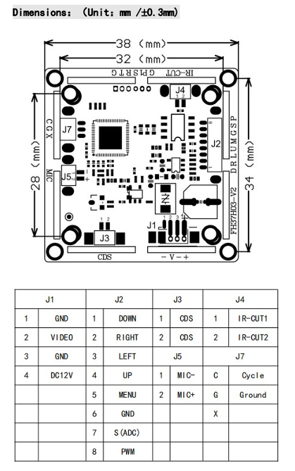

**Figure _. Camera driver module schematic**

**Appendix B**

**Camera Transceiver Module**

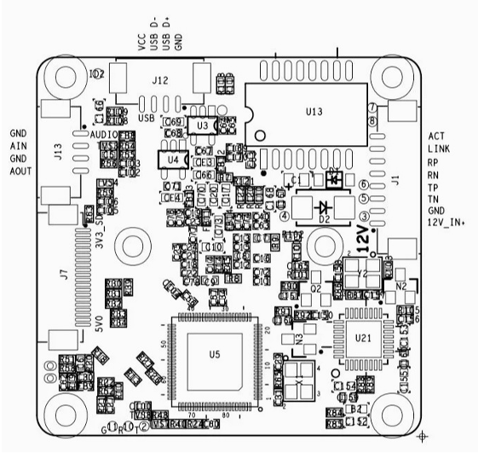

**Figure _. Camera transciever module schematic**

**Appendix C**

**Camera Power Supply**

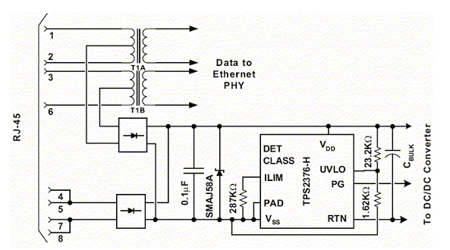

**Figure _. Power Supply for CCTV Camera**

**Appendix D**

**Custom 2-Layer PCB Design for ESP32-S3**

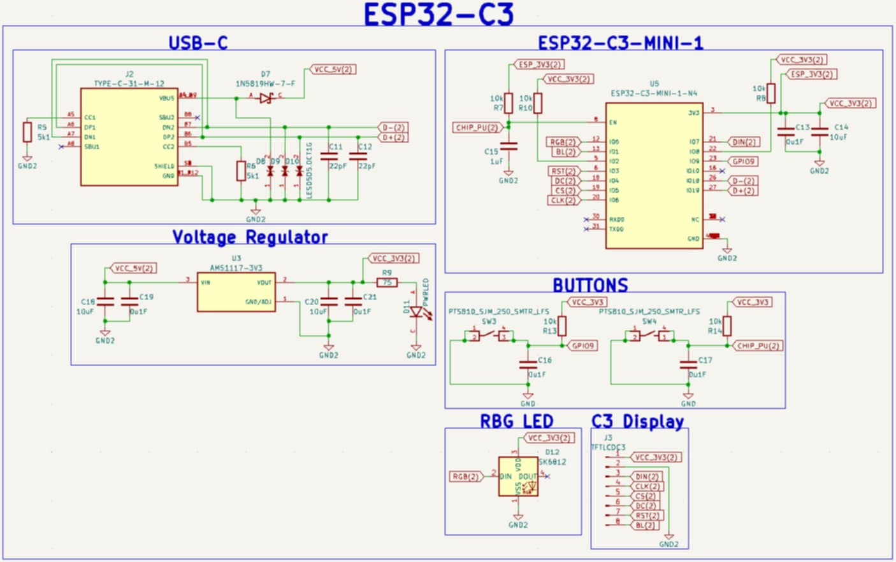

**Figure _. Custom ESP32 Schematics**

**Appendix E**

**Initial Interview with the Head of Disaster Risk Management Office**



**Appendix F**

**Transcript of Interview**





**Appendix G**

**Interview Letter for Barangay Pag-asa**

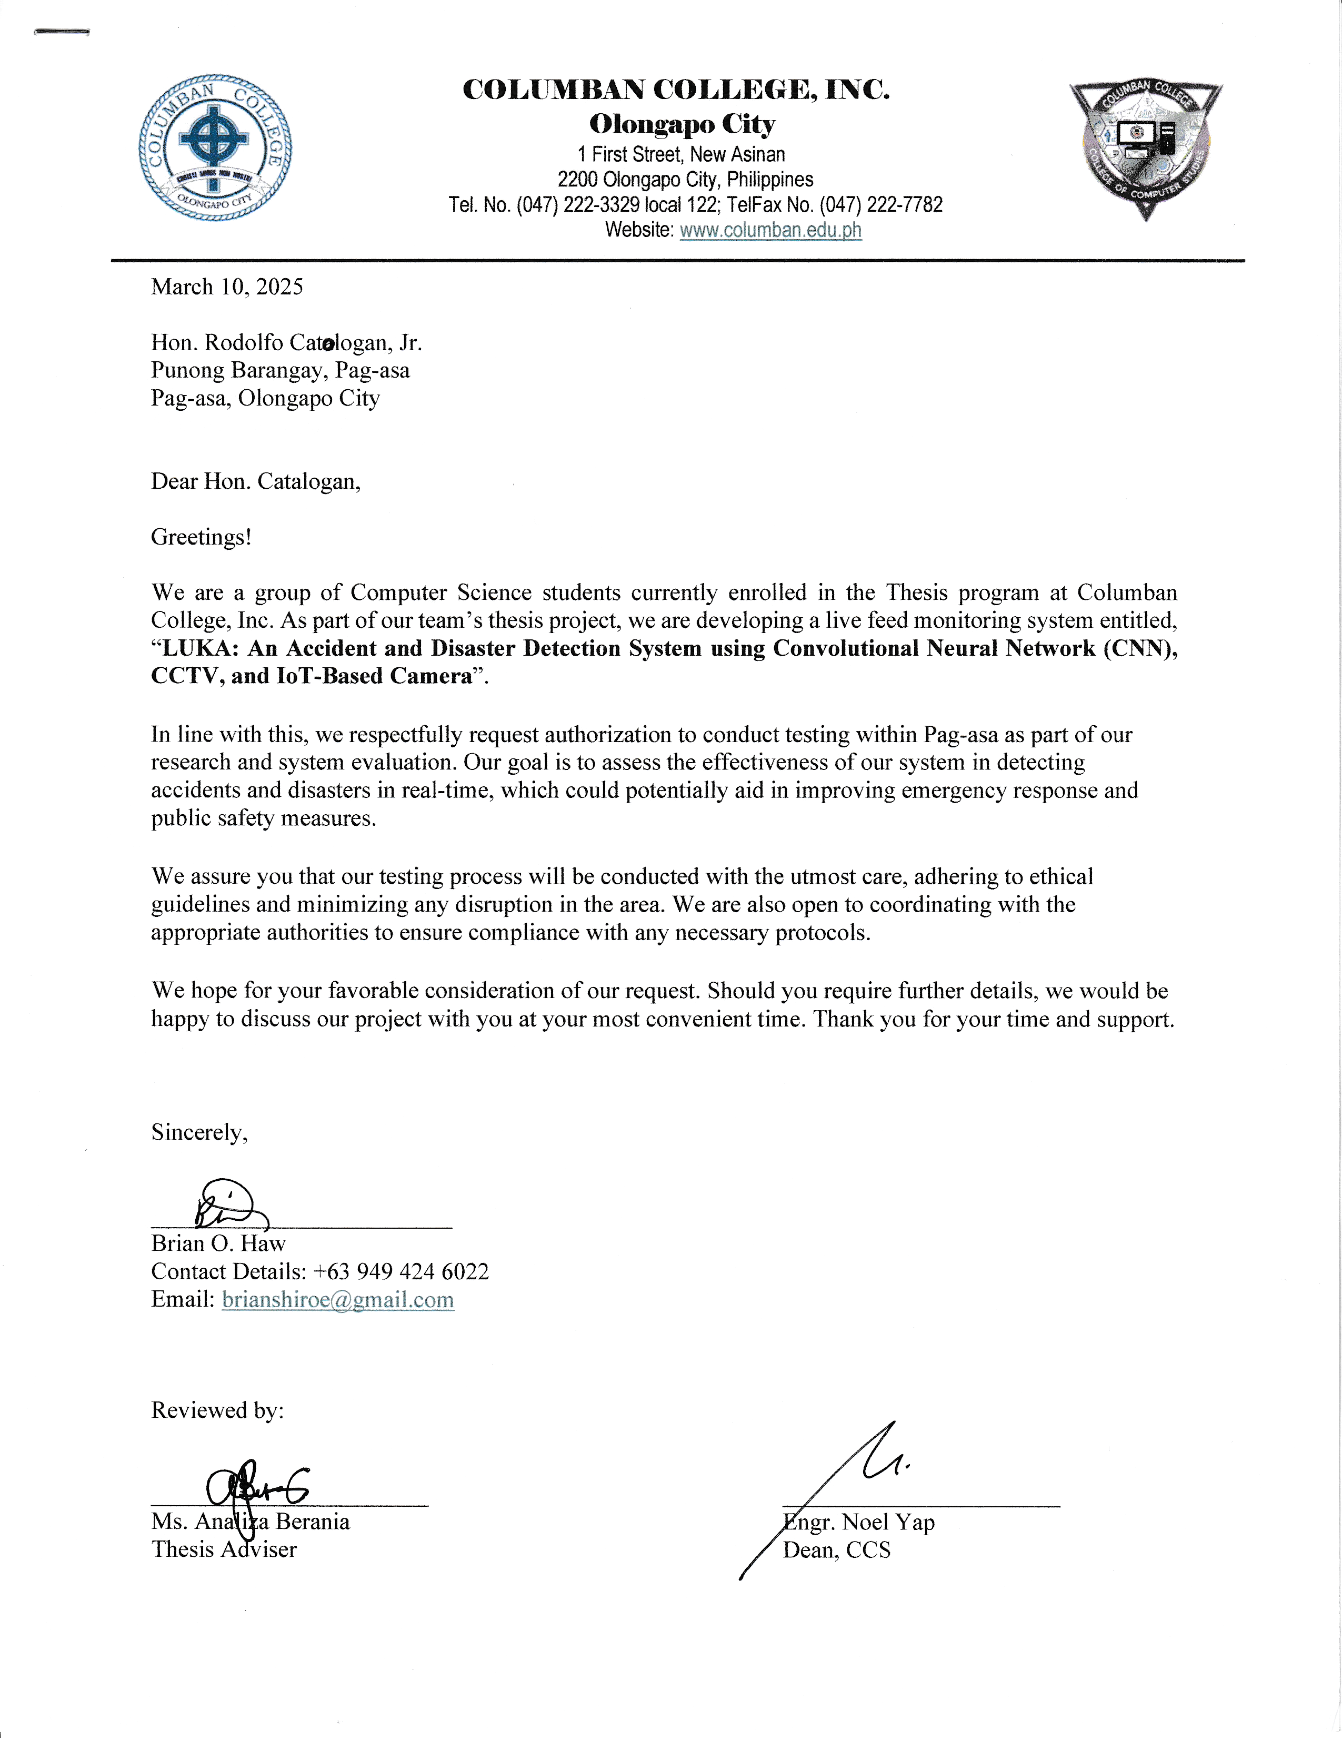



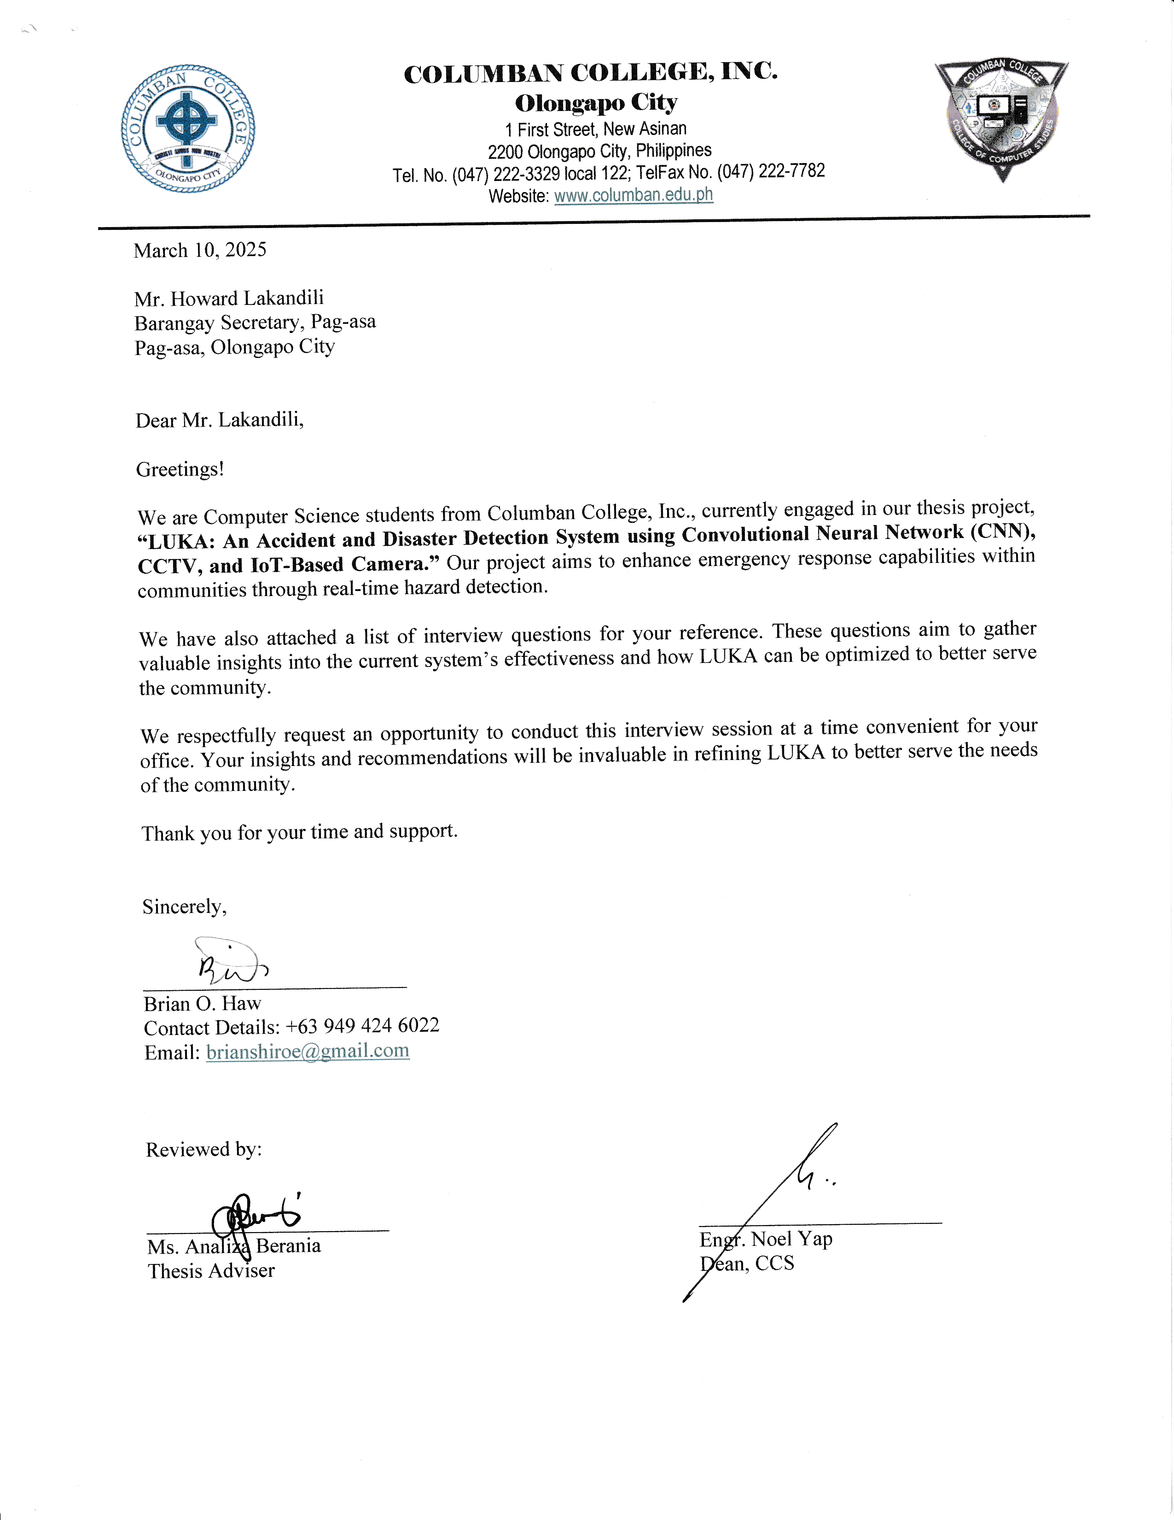

**Appendix H**

**CCTV Operations Interview in Barangay Pag asa**

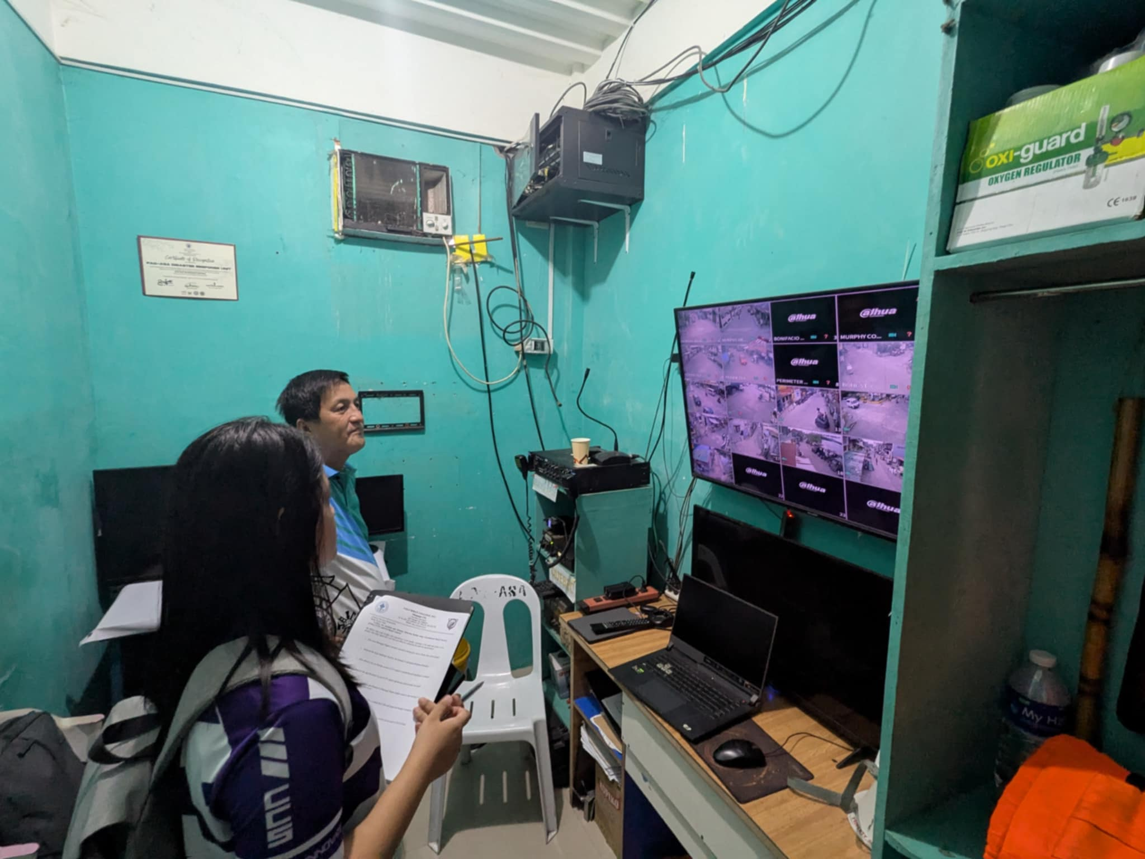

**Figure _. Assessing CCTV operations in Barangay Pag-asa**

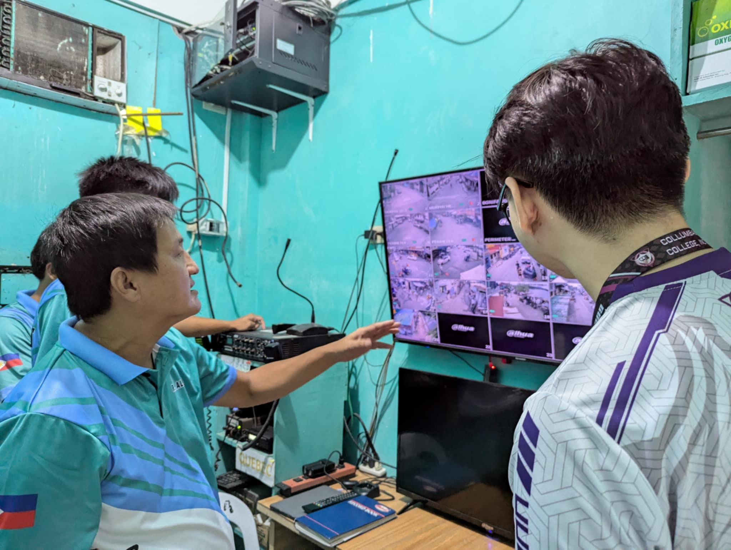

**Figure _. Interview about CCTV operations in Barangay Pag-asa**

**Appendix I**

**Sample Survey Form**

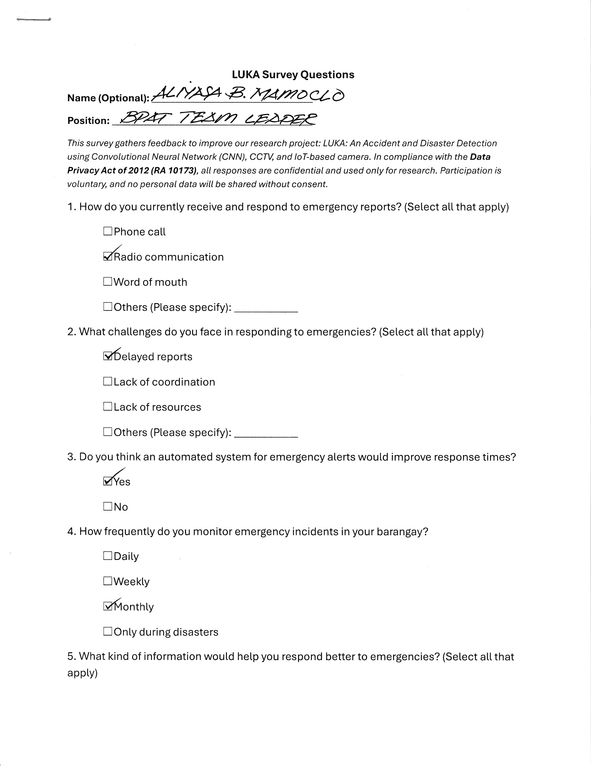



**RELEVANT SOURCE CODE**

**EVALUATION TOOL / TEST DOCUMENTS**

**Python Unit Testing using `unittest` library**

**`initialize_streams` method**

Test if mock streams will be read and initialized

import unittest

from unittest.mock import patch, MagicMock

import cv2

import app

from app import initialize_stream

class TestStreamInitialization(unittest.TestCase):

    @patch('cv2.VideoCapture')

    def test_initialize_stream(self, MockVideoCapture):

        # Test with mock video capture

        mock_cap = MagicMock()

        MockVideoCapture.return_value = mock_cap

        mock_cap.isOpened.return_value = True  # With this, we set a sample value 'True' to simulate successful input

        stream_url = "https://www.youtube.com/watch?v=aApSteSbeGA&t=234s"

        device_title = "Camera 1"

        result = initialize_stream(stream_url, device_title)

        self.assertEqual(result, mock_cap)  # This should return mock VideoCapture object

        mock_cap.isOpened.assert_called_once()

    # Test when stream returns 'False' value

    @patch('cv2.VideoCapture')

    def test_initialize_stream_failure(self, MockVideoCapture):

        mock_cap = MagicMock()

        MockVideoCapture.return_value = mock_cap

        mock_cap.isOpened.return_value = False  # Simulate failed stream opening

        stream_url = "https://www.youtube.com/watch?v=aApSteSbeGA&t=234s"

        device_title = "Camera 1"

        result = initialize_stream(stream_url, device_title)

        self.assertIsNone(result)  # None should be returned

        mock_cap.isOpened.assert_called_once()

if __name__ == '__main__':

    unittest.main()

**Output**

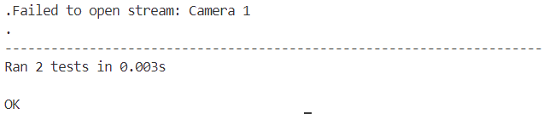

**Figure_. Test Case for initializing stream**

**`add_device` method**

Test if the system would add device with database connection

import unittest

import json

from app import app

from unittest.mock import patch, MagicMock

class AddDeviceTestCase(unittest.TestCase):

    def setUp(self):

        self.client = app.test_client()

        self.test_data = {

            "title": "Cam 01",

            "ip_address": "192.168.1.10",

            "location": "Entrance"

        }

    @patch('app.get_db')

    def test_add_device_success(self, mock_get_db):

        # Mock DB connection and cursor

        mock_conn = MagicMock()

        mock_cursor = MagicMock()

        mock_conn.cursor.return_value = mock_cursor

        mock_cursor.lastrowid = 1

        mock_get_db.return_value = mock_conn

        response = self.client.post(

            '/add_device',

            data=json.dumps(self.test_data),

            content_type='application/json'

        )

        self.assertEqual(response.status_code, 200)

        data = response.get_json()

        self.assertEqual(data["id"], 1)

        self.assertEqual(data["title"], "Cam 01")

        self.assertEqual(data["ip_address"], "192.168.1.10")

        self.assertEqual(data["location"], "Entrance")

        # Validate if database insert was called with correct SQL and data

        mock_cursor.execute.assert_called_once_with(

            "INSERT INTO camera (title, ip_address, location, status) VALUES (?, ?, ?, 'active')",

            ('Cam 01', '192.168.1.10', 'Entrance')

        )

        mock_conn.commit.assert_called_once()

if __name__ == '__main__':

    unittest.main()

**Output**

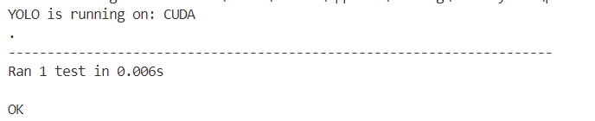

**Figure_. Test Case for Adding Device**

**get_incidents method**

Simulate GET request with mock database access and return mock list of incidents

import unittest

from unittest.mock import patch, MagicMock

from app import app

import json

class GetIncidentsTestCase(unittest.TestCase):

    def setUp(self):

        self.client = app.test_client()

    @patch('app.get_db')

    def test_get_incidents_success(self, mock_get_db):

        mock_rows = [

            {"detected_at": "2024-04-0 1 12:30:00", "event_type": "Fire", "camera_title": "Cam 01", "location": "Main Hall"},

            {"detected_at": "2024-04-01 11:45:00", "event_type": "Intrusion", "camera_title": "Cam 02", "location": "Back Gate"}

        ]

        mock_conn = MagicMock()

        mock_conn.execute.return_value.fetchall.return_value = mock_rows

        mock_get_db.return_value = mock_conn

        response = self.client.get("/api/incidents")

        self.assertEqual(response.status_code, 200)

        data = response.get_json()

        self.assertEqual(len(data), 2)

        self.assertEqual(data[0]["event_type"], "Fire")

        self.assertEqual(data[1]["camera_title"], "Cam 02")

        self.assertEqual(data[1]["location"], "Back Gate")

        mock_conn.execute.assert_called_once_with("SELECT detected_at, event_type, camera_title, location FROM alert ORDER BY detected_at DESC")

if __name__ == "__main__":

    unittest.main()

**Output**

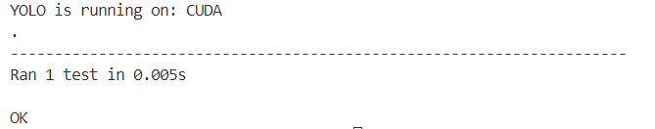

**Figure_. Test Case for Fetching Incidents in Analytics**

**`get_recorded_files` method**

Simulate test for successful file listing and an exception case

import unittest

from unittest.mock import patch

from app import app

import os

class GetRecordedFilesTestCase(unittest.TestCase):

    def setUp(self):

        self.client = app.test_client()

    @patch('app.os.listdir')

    @patch('app.detected_records_path', '/fake/path')

    def test_get_recorded_files_success(self, mock_listdir):

        mock_listdir.return_value = [

            'video1.mp4', 'image1.jpg', 'note.txt', 'clip.avi', 'ignore.docx'

        ]

        response = self.client.get('/get_recorded_files')

        self.assertEqual(response.status_code, 200)

        data = response.get_json()

        # This should only return VALID media files

        self.assertIn('video1.mp4', data)

        self.assertIn('image1.jpg', data)

        self.assertIn('clip.avi', data)

        self.assertNotIn('note.txt', data)

        self.assertNotIn('ignore.docx', data)

    @patch('app.os.listdir', side_effect=Exception('Disk not found'))

    def test_get_recorded_files_exception(self, mock_listdir):

        response = self.client.get('/get_recorded_files')

        self.assertEqual(response.status_code, 500)

        data = response.get_json()

        self.assertIn('error', data)

        self.assertEqual(data['error'], 'Disk not found')

if __name__ == '__main__':

    unittest.main()

**Output**

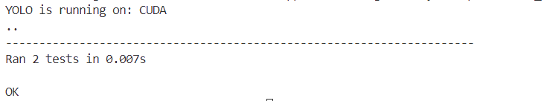

**Figure_. Test Case for**

**`auth_check ` method**

Simulate test for system user authentication

import unittest

from unittest.mock import patch, MagicMock

from app import app

class AuthCheckTestCase(unittest.TestCase):

    def setUp(self):

        self.client = app.test_client()

    @patch('app.current_user')

    def test_auth_check_authenticated(self, mock_user):

        mock_user.is_authenticated = True

        mock_user.username = 'admin'

        mock_user.role = 'superuser'

        response = self.client.get('/auth/check')

        self.assertEqual(response.status_code, 200)

        data = response.get_json()

        self.assertTrue(data['logged_in'])

        self.assertEqual(data['username'], 'admin')

        self.assertEqual(data['role'], 'superuser')

    @patch('app.current_user')

    def test_auth_check_unauthenticated(self, mock_user):

        mock_user.is_authenticated = False

        response = self.client.get('/auth/check')

        self.assertEqual(response.status_code, 401)

        data = response.get_json()

        self.assertFalse(data['logged_in'])

if __name__ == '__main__':

    unittest.main()

**Output**

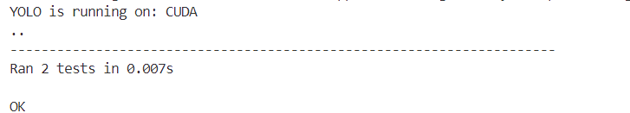

**Figure_. Test Case for Verifying Authentication**

**MENTORING SHEET**



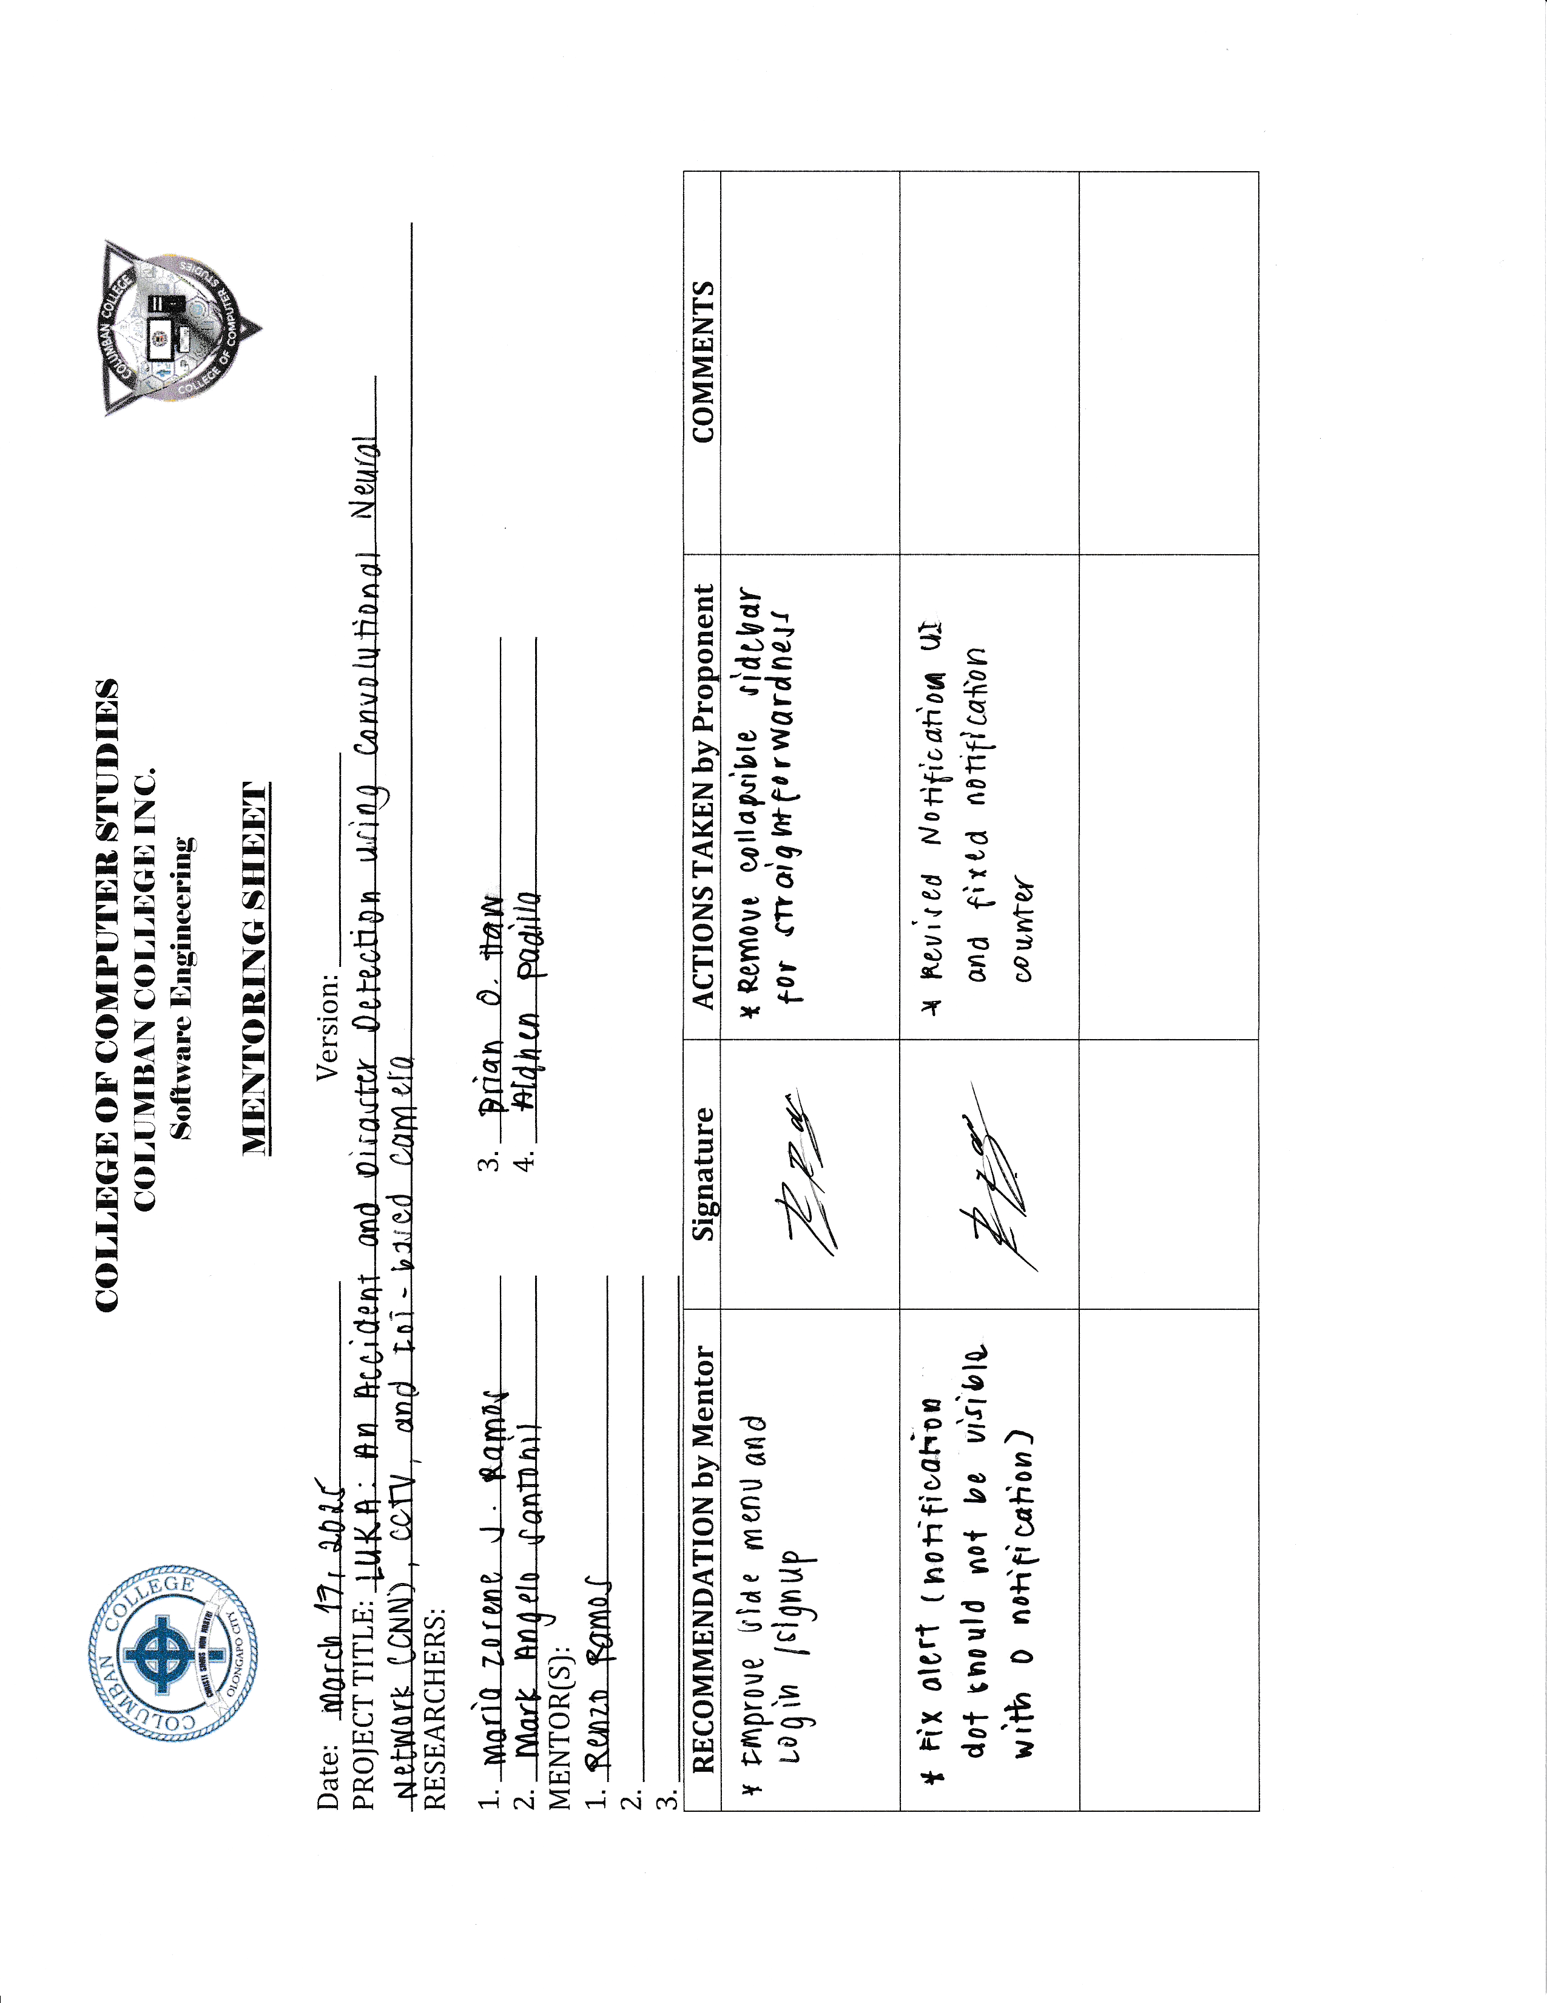



**User Acceptance**

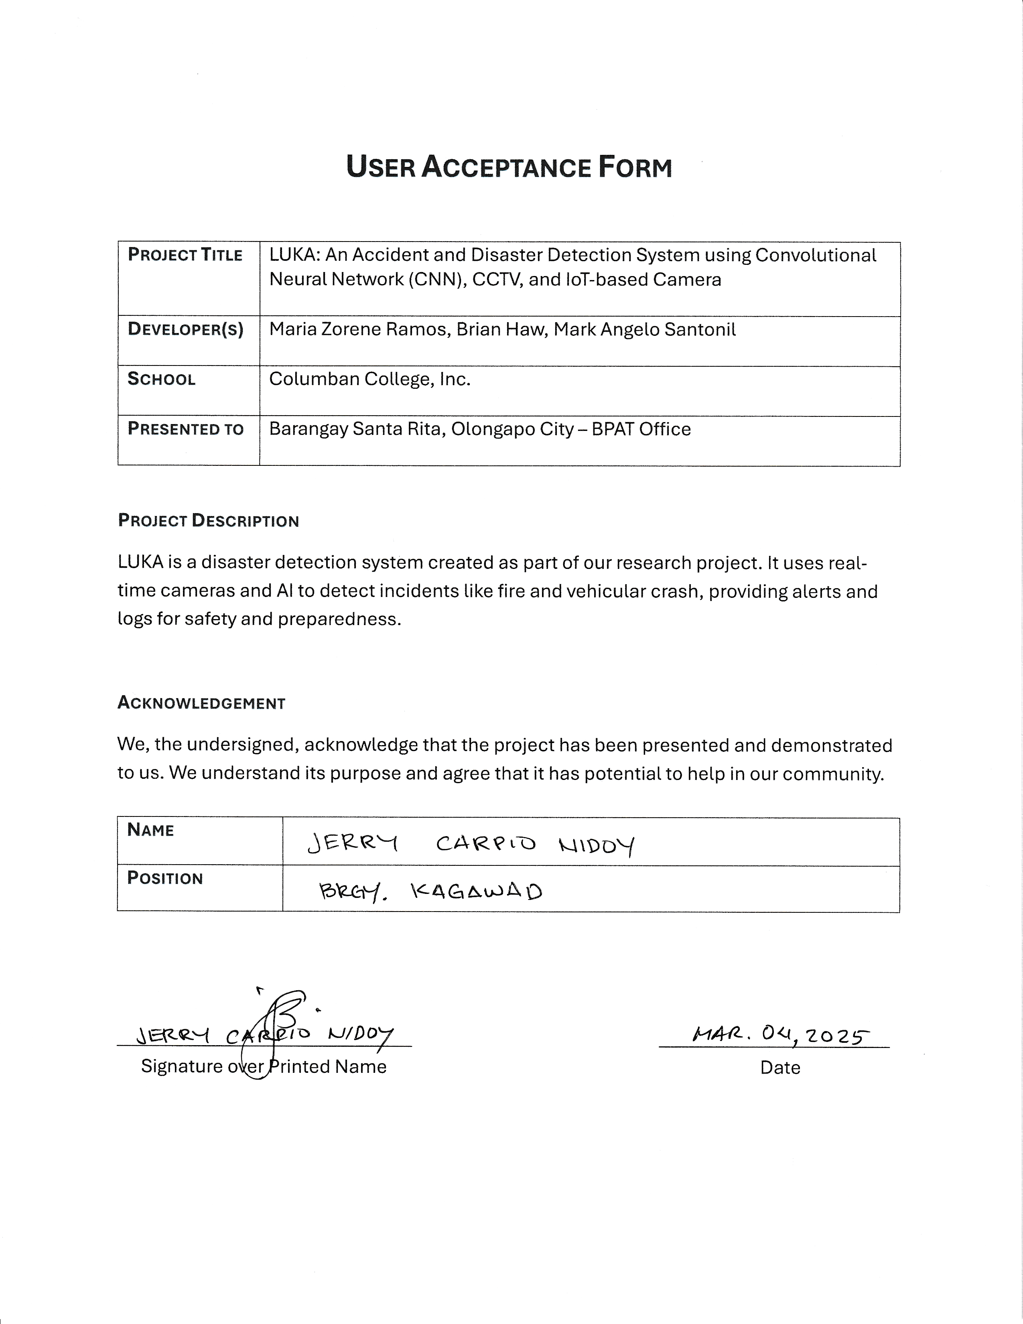

**Figure _. User Acceptance Form**

**END USER EVALUATION FORM**

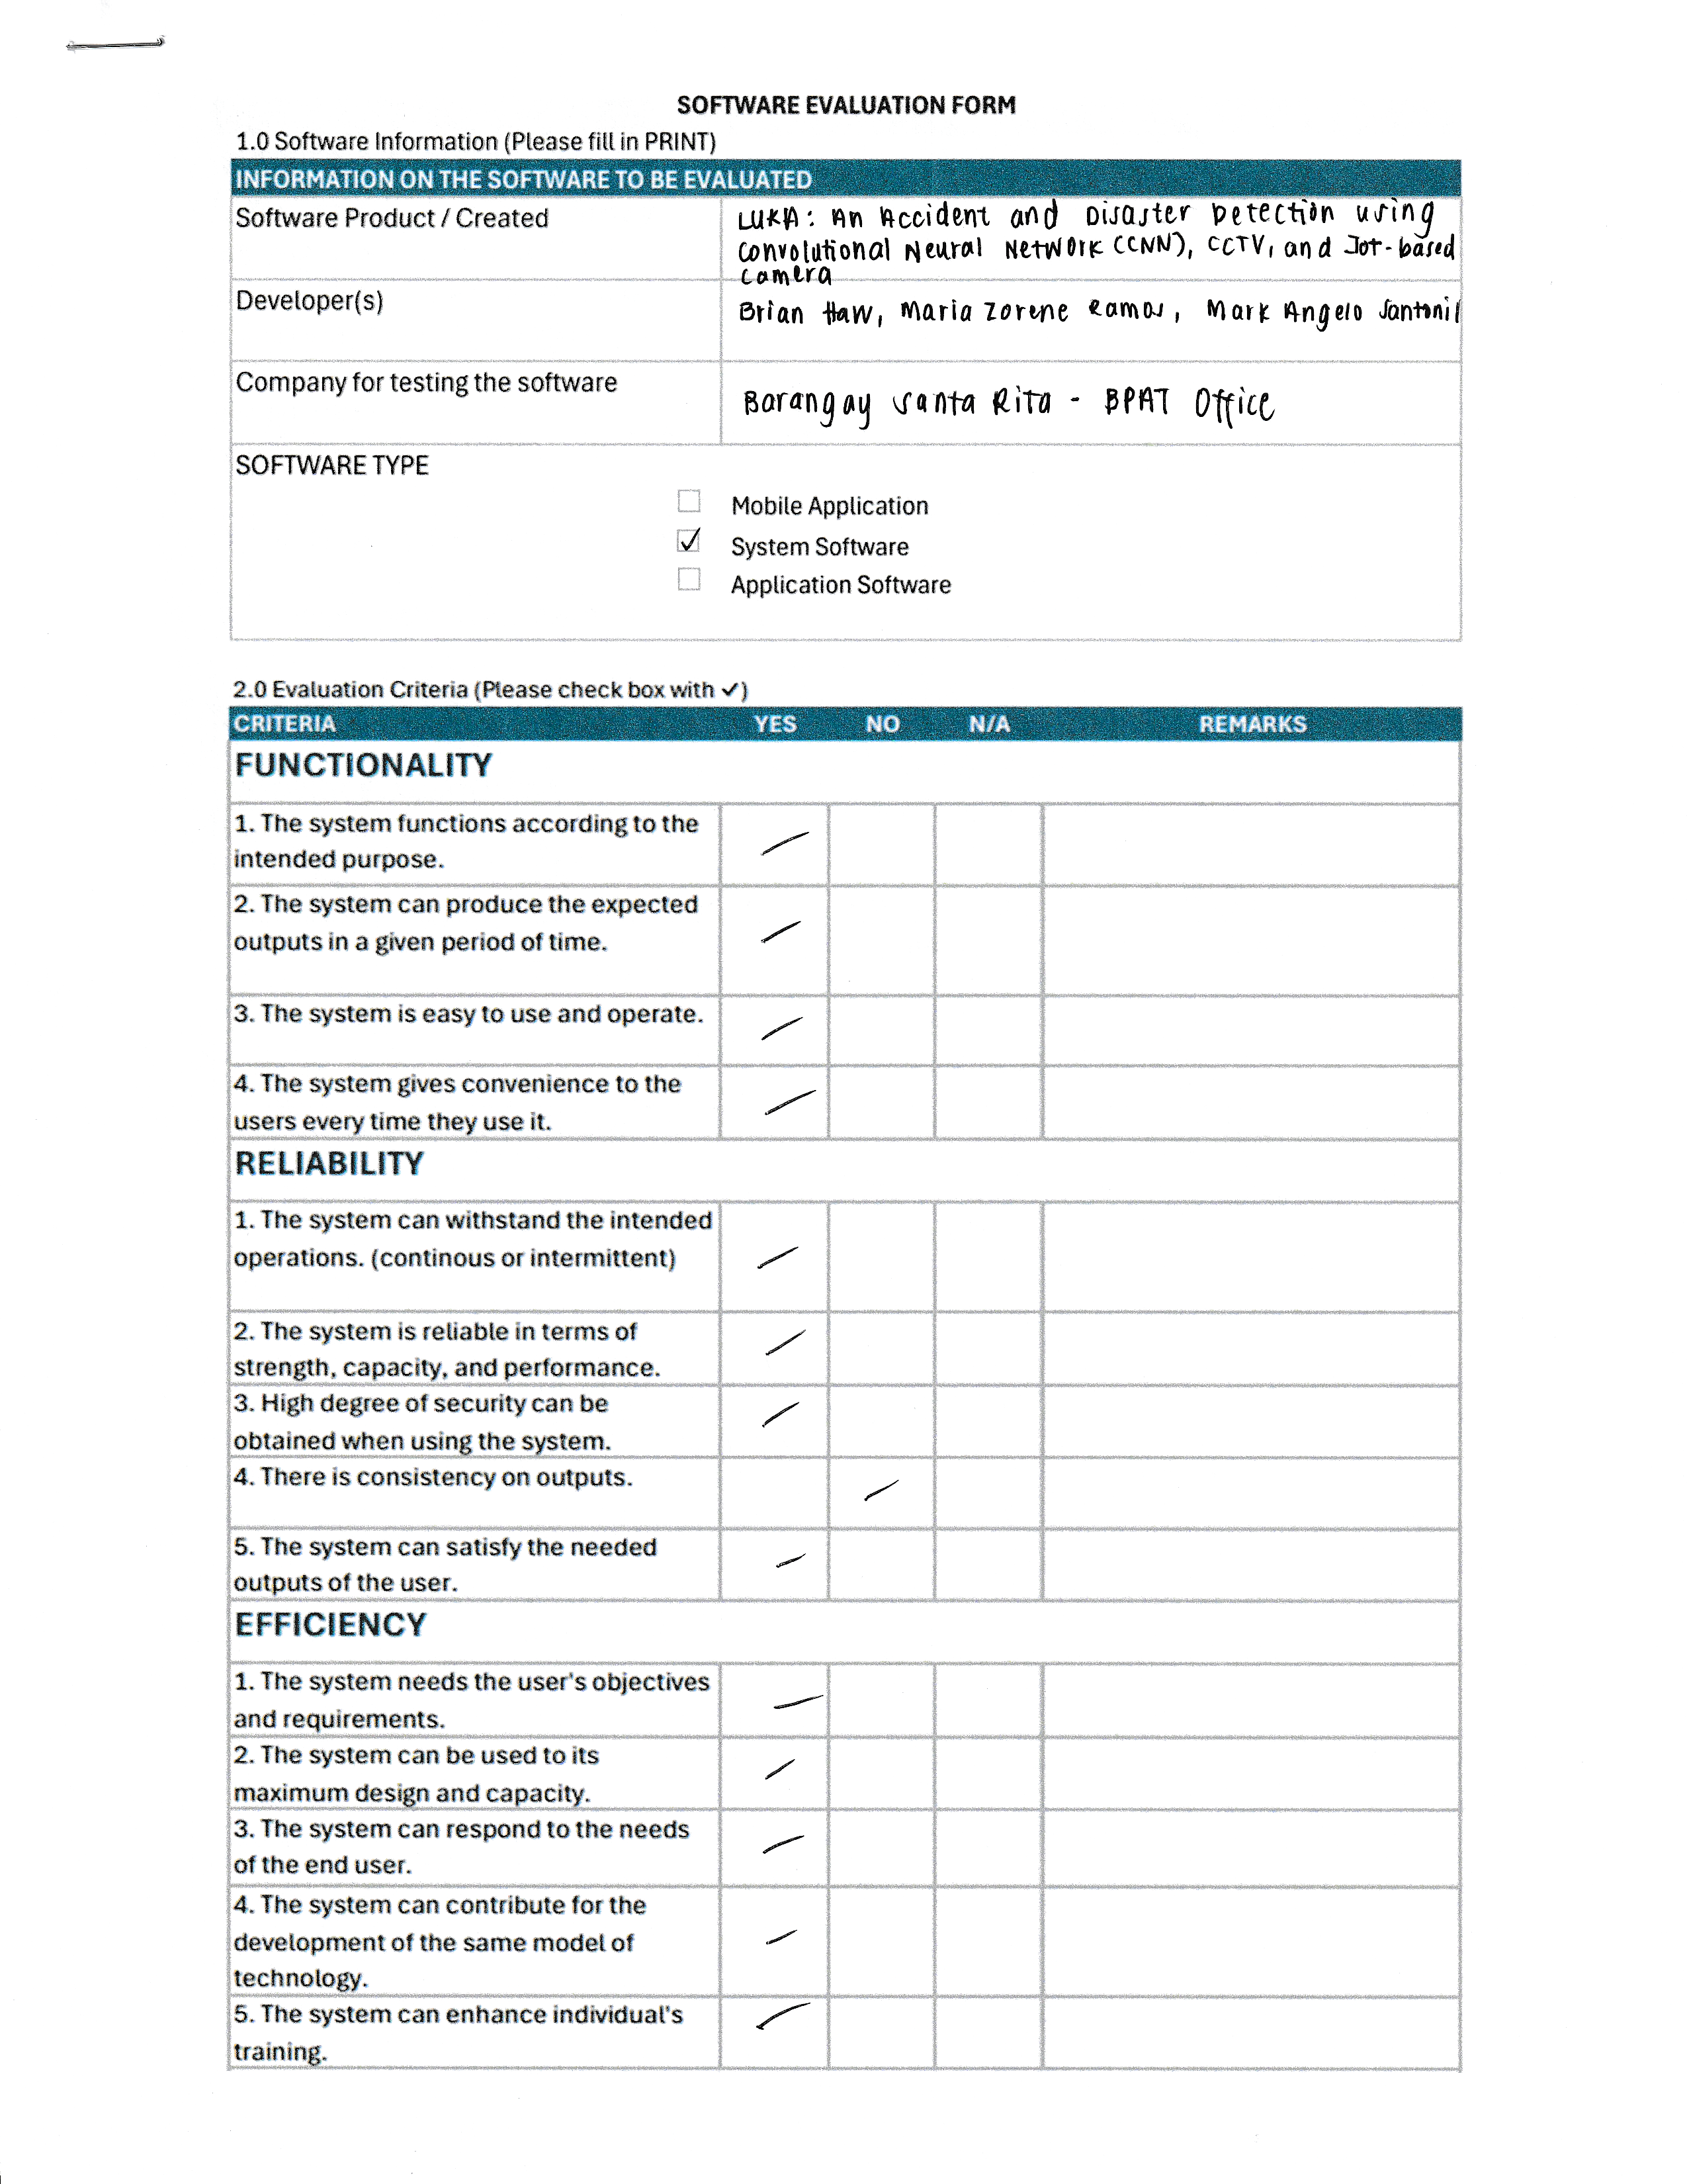

**CURRICULUM VITAE**





